Fish Passage Plan (FPP) Change Request Form
Change Form # & Title: 17BON003 – Nighttime Lamprey Operations
Date Submitted: 8/14/2016
Project: BON
Requester Name, Agency: BON Fisheries
Final Action:
FPP Section: BON 2.4.2.12.c. – Adult Facilities Operating Criteria – Fish Passage Season (Mar 1-Nov 30) – PH2
Justification for Change: Lamprey currently benefit from “nighttime lamprey operations” at PH2 entrances but not at the fishway entrances at the spillway or PH1. We would like to extend nighttime operations to these places. Entrance efficiency and passage times have been shown to benefit from reduced velocities at entrance gates (Clabough, Johnson, Keefer, Caudill, Moser, 2011). More recently, Project and Field Unit Biologists have, on separate occasions, observed and photographed lamprey attempting to enter at B-Branch and repeatedly thwarted by the high current velocity.
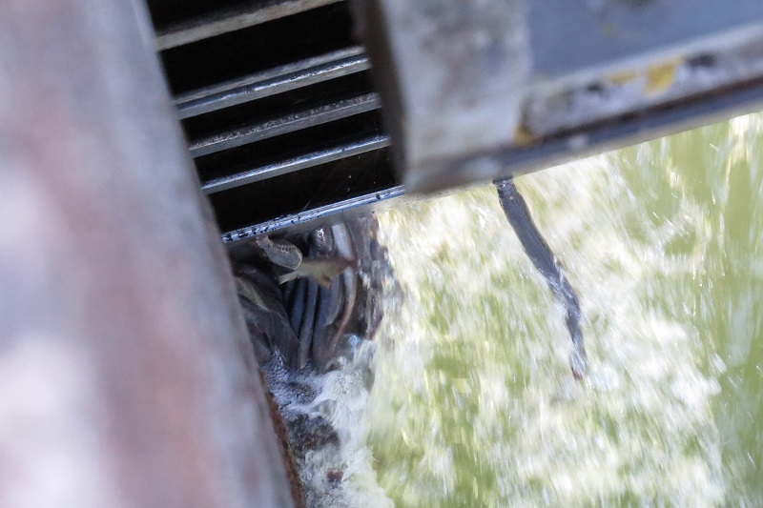 Photo courtesy of Bjorn Van der Leeuw
Proposed Change:
2.4.2.12.c. Lamprey Operations June 1–August 31: During night spill hours (Table BON-5), reduce fish unit output to operate all north (NUE, NDE) and south (SUE, SDE) entrances at 0.5’ of entrance head. To ensure proper function of fish units, B2 fish unit output can be further reduced or placed on standby to float debris as necessary from 2200-0400 hours. Fishway entrance differentials at Cascade Island, B-Branch, and PH1 will be reduced to 0.5’ by reprogramming of existing PLC Fish Valve control systems.
Comments:
Record of Final Action:

