Fish Passage Plan (FPP) Change Request Form
Change Form # & Title: 19BON002 – Update Temperature Monitor Locations
Date Submitted: March 15, 2019
Project: BON
Requester Name, Agency: Brian Bissell, USACE BON Fisheries
Final Action:

FPP Section: Figures BON-3, BON-4, and BON-5

Justification for Change: Need to update the BON graphics as follows:

- Figure BON-3 (Spillway, Cascades Island, and UMT): There is currently no temperature monitor at Cascades Island. We don't want a cable and probe flailing around in the fish ladder so we've installed stillwells for the hobos. Those have to be installed in the dry and requires dewatering CI (unknown next opportunity due to subsidence issues).

- Figure BON-4 (PH2 and WA Shore Ladder): The probe near the UMT/WA shore junction pool no longer exists as it was the previous Telog technology. Per FPP criteria there are probes at the entrance and exit of the WA shore ladder. There is an additional probe located in the AFF for research purposes.

- Figure BON-5 (SMF): Need to add an indicator for the temperature monitor at the SMF.

Proposed Change:

See Figures BON-3, 4, and 5 on following pages noting which monitors to delete and add.

Comments:

Record of Final Action:

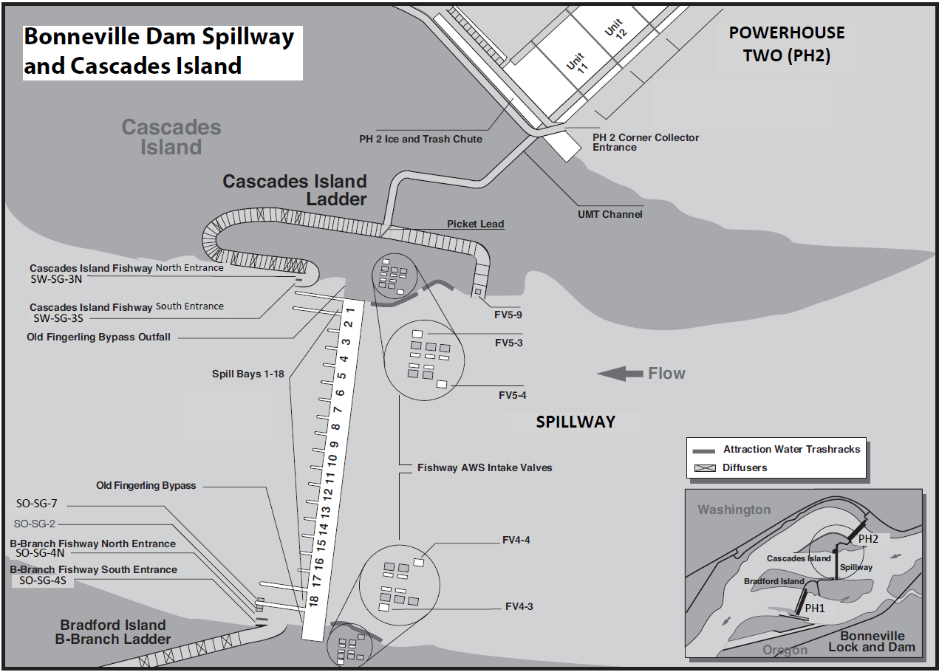
Delete

= Ladder Temperature Monitors (1)

Figure BON-3. Bonneville Dam Spillway, Cascades Island Fish Ladder and Upstream Migrant Transportation (UMT) Channel.
= Ladder Temperature Monitors (4)

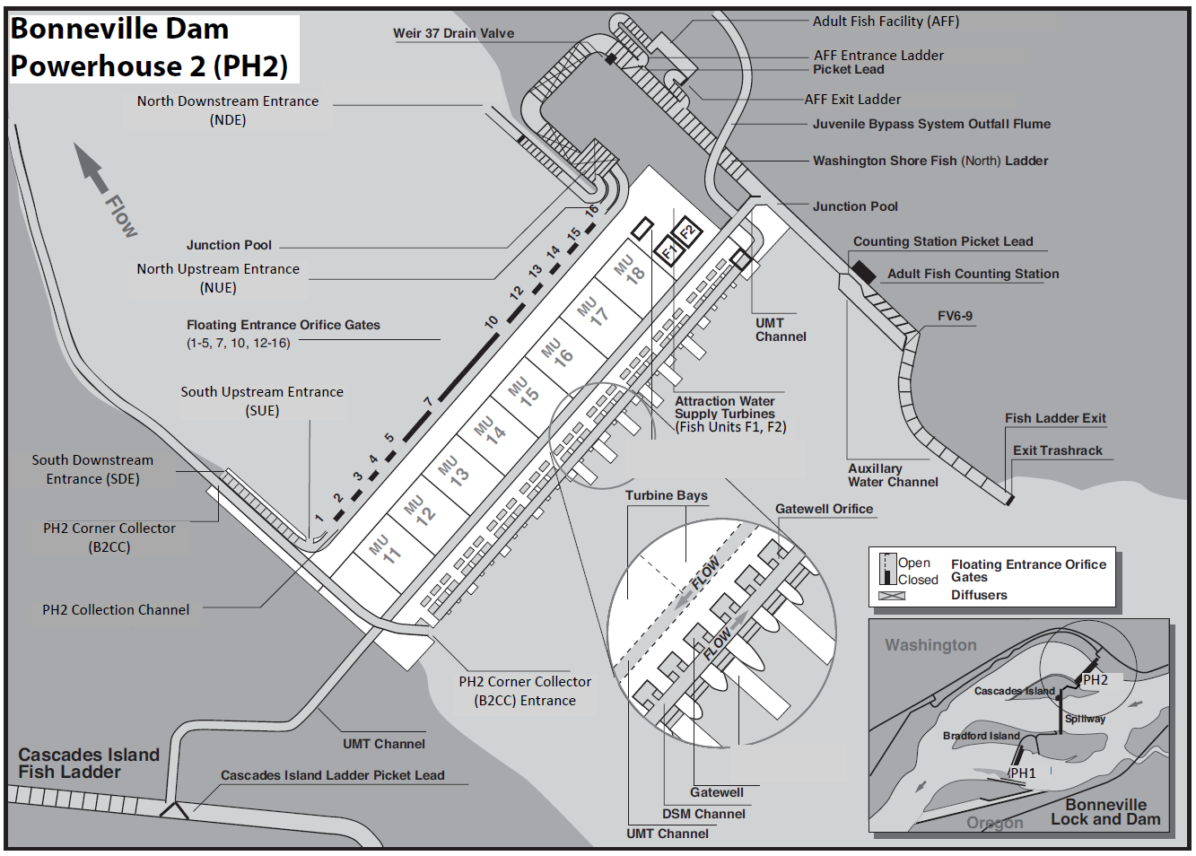
Delete

= Ladder Temperature Monitors (3)

Figure BON-4. Bonneville Dam Powerhouse 2 (PH2) and Washington Shore (WS) North Fish Ladder.
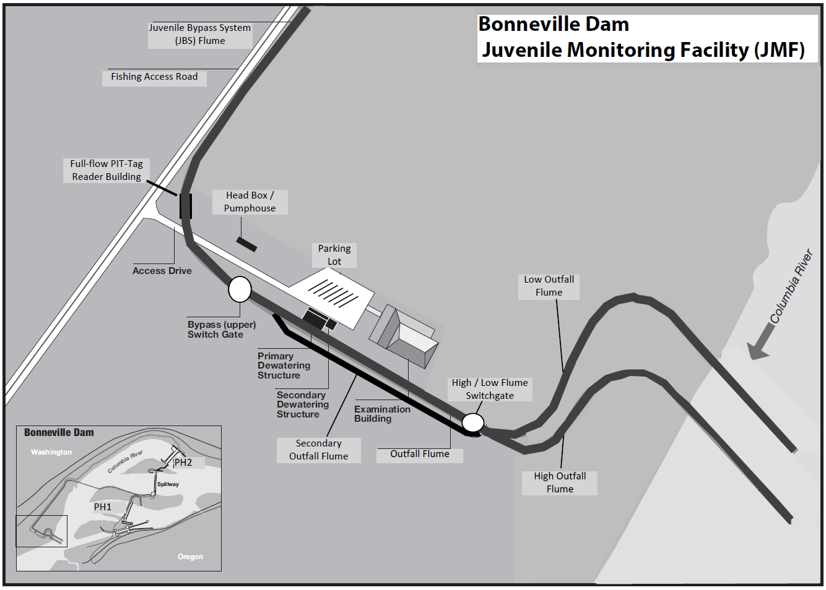
Add

= Ladder Temperature Monitors (1)

Figure BON-5. Bonneville Dam Juvenile (Smolt) Monitoring Facility (JMF) and Outfall Flumes.

