  - RCC update
Project | Previous Day (10/13) Average Outflow (kcfs) | 5 Day (10/18) Forecasted Inflow (kcfs) | 10 Day (10/23) Forecasted Inflow (kcfs) | Forecasted Inflow Low/High (kcfs)
LWG | 15 | 15 | 15 | 15 (10/23) / 15 (10/14)
MCN | 89 | 80 | 81 | 79 (10/21) / 96 (10/14)
BON | 97 | 87 | 87 | 86 (10/21) / 106 (10/14)
Table 1. NOAA Northwest River Forecast Center inflow forecast.

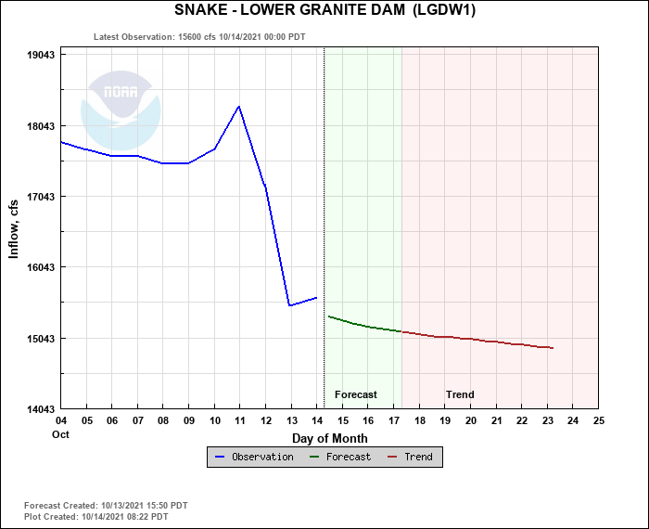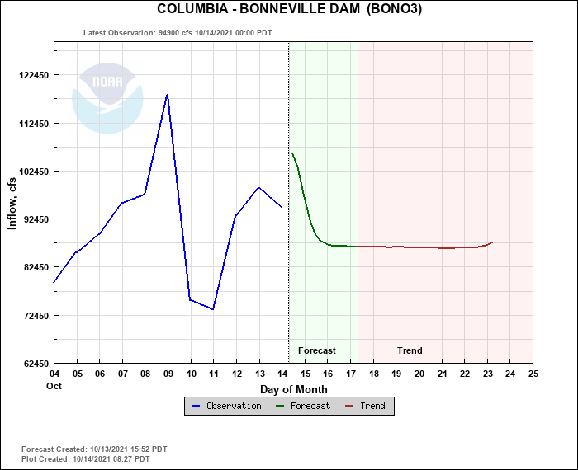

https://www.farmersalmanac.com/extended-forecast

