CENWP-OD-B 04 April 2024

MEMORANDUM FOR THE RECORD

SUBJECT: 24BON011 MFR BON FG3-31 Diffuser Hatch Failure

On the morning of 02 April 2024, Project Biologists discovered very turbulent water near Bradford Island Diffuser FG 3-31 in the B-Branch Entrance Bay (Figure 1). Attempts were made to reduce the amount of water flowing through FG 3-31 by opening diffuser FG 3-32 and lowering FV 4-4 from approximately 5.2’ open to 3.8’ open. However, the water flow produced from FG 3-31 remained extremely turbulent which led Project Biologists to suspect that it had blown grating above the diffuser pit.

An ROV inspection of the area was conducted on 03 April 2024 from approximately 1300 to 1330. The ROV inspection required the closure of FV 4-3 and FV4-4 for effective use of the ROV in the Bradford Island B-Branch Entrance Bay. The closure of both Fish Valves reduced the attraction flow to the Bradford Island B-Branch entrance below 1’, not complying with section 2.4.2.4 of the FPP “Maintain head on all entrances in the range of 1’-2’ (1.5’ preferred).” Attraction flow was restored at 1330 when both fish valves were opened. The ROV inspection determined that the FG 3-31 diffuser access hatch had blown out of place (Figures 2 and 3).

A dive operation was conducted on the morning of 04 April 2024 with the coordination between the District Dive Team and Bonneville Staff (Figure 4). Divers were successfully able secure the hatch back in place over the hole using a metal strongback beam. It is recommended that each diffuser hatch in the fishways should have these strongback beams added during the next fishway dewater for winter maintenance as a preventative measure.

The dive operation required the closure of FV 4-3 and FV 4-4 from 1000 to 1330 and a clearance placed on these valves to provide a safe working environment for the divers. Both FV 4-3 and 4-4 were opened immediately following the diving operations and the fishway is back to normal operations with proper head at the fishway entrance.

Bonneville Project Fisheries and Operations will continue to monitor the fishway conditions closely to watch for any further abnormal turbulence.

- Species – n/a, but still minimal fish passage at Bonneville at this time (04/03/24 fish count numbers: 19 Adult Spring Chinook, 0 Jack Spring Chinook, 38 Steelhead)
- Origin – n/a
- Length – n/a
- Marks and tags – n/a
- Marks and Injuries found on carcass – n/a
- Cause and Time of Death – n/a
- Future and Preventative Measures – continue to monitor fishways actively for abnormal turbulence. It is also recommended to add strongback beams to each diffuser hatch during future winter maintenance in water work periods.

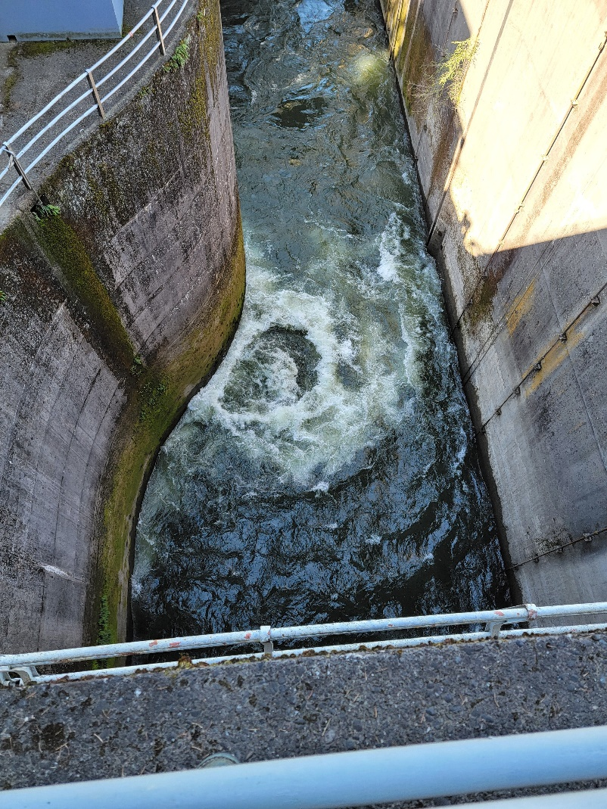
Figure 1. Turbulent water in Bradford Island Fishway Entrance Bay on 02 April 2024

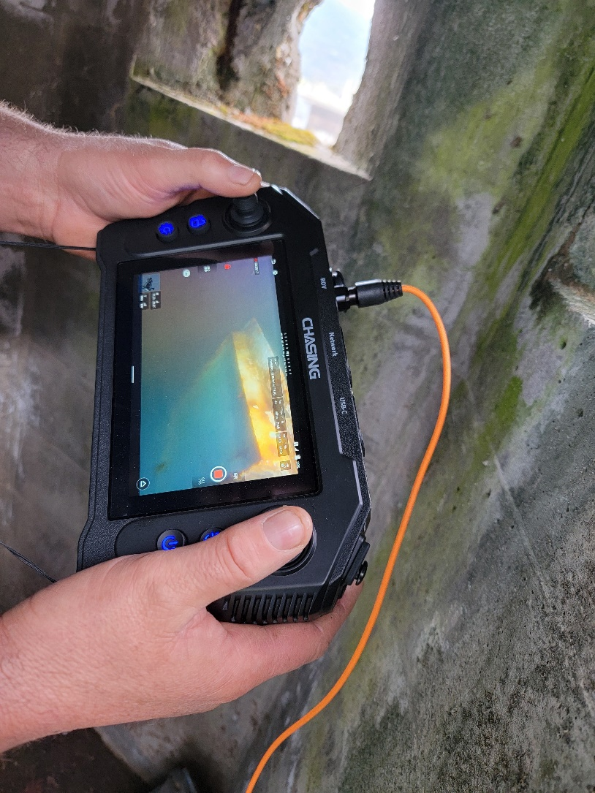
Figure 2. BI B-Branch FG 3-31 diffuser chamber access hatch dislodged and damaged on 03 April 2024.

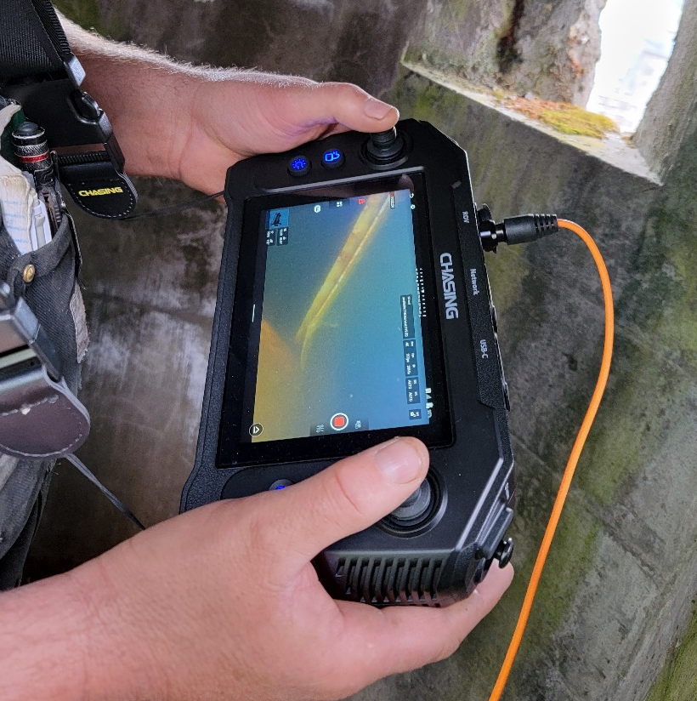
Figure 3. BI B-Branch FG 3-31 diffuser chamber access hatch dislodged and damaged on 03 April 2024.

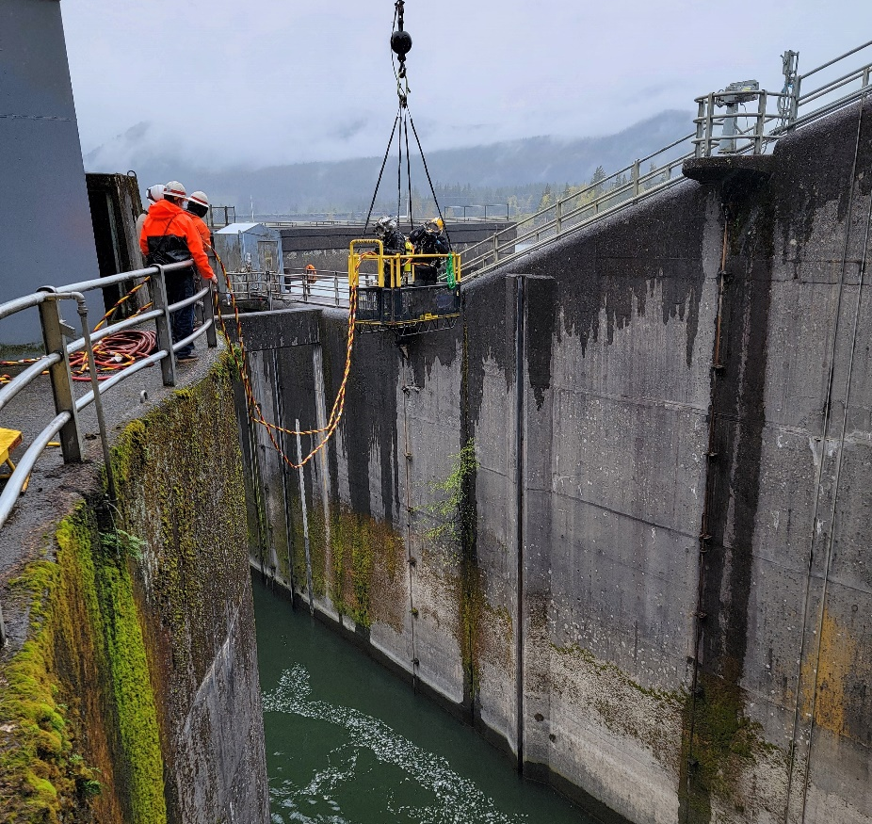
Figure 4. Divers accessing B-Branch Entrance Bay to make repairs on 04 April 2024.

Sincerely,
Bonneville Project Fisheries

