CENWP-OD-D 4/17/2024

MEMORANDUM FOR THE RECORD

SUBJECT: 24TDA04 The Dalles Dam Gatewell Mortality

April 11 one Chinook yearling mortality was found in gatewell 8-2 during inspection and gatewell drawdown check. The mort was not scanned for PIT.

- Species – Chinook
- Origin – unknown
- Length – NA
- Marks and tags – NA
- Marks and Injuries found on carcass – appears descaled on one side.
- Cause and Time of Death – unknown
- Future and Preventative Measures – none

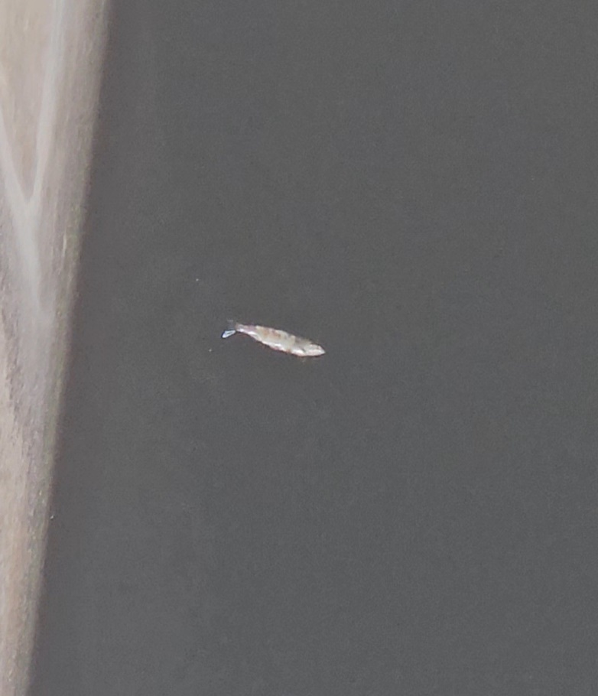
Sincerely,
TDA Project Fisheries

