Research Packet/Project Impacts Document

Development and Evaluation of Adult Lamprey Wetted Wall Structure at Bradford Island Fishway 2017-2019

Study Code: LMP-P-17-1, Objective 5

National Marine Fisheries Service, Northwest Fisheries Science Center

Project Leader

Kinsey Frick
Fish Ecology Division
Northwest Fisheries Science Center
2725 Montlake Blvd. East, Seattle, Washington 98112
(206) 860-5619

Submitted February 2018

Development and Evaluation of Adult Lamprey Wetted Wall Structure at Bradford Island Fishway 2017-2019

Background

Pacific lamprey are anadromous and adults in the interior Columbia River basin must pass up to eight or nine dams and reservoirs to reach historically-used spawning areas: up to four dams in the lower Columbia, five in the mid-Columbia, and four in the Snake River (Close et al. 1995; Luzier et al. 2011). Studies indicate that lamprey passage is restricted by the dams, particularly Bonneville and John Day (Moser et al. 2002a,b, 2005a,b; Keefer et al. 2013), and that these projects may be contributing to declines in basin-wide lamprey abundance. Of particular concern is the poor performance of lamprey at fishway entrances, through collection channels/transition areas, and past vertical slot and serpentine weir sections at the tops of the Bonneville Dam fishways (Moser et al. 2002b; Johnson et al. 2009b; Clabough et al. 2011a). Radio-telemetry results indicated that most lamprey pass the count windows, but are obstructed in the section of the fishway ladder containing the vertical-slot and serpentine weirs upstream from the count stations (Moser et al. 2003; Johnson et al. 2009b).

Radio-telemetry results and visual observations indicated that lamprey are obstructed by the serpentine weir section at the top of the fishways and therefore can accumulate in the adjacent makeup water supply (MUWS) channel (Figure 1). Because this area posed a significant threat to lamprey passage, we developed structures to collect adult lamprey from the MUWS channels at the top of the Bonneville Dam fishways (Keefer et al. 2011a, Moser et al. 2011). These structures allowed lamprey to move directly from the MUWS to the forebay. The lamprey passage structures (LPSs) were regularly used by adult lamprey and have become a method for routing lamprey around passage obstacles in fishways (Moser et al. 2011). In total, LPSs have been installed in the MUWS sections of the Bradford and Washington-shore ladders, and inside the entrances at BON Cascades Island Fishway and JDA North Fishway. LPS components are also integral to the BON Washington shore Lamprey Flume System (LFS).

Installation of new passage structures or improvements at several locations will yield further benefits to lamprey passage. Once lamprey are in the serpentine weir section they have to move downstream to access existing LPSs. We will help provide lamprey with an alternate route into the MUWS at Bradford Island by contributing to design and installation of a wetted wall in the serpentine weir section of the fishway that lamprey can climb and subsequently exit into the adjacent MUWS. The structure design will be based on one used in successful lab tests in 2014 (Corbett et al. 2015, Frick et al. 2017). Once approved and installed in the Bradford Island fishway, non-invasive assessment of lamprey use of the structure and salmonid behavioral response to its presence in the fishway will be conducted with video monitoring. Additional evaluation of use of the structure will capitalize on planned PIT- and radio-tag studies to be conducted in 2018 and 2019. Assessing lamprey use is critical at this location to adjust lamprey escapement estimates at Bonneville Dam.

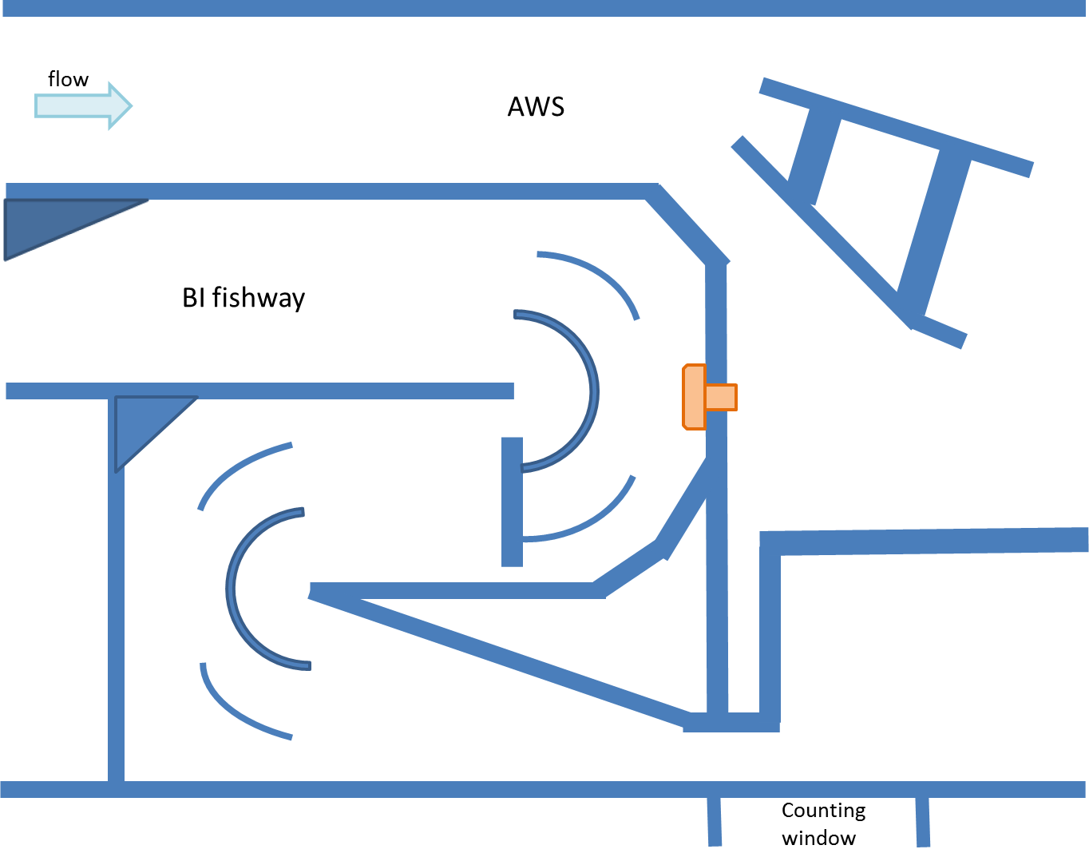

Figure 1. Schematic of a section of the Bradford Island Fish Ladder showing approximate potential location (orange) of the proposed wetted wall lamprey climbing structure allowing passage from the base of the serpentine weir section into the adjacent MUWS (AWS) channel. Yellow star shows proposed location of waterproof video camera with a view of the climbing surface and water interface. Green star indicates location of infrared camera for monitoring lamprey exiting the structure.

Objectives and Methods

- Consult with USACE staff on design, fabrication, and installation of an experimental wetted wall adult lamprey passage structure to be installed at BON Bradford Island Fish ladder.
  - Site visits and conference calls during the design, fabrication, and installation of a wetted wall climbing structure.

Lamprey reaching the serpentine weir section of the Bradford Island fishway cannot access LPSs without moving back downstream to the picketed leads. Such downstream movements may induce ladder fallout, without subsequent passage attempts. To aid passage, a wetted wall will take advantage of Pacific lamprey’s vertical climbing ability and proven use of an experimental wetted wall structure. This smooth vertical sheet with a radiused crest will be provided with minimal attractant flow (approximately 2.0 L∙m⁻¹∙cm⁻¹) and installed at the upper turn pool section downstream from the serpentine weirs by the USACE (Figure 1, exact location coordinated with USACE Bonneville Project staff). It will collect lamprey from the top of the Bradford Island fishway and pass them into the adjacent MUWS channel, which is outfitted with an LPS. Water will be pumped from the MUWS channel into an integrated reservoir to water the structure using a sidewelling mechanism. This design proved to be reliably successful in passing lamprey with apparently low stress in lab trials (Corbett et al., 2015; Frick et al. 2017). We will work closely with USACE fabricators and installers to help develop a structure that will be attractive to lamprey.

PIT detecting equipment will be provided by NOAA, with installation at the wetted wall structure exit coordinated with USACE fabricators. The wetted wall design has no areas where lamprey can hold without active attachment.

- Evaluate experimental wetted wall adult lamprey passage structure (LMP-P-17-1.5)
  - BON Bradford Island Ladder minor fishway modifications: wetted wall structure. Use non-invasive visual tools to evaluate efficacy and potential negative effects of a prototype “wetted wall” structure designed to guide lamprey from the main fishway to the Make-Up Water Supply (MUWS) channel LPS.
    - Evaluate adult lamprey use and behavior at the wetted wall structure, including enumeration of lamprey diverted from the main fishway to the adjacent MUWS channel.
    - Evaluate possible risk of the wetted wall structure to migrating adult salmonids through injury or delay.
    - Use relative passage route use and fate of radio- and PIT- tagged lamprey using the structure to assess potential benefits of the structure.

Camera systems will be installed to evaluate lamprey use of the wetted wall structure and to evaluate the effects on salmonids (Figure 1). One camera will be mounted with a view of the climbing surface and water interface for conducting daytime observations of lamprey climbing behavior and success, and to look for salmonid interactions (jumping, nosing) with the wetted wall structure. A second (infrared) camera will be mounted at the wetted wall exit (attached to the hood with a view of the pan and exit) to enumerate passing lamprey. These wireless cameras will record continuously while the structure is wetted, with data stored on a hard drive housed in a weatherproof box on the adjacent deck. Data will be downloaded regularly and processing of the resulting video will begin in-season. The daylight hours of video of the climbing surface will be reviewed for climbing lamprey, and subsequent time periods of exit video reviewed for passage success. Nighttime videos of the lighted exit will be reviewed for enumeration of lamprey passing at night. Video monitoring for lamprey passage at the exit of the structure will be conducted for the entirety of the lamprey passage season, and video review will provide a count of lamprey passing via the wetted wall structure. Ten-minute video clips per daylight hour for a week-long period per month (mid-April through mid-August) will be analyzed with a focus on potential negative behavioral interactions by salmonids. Hence, we propose to make observations of salmonid interactions for 16.7% of the daylight hours for one week each month during the operational season to cover a broad array of conditions and potential interactions by various species. The resulting observations will be descriptive (number and type of interactions observed) and reported monthly following video review. If such interactions are commonly observed and deemed problematic (in consultation with USACE and NOAA Fisheries), the attractant flow for the structure will be reduced; if problematic behaviors by salmonids persist, the flow to the wetted wall can be turned off, removing the stimulus.

Previous aids to lamprey passage have been assessed using a combination of lamprey counts, PIT and radiotelemetry detections, and video assessment of behavior. Armed with this information for the wetted wall (using lamprey tagged for other purposes when available), we will be able to determine the percentage of tagged lamprey in the vicinity of the structure that use it, and enumerate lamprey passing at the structure relative to counts at the Bradford Island LPS and count window. The early use of the structure (2018 and 2019) will be compared to the early use of other devices designed to improve lamprey passage (WA-shore, Bradford, and Cascades Island LPSs, John Day LPS, Lamprey refuge box use, etc.). We will report the relative number of lamprey passing via the wetted wall compared to those available in the fishway based on counts at the Bradford Island counting window. Based on the relative rates of interaction of lamprey with the wetted wall structure compared to early use of other lamprey passage structures, we will help USACE managers determine the potential future utility of a wetted wall at this location and its likely contribution to lamprey passage and, ultimately, recruitment.

Justification of the Proposed Study Area

The proposed work addresses research priorities and installation/modification needs identified by the Corps of Engineers and tribal fish agencies. The lamprey passage systems in question are installed at Bonneville Dam, and it is an ideal place for testing a climbing wall due to the potential for future proposed installation and access to fish.

Schedule

During the in-water work window in the winter of 2017/2018 we will mount PIT and video monitoring equipment (antenna and cameras) on the newly installed wetted wall structure in the Bradford Island fishway. These components will be connected to electronics housed in a deck box on the adjacent deck and connected to on-site power supply. This installation will require access to the structure from the fishway for two days during the dewatering period. Regular (weekly) access to the deck box will be required throughout the season (April – September) to download videos and PIT detections and to maintain the electronic equipment.

Facilities and Equipment

Installation of the Bradford Island fishway wetted wall will be conducted by USACE during the winter maintenance period at Bonneville Dam, and will be completed prior to commencement of the lamprey migration in the spring of 2018. NOAA-provided components for PIT detection at the structure will be fabricated off site and delivered/installed in coordination with USACE personnel and contractors. Electrical hookup for the electronic components will be needed at the site of the deck box, to be coordinated with USACE personnel. We request permission to access sites where LPS structures are located, access to electrical outlets in areas where PIT detectors and counting equipment for LPS/wetted wall structures are installed.

Impacts of Study on CORPS Projects and Other Activities

- Biological Effects

There will be minimal biological effects of this work as we are not handling any fish. The wetted wall structure has no areas where lamprey can hold or become entrapped for extended periods. Salmonids utilizing the fishway may be drawn to the falling water; salmonid behavioral responses will be assessed and we do not expect much salmonid response given the small input of water and the flow conditions of the fishway at this location.

- Personnel Effects

Consultation in design and installation will require regular interaction with fabricators, installers, and project biologists. Access to the prototype in advance of its installation will be necessary for inclusion of PIT detection equipment.

- Project Services

During the maintenance season we will need access to the Bradford Island fishway in order to install PIT and video equipment on the newly installed wetted wall structure.

- Security

All NOAA Fisheries personnel will carry Bonneville Dam ID badges and will notify project personnel when they enter and leave Bonneville Dam. Project security issues involve access to the study areas by study personnel and vehicles. Primary work areas will be in and around the Bradford Island fishway.

All NOAA Fisheries personnel listed on the ensuing page are U.S. citizens. We have no current plans to conduct research work in the Boat Restricted Zone (BRZ).

- Safety

All personnel will wear hard hats and safety shoes while on the dam. Other suitable work clothing will include long pants and no tank tops, suitable hand covering, and cold weather/rain gear and safety gear will be used as necessary. All personnel will follow procedures provided in the USACE Safety and Health requirements Manual, EM 385-1-1.

Care will be taken to eliminate any slippery areas near the lamprey passage structures where employees must walk. Care will be taken not to walk outside of approved walkways after dark. Provisions for adequate lighting will be made for working near the lamprey passage structures during the night. Safety procedures and hazard analysis will be followed when specific repairs are needed. All safe work practices will be followed during repairs. Project personnel will be notified before work proceeds on unscheduled repairs. The Activity Hazard Analysis is attached.

Personnel and Vehicles

Name Agency Activity
Frick, Kinsey NOAA-F LPSs and FERL
Corbett, Steve NOAA-F LPSs and FERL
Brooks, Gabriel NOAA-F LPSs and FERL
Rambo, Samuel NOAA-F LPSs and FERL
Tullos, Louis NOAA-F LPSs and FERL
Moser, Mary NOAA-F LPSs and FERL

List of Regular Vehicles
GSA

Accident Prevention Plan
Bonneville Dam – 2018

NOAA Fisheries

Development and Evaluation of Adult Lamprey Wetted Wall Structure at Bradford Island Fishway 2017-2019

February 21, 2018

Prepared by: Kinsey Frick
Research Fisheries Biologist
NOAA-Fisheries, Northwest Fisheries Science Center
206-860-5619

Approved: Name
Title
Agency
Phone

- Location of the Project
Bradford Island ladder (see Figure 1 above).

- Safety and Health Policy
NOAA Fisheries actively promotes safety awareness and safe work practices for all its employees. NOAA Fisheries safety policies cover a wide range of activities and work situations. All new employees are required to read and familiarize themselves with those policies that apply to their position. In addition to NOAA Fisheries’ safety policies, our employees must also adhere to federal and state OSHA requirements as well as to the USACE Safety and Health Requirements (EM 385-1-1).

- Procedures for Reporting and Investigating Accidents
Any safety violations are documented and reported to the Northwest Fisheries Science Center Safety Office for investigation and corrective action.

The NOAA Fisheries project supervisor, Kinsey Frick, will contact USACE project staff within 24 hours if an accident should occur. Any serious accidents requiring emergency medical services will be reported immediately to the Control Room. In case of medical emergencies, crew leaders (Steve Corbett) will use cell phone numbers to keep in contact with distant crew members should a severe weather or emergency evacuation event occur. If working alone, crew members will be in places easily visible to the public and project personnel.

- Drinking Water Provisions, Toilet, and Washing Facilities
Available at the visitor’s center and the AFF.

- Personal Protective Equipment
All NOAA Fisheries personnel will wear hard hats, long pants, and steel-toed boots when working in or around the Bradford Island fishway and lamprey passage structures. Hearing protection is available when working in loud environments, including prolonged exposure to the sound of rushing water.

- Control of Hazardous Energy and Lockout/Tagout
All NOAA Fisheries personnel will attend a pre-work safety meeting with project staff and abide by lockout/tagout rules.

AHA
Hazard analysis forms specific to each installation task will be submitted prior to initiation of the work.

Principle Steps | Potential Hazards | Recommended Controls
Installing wetted wall monitoring electronics (PIT, video) | Exposure to noise. | Use ear protection devices when using power tools.
 | Potential for head and foot injury from working around industrial equipment. | Wear hard hat and steel-toed boots at all times.
 | Electrical shock/Personal injury | Use UL listed extension cords with ground wire. Protect extension cords from damage. Rubber gloves to be worn where necessary. Insulated mats to be used where necessary. Proper battery charging procedures.
 | Tripping hazards. | Practice good housekeeping in keeping work area uncluttered. Be aware of potential tripping hazards that cannot be removed.
Conducting wetted wall evaluation | Potential for head and foot injury from working around industrial equipment. | Wear hard hat and steel-toed boots at all times.
 | Electrical shock/Personal injury | Use UL listed extension cords with ground wire. Protect extension cords from damage. Rubber gloves to be worn where necessary. Insulated mats to be used where necessary. Proper battery charging procedures.
 | Tripping hazards | Practice good housekeeping in keeping work area uncluttered. Be aware of potential tripping hazards that cannot be removed.

