2018 Water Management Plan
Seasonal Update
November 29, 2018
- Introduction
The annual Water Management Plan (WMP) is developed prior to the implementation of Federal Columbia River Power System (FCRPS) operational measures identified in the NOAA Fisheries 2008 FCRPS Biolgical Opinion (BiOp), as supplemented in 2010 and 2014 (collectively referred to as the 2014 NOAA Fisheries Supplemental BiOp), and the U.S. Fish and Wildlife Service (USFWS) 2000 FCRPS BiOp and 2006 Libby BiOp. The WMP is also developed prior to the receipt of any seasonal information that may determine how many of the operation measures are implemented. The Seasonal Update is intended to supplement the WMP with more detailed information on operations as the water year progresses. Each section of the Seasonal Update will be updated when information is available and finalized when no further information is available.

The first update for the primary elements of Fall and Winter will be posted by November 1 of each year. The first update for the primary elements of Spring and Summer will be posted by March 1 of each year. The elements and operations included in the Seasonal Update are generally the same as have been previously presented in the Fall/Winter and Spring/Summer Updates to the WMP. The change to update in this manner is intended to present better continuity for tracking operations as they change throughout and across each season. The elements and operations described in the Seasonal Update and the approximate schedule for updates and finalization are as displayed in Table 1.

Table 1. Schedule for update and finalization of Seasonal Update elements and operations.
Section | Element | Begins | Finalized | Last Updated
2.1 | Current Conditions (e.g., WSF, Streamflows) | October | July | October 22, 2018
2.2 | Seasonal Flow Objectives | April | August | October 22, 2018
2.3 | Flood Control | January | June | October 22, 2018
2.4 | Storage Project Operations | September | September | March 1, 2018
2.5 | Water Quality (Spill Priority Lists) | January | December | October 22, 2018
 | Specific Operations | Start Date | End Date | Last Updated
2.6 | Burbot spawning temperature management (Libby Dam) | November | December 30 | November 10, 2010
2.7 | Lake Pend Oreille Kokanee (Albeni Falls Dam) | September 1 | December 30 | October 22, 2018
2.8 | Upper Snake Flow Augmentation | April 1 | August 31 | October 22, 2018
2.9 | Chum Flows (Bonneville Dam) | November 1 | April 10 | March 1, 2018
2.10 | Hanford Reach Fall Chinook Protection | November | June | October 22, 2018
2.11 | Snake River Zero Generation | December | February | March 1, 2018
2.12 | Minimum Operating Pool | April 3 | September 30 | October 22, 2018
2.13 | Spill Operations | April 3 | September 30 | October 22, 2018
2.14 | Transport Operations | May 1 | - | October 16, 2018
2.15 | Fish Passage Research | March | October | October 16, 2018
- Seasonal Update Elements and Specific Operations
  - Current Conditions

Water Supply Forecasts – NWRFC
The final water supply forecast (WSF) is defined as the forecast posted on NOAA’s Northwest River Forecast Center (NWRFC) website at 5:00 pm Pacific Standard Time on the 3rd business day of the month. NWRFC water supply forecasts are available on the following website: http://www.nwrfc.noaa.gov/ws/

Table 2. The Dalles Dam Final Water Supply Forecasts.
Forecast Issue Date | January-July 2018 |  | April-August 2018
Forecast Issue Date | Volume (MAF) | % of 30-year Average (101.4 MAF) | Volume (MAF) | % of 30-year Average (87.5 MAF)
January 4, 2018 | 99.4 | 98% | 87.3 | 100%
February 5, 2018 | 111.5 | 110% | 94.7 | 108%
March 5, 2018 | 114.0 | 112% | 98.1 | 112%
April 4, 2018 | 117.6 | 116% | 103.3 | 118%
May 3, 2018 | 122.2 | 120% | 106.9 | 122%
June 5, 2018 | 121.3 | 119% | 105.9 | 121%
July 5, 2018 | 119.5 | 118% | 103.7 | 118%

Table 3. Grand Coulee Dam Final Water Supply Forecasts.
Forecast Issue Date | January-July 2018 |  | April-August 2018
Forecast Issue Date | Volume (MAF) | % of 30-year Average (59.6 MAF) | Volume (MAF) | % of 30-year Average (56.8 MAF)
January 4, 2018 | 58.0 | 97% | 55.9 | 98%
February 5, 2018 | 67.6 | 113% | 64.8 | 114%
March 5, 2018 | 68.6 | 115% | 65.9 | 116%
April 4, 2018 | 70.1 | 119% | 68.5 | 121%
May 3, 2018 | 74.1 | 124% | 71.5 | 126%
June 5, 2018 | 72.1 | 121% | 69.1 | 122%
July 5, 2018 | 71.4 | 120% | 67.8 | 119%

Table 4. Lower Granite Dam Final Water Supply Forecasts.
Forecast Issue Date | January-July 2018 |  | April-August 2018
Forecast Issue Date | Volume (MAF) | % of 30-year Average (27.4 MAF) | Volume (MAF) | % of 30-year Average (21.1 MAF)
January 4, 2018 | 27.4 | 100% | 21.7 | 103%
February 5, 2018 | 30.5 | 111% | 22.2 | 105%
March 5, 2018 | 30.5 | 111% | 22.9 | 111%
April 4, 2018 | 31.8 | 116% | 24.6 | 117%
May 3, 2018 | 31.6 | 115% | 24.3 | 115%
June 5, 2018 | 32.8 | 118% | 25.1 | 119%
July 5, 2018 | 31.8 | 116% | 24.5 | 116%

Water Supply Forecasts - Corps
Water supply forecasts for Libby and Dworshak dams are produced by the Corps’ Seattle and Walla Walla Districts, respectively. Corps’ forecasts are available on the following website:

http://www.nwd.usace.army.mil/Missions/Water/Columbia/Flood-Control/

Table 5. Libby Dam Final Water Supply Forecasts.
Forecast Issue Date | April-August 2018
Forecast Issue Date | Volume (KAF) | % of 79-year (1929-2008) Average (6,282 KAF)
December | 6697 | 107%
January | 6645 | 106%
February | 6765 | 108%
March | 7205 | 115%
April | 7189 | 114%
May | 7356 | 117%
June | 7213 | 115%

Table 6. Dworshak Dam Final Water Supply Forecasts.
Forecast Issue Date | April-July 2018
Forecast Issue Date | Volume (KAF) | % of 79-year (1929-2008) Average (2,696 KAF)
December | 3134 | 116%
January | 2941 | 109%
February | 2849 | 106%
March | 3093 | 115%
April | 3040 | 113%
May | 3032 | 112%
June | 2966 | 110%

Water Supply Forecasts – Bureau of Reclamation
Water supply forecasts for Hungry Horse Dam are produced by the Bureau of Reclamation.

Table 7. Hungry Horse Dam Final Water Supply Forecasts.
Forecast Issue Date | April-August 2018 |  | January-July 2018 |  | May-September 2018
Forecast Issue Date | Volume (KAF) | % of 30-year Average (2,070 KAF) | Volume (KAF) | % of 30-year Average (2,224 KAF) | Volume (KAF) | % of 30-year Average (1,835 KAF)
January | 2246 | 116% | 2437 | 116% | 1964 | 116%
February | 2358 | 122% | 2547 | 121% | 2062 | 122%
March | 2633 | 136% | 2863 | 136% | 2302 | 136%
April | 2636 | 136% | 2861 | 136% | 2395 | 141%
May | 2780 | 144% | 2950 | 141% | 2500 | 148%
June | 2848 | 148% | 2880 | 139% | 2538 | 150%

Weekly Weather and Precipitation Retrospectives
Week | Weekly Weather / Precipitation Retrospective
October 2, 2017 | Temperatures: Above average northwest. Below average southeast.  Precipitation: Increased to near average, with some snow accumulations above 7000 feet in BC, ID, and MT.  Streamflows: Mostly flat, as most precipitation either went into moistening soils, or fell as mountain snow.
October 9, 2017 | Temperatures: Below average, with snow levels at pass levels. First widespread freeze east of the Cascades.  Precipitation: Near average, but locally heavy in Cascades, Spokane/Clearwater and Clark Fork basins.  Streamflows: Very minor rises on the Willamettes and Bonneville side streams. Mostly flat elsewhere.
October 16, 2017 | Temperatures: Rising to above average.  Precipitation: Well above average (250-500% of normal), especially northwest half.  Streamflows: Minor but widespread rises on most US low elevation streams, especially in the Willamette, lower Columbia, mid-Cs, and Spokane basins.
October 23, 2017 | Temperatures: Above average.  Precipitation: Mostly dry.  Streamflows: Basinwide recessions after peaking Monday - Tuesday.
October 30, 2017 | Temperatures: Fell to below average. Snow levels dropped to valley floors east of Cascades and in the Seattle metro area.  Precipitation: Increased to near average. First accumulating snow of the season on the eastern valley floors this weekend.  Streamflows: Flat or receding, except for minor rises in the Willamettes/lower Columbia.
November 6, 2017 | Temperatures: Fell to below average for much of week then climbed to normal end of the week. Snow levels dropped to valley floors east of Cascades and in the Seattle metro area.  Precipitation: Increased to near average. First accumulating snow of the season on the eastern valley floors this weekend.  Streamflows: Flat or receding, except for minor rises in the Willamettes/lower Columbia.
November 13, 2017 | Temperatures: Slightly above average.  Precipitation: Above average NW WA, BC and SE ID. Below average elsewhere.  Streamflows: Minor rises on the Willamettes, otherwise mostly flat.
November 20, 2017 | Temperatures: Well above average. Record warmth Wednesday - Friday. Snow levels well above pass levels US basins.  Precipitation: Well above average, especially northwest 2/3 (200-300% of normal), with some falling as rain on snowpack.  Streamflows: Significant rises in the mid-Cs, lower Snake, Clearwater, Spokane, and Clark Fork/Pend Oreille. Moderate rises on the lower Columbia, Willamette and BC. Unregulated flows reached late November records at Lower Granite (70kcfs) and approached records at The Dalles (200kcfs) this weekend. Several rivers reached moderate and major flood stages in NW WA.
November 27, 2017 | Temperatures: Fell to near average.  Precipitation: Near average.  Streamflows: Basinwide recessions due to colder weather.
December 4, 2017 | Temperatures: Below average valleys, but well above average in the mountains due to strong temperature inversions.  Precipitation: No precipitation in what is normally wet time of year.  Streamflows: Receding. Significant drop in water supply forecast due to lack of mountain snowfall
December 11, 2017 | Temperatures: Near average, then rose to above average this weekend.  Precipitation: Below average, but with significant precipitation in BC Sun. Mostly dry south.  Streamflow: Flat or receding. Significant snowpack loss relative to average due to unusually dry December.
December 18, 2017 | Temperatures: Fell to well below average, but just short of cold snap criteria.  Precipitation: Increased to above average, with snow levels down to valley floors on both sides of the Cascades.  Streamflow: Flat or receding. Increasing ice jamming noted in western MT and ID.
December 25, 2017 | Temperatures: Below average, except briefly above average west Thursday - Friday.  Precipitation: Well above average WA, N ID and Western MT. Below average elsewhere.  Streamflow: Brief but noticeable rises on the lower Columbia, Yakima, Clearwater and Spokane on Friday which have since receded. Otherwise flat.
January 1, 2018 | Temperatures: Slightly above average.  Precipitation: Below average. Causing snow pack average to decline across the basin  Streamflow: Flat or receding.
January 8, 2018 | Temperatures: Above average.  Precipitation: Above average basinwide.  Streamflow: Notable rises on the Willamettes, lower Columbia, lower Snake, Yakima, Clearwater and Spokane. Unregulated flows on the lower Snake well above average for January (50-60 kcfs; normal is around 35 kcfs).
January 15, 2018 | Temperatures: Above average, but cooled closer to average this weekend.  Precipitation: Near average.  Streamflow: Minor rises Thursday - Friday on the Willamettes, lower Columbia, lower Snake, Clearwater and Spokane which since receded. Mostly flat elsewhere.
January 22, 2018 | Temperatures: Slightly above average, but with snow levels mostly below pass levels. Temperatures briefly rose well above average Sun.  Precipitation: Well above average basinwide (150-250% of normal). Significant snowpack gains, especially above Grand Coulee and in BC.  Streamflow: Moderate rises on the Willamettes. Minor rises on the lower Columbia, Spokane and lower Snake. Mostly flat elsewhere.
January 29, 218 | Temperatures: Well above average, except closer to average in BC. Several record highs Sunday. Precipitation: Well above average (150-250% of normal), especially above Grand Coulee. Below average western and southern OR. A second week of significant snowpack gains, especially above Grand Coulee and the upper Snake.  Streamflow: Significant rises on most lower elevation US streams. Unregulated flows at Lower Granite approaching record early February levels.
February 5, 2018 | Temperatures: Well above average thru Friday, then cooling slightly below average.  Precipitation: Well above average (150-250% of normal) in BC, western MT and northern ID, with a third week of significant snowpack gains. Below average elsewhere, and well below average in OR.  Streamflow: Crests on most US streams Monday / Tuesday, then receded due to colder temps. Baseflows remain well above normal for early February, especially in the lower Snake/lower Columbia.
February 12, 2018 | Temperatures: Below average. Near record cold Monday and snow levels dropping to valley floors.  Precipitation: Dry initially, then increased to above average.  Streamflow: Gradual recessions due to colder temps. Baseflows gradually falling closer to normal.
February 19, 2018 | Temperatures: Well below average, with several record lows and snow levels at valley floors.  Precipitation: Below average initially, then increased to above average US basins. Most precipitation fell as snow.  Streamflow: Flat or receding. For the first time since mid-December, unregulated flows at The Dalles fell below the long term average.
February 26, 2018 | Temperatures: Below average, with unusually low snow levels.  Precipitation: Above average, especially US basins.  Streamflow: Flat or receding. Unregulated flows slightly below average for this time of year.
March 5, 2018 | Temperatures: Below average.  Precipitation: Above average east; below average west.  Streamflow: Minor rises on the Clearwater, Spokane, lower Snake and Willamettes Fri-Sun, which have since receded. Flat elsewhere.
March 12, 2018 | Temperatures: Slightly above average, with load centers being especially above average.  Precipitation: Slightly below average, but with some snowpack gains  Streamflow: Small to moderate rises on many low elevation basins, especially the Clearwater, Spokane, Yakima, lower Snake and lower Columbia. Unregulated flows at Lower Granite increased to near 75kcfs (normal is around 50kcfs in late March).
March 26, 2018 | Temperatures: Slightly above average west; slightly below average east.  Precipitation: Slightly above average north and east; below average south and west.  Streamflow: Slow recessions due to cooler and drier weather.
April 2, 2018 | Temperatures: Below average Mon-Thu, then rose to above average.  Precipitation: Well above average (300-500% of normal in US basins). Several daily rainfall records broken.  Streamflow: Significant rises on the Snake, Yakima, Clearwater, Spokane, lower Columbia and Willamettes. Mostly flat in BC and western MT where most precip fell as snow.
April 9, 2018 | Temperatures: Near average ending below average  Precipitation: Well above average. Significant snowpack gains.  Streamflow: Snake and Spokane basins saw significant rises throughout the week with minor rises across the rest of the basin as week progressed.
April 16, 2018 | Temperatures: Below average initially, then rose to near average.  Precipitation: Above average in BC and western WA. Below average elsewhere.  Streamflow: Moderate snowmelt flows on many low elevation basins, which receded slightly late in the week. Unregulated flows at Lower Granite fell to 100 kcfs, and leveled off at The Dalles near 270 kcfs.
April 23, 2018 | Precipitation: Mostly dry initially, then increased to above average.  Streamflow: Substantial snowmelt rises, especially Snake, Clearwater, Spokane, Pend Oreille, Yakima, Kettle and Okanogan Basins. Unregulated flows rose to 150kcfs at Lower Granite, and likely reached the Internal Control Flow of 381 kcfs at The Dalles on Sunday.
April 30, 2018 | Temperatures: Near average Mon-Wed, then rose to well above average.  Precipitation: Below average, but with scattered showers and thunderstorms this weekend.  Streamflow: Spring freshet underway. High basinwide flows. Unregulated flows at The Dalles peaked near 475 kcfs Tue, fell briefly, then rose over 500 kcfs this weekend. Flooding began in the Pend Oreille, Okanagon, Ketlle, Kootenay and far upper Snake basins.
May 7, 2018 | Temperatures: Above average thru Wed, briefly cooler Thu-Fri, then well above average this weekend.  Precipitation: Above average, much of which fell as rain on the melting snowpack.  Streamflow: Very high snowmelt flows, with considerable flooding in the Pend Oreille, Okanagan, Kettle, and Kootenay basins. Unregulated flows increased to 550 kcfs into Grand Coulee and over 800 kcfs at The Dalles – both setting new early May records. See PGPW briefing page for specific inflow forecasts.
May 14, 2018 | Temperatures: Well above average thru Tue, then cooled to near average.  Precipitation: Above average east from scattered thunderstorms; below average west.  Streamflow: Very high snowmelt flows. Considerable flooding in the Pend Oreille, Okanagan and Kootenay basins, although flows eased somewhat due to cooler temps. Unregulated flows at The Dalles were near 900 kcfs this weekend -- the highest since 2008. Snake River flows appear to have peaked for the season.
May 21, 2018 | Temperatures: Above average.  Precipitation: Above average southeast from scattered thunderstorms; well below average north and west.  Streamflow: Very high snowmelt flows, but ongoing flooding eased in the Pend Oreille, Okanagan, far upper Snake and Kootenay basins. Unregulated flows at The Dalles hovered near 800 kcfs, and have likely peaked for the season.
May 28, 2018 | Temperatures: Near average.  Precipitation: Near average east with locally heavy rains and thunderstorms. Below average west. Streamflow: Very high snowmelt flows and flooding began to ease. Unregulated flows at The Dalles hovered near 800 kcfs before falling rapidly below 650 kcfs this weekend.
June 4, 2018 | Temperatures: Near average, then fell below average with snow levels briefly falling to 4000ft.  Precipitation: Above average western OR, BC, and central ID. Below average elsewhere.  Streamflow: Basinwide recessions overall, but with highly localized, minor rises from heavy rain and thunderstorms this weekend. Unregulated flows fell below 500 kcfs at The Dalles, which is below average for early June.
June 11, 2018 | Temperatures: Below average.  Precipitation: Slightly above average in BC, western MT and ID; below average elsewhere.  Streamflow: Basinwide recessions, except for highly localized, minor rises from thunderstorms. Unregulated flows fell below 400 kcfs at The Dalles, which is below average for mid June.
June 18, 2018 | Temperatures: Above average, especially Mon-Wed and again on Sunday.  Precipitation: Above average east of Cascades; below average west.  Streamflow: Increasing flows in BC from rain and high elevation snowmelt. Receding elsewhere, except for highly localized flow spikes in ID and MT from thunderstorms. Unregulated flows at The Dalles between 300-400kcfs, which is slightly below average for mid-June.
June 25, 2018 | Temperatures: Slightly below average.  Precipitation: Above average in BC, western MT and extreme SE ID; below average elsewhere.  Streamflow: Gradual basinwide recessions. Unregulated flows at The Dalles fell below 300kcfs, which is about a week earlier than usual.
July 2, 2018 | Temperatures: Below average northwest 2/3rd. Slightly above average 1/3rd. Record breaking heat wave in Southern CA Fri-Sun.  Precipitation: Above average in BC; mostly dry elsewhere except for isolated mountain thunderstorms.  Streamflow: Gradual basinwide recessions, except flat flows in BC due to showers and ongoing snowmelt.
July 9, 2018 | Temperatures: Warmed to above average, especially in the upper Snake Basin. First 100°F day in Portland on Sunday.  Precipitation: Hit-and-miss thunderstorms in BC. Mostly dry elsewhere. Basin is into its climatologically driest time of year.  Streamflow: Gradual basinwide recessions, although flows above Revelstoke, BC remained high due to scattered rainfall and high elevation snowmelt.
July 16, 2018 | Temperatures: Well above average Mon-Tue, near average Wed-Sat, then rising above average yesterday.  Precipitation: Mostly dry, except for isolated thunderstorms in BC.  Streamflow: Gradual recessions, although flows above Revelstoke, BC remained high due to scattered rainfall and high elevation snowmelt.
July 23, 2018 | Temperatures: Westwide heat wave began on Wed. Hottest week of the year so far in the Columbia Basin.  Precipitation: Mostly dry.  Streamflow: Gradual recessions, although flows above Revelstoke, BC remained high due to high elevation snowmelt.
July 30, 2018 | Temperatures: Latest Pacific NW heat episode ended Tue, then cooled sharply to slightly below average.  Precipitation: Mostly dry, except for isolated thunderstorms in BC and the WA Cascades.  Streamflow: Gradual recessions.
August 6, 2018 | Temperatures: West-wide heat wave. Load center average temperatures peaked Thu at 80.7°F, which was the hottest day since Aug 4, 2017. Hottest weather east of Cascades since 2015 heat waves. Briefly cooled to near average this weekend.  Precipitation: Mostly dry, except for isolated thunderstorms in BC, western OR and western WA this weekend.  Streamflow: Gradual recessions.
August 13, 2018 | Temperatures: Well above average, although heat was held in check by dense smoke and haze. Briefly cooled closer to average Thu-Sat.  Precipitation: Mostly dry, except for isolated thunderstorms east of the Cascades.  Streamflow: Gradual recessions.
August 20, 2018 | Temperatures: Well above average through Wed with dense smoke. Major pattern change began on Thu, with temperatures falling below average.  Precipitation: Below average, but with scattered showers and thunderstorms.  Streamflow: Very minor rises in ID/MT headwaters from scattered thunderstorms. Otherwise gradual recessions, especially in BC as cooler temperatures reduced residual snow and glacier melt.
August 27, 2018 | Temperatures: Near average.  Precipitation: Above average in BC and SE ID; below average elsewhere  Streamflow: Very minor rises in ID/MT/BC headwaters from scattered thunderstorms. Otherwise gradual recessions.
September 3, 2018 | Temperatures: Fell to below average.  Rainfall: Above average in BC; below average elsewhere  Streamflow: Very minor rises BC. Flat elsewhere.
September 10, 2018 | Temperatures: Started above average and dropped to below average.  Rainfall: Above average in BC; below average elsewhere  Streamflow: Very minor rises BC. Flat elsewhere.
September 17, 2018 | Temperatures: Below average northwest 2/3rd; above average SE 1/3rd. First freeze of the season eastern Oregon valleys this morning.  Rainfall: Slightly above average in BC; below average elsewhere  Streamflow: Very minor rises BC this weekend. Flat elsewhere.
September 24, 2018 | Temperatures: Above average, then cooled to near average this weekend.  Precipitation: Dry initially, then increased to above average in BC/western MT where mountain snows of the season were noted.  Streamflow: Very minor rises BC early in the week before receding. Flat elsewhere.

  - Seasonal Flow Objectives
Project | Planning Dates | BiOp Season Average Flow Objective – (kcfs) | Season Average Flow to date (kcfs)
Priest Rapids | Spring 4/10–6/30 | 135 | 229.6
McNary | Spring 4/10–6/30 | 220-260^{i} | 343.0
McNary | Summer 7/1–8/31 | 200 | 171.8
Lower Granite | Spring 4/3–6/20 | 85-100^{i} | 112.5
Lower Granite | Summer 6/21–8/31 | 50-55 ^{ii} | 41.8
- Varies according to NWRFC April forecast.
- Varies according to NWRFC June forecast.
  - Flood Control
Flood Control Elevations and April 10 objective elevations per each forecast period are listed in the table below. Forecasted flood control elevations will be calculated beginning in December after the Libby and Dworshak water supply forecasts are available. Subsequent forecasted flood controls will be updated after the final water supply forecasts are available January-April.

Grand Coulee and all Canadian projects will be operated for standard flood control. Hungry Horse and Libby will be operated for Variable Q (VARQ) Flood Control. Beginning in January, the Corps calculates Upper Rule Curve elevations based on the monthly official final forecasts. Projects are operated using these elevations as an upper limit, with the objective of reaching their spring refill elevations. Detailed flood control operations are available at the following website: http://www.nwd-wc.usace.army.mil/report/colsum.

The April 10 elevations shown in the table below are calculated by linear interpolation between the March 31 and April 15 forecasted flood control elevations.

Project | Elevation Date Objective | Dec | Jan | Feb | Mar | Apr
Libby | Jan 31 | 2400.5 | 2401.8
Libby | Feb 28 | 2390.9 | 2393.2 | 2387.7
Libby | March 31 | 2386.5 | 2389.2 | 2383.0 | 2358.3
Libby | April 10 | 2386.5 | 2389.2 | 2383.0 | 2358.3
 | April 15 | 2386.5 | 2389.2 | 2383.0 | 2358.3 | 2359.3
 | April 30 | 2386.5 | 2389.2 | 2383.0 | 2358.3 | 2359.3
Hungry Horse | Jan 31 | - | 3541.5
Hungry Horse | Feb 28 | - | 3534.3 | 3529.6
Hungry Horse | March 31 | - | 3525.9 | 3518.4 | 3496.2
Hungry Horse | April 10 | - |  |  | 3489.7
Hungry Horse | April 15 | - | 3521.8 | 3512.8 | 3486.5 | 3476.6
Hungry Horse | April 30 | - | 3517.5 | 3509.2 | 3485.4 | 3475.5
Grand Coulee | Jan 31 | - | 1290.0
Grand Coulee | Feb 28 | - | 1290.0 | 1289.6
Grand Coulee | March 31 | - | 1280.9 | 1262.2 | 1256.9
Grand Coulee | April 10 | - |  |  | 1246.0
Grand Coulee | April 15 | - | 1265.0 | 1244.8 | 1240.5 | 1234.0
Grand Coulee | April 30 | - | 1248.5 | 1232.1 | 1228.4 | 1222.7
Brownlee | Jan 31 | - | 2077.0
Brownlee | Feb 28 | - | 2045.9 | 2046.8
Brownlee | March 31 | - | 2040.4 | 2039.6 | 2037.2
Brownlee | April 15 | - | 2036.8 | 2035.9 | 2031.6 | 2025.0
Brownlee | April 30 | - | 2035.8 | 2032.1 | 2026.1 | 2014.7
Dworshak | Jan 31 | - | 1530.5
Dworshak | Feb 28 | - | 1511.9 | 1516.5
Dworshak | March 31 | - | 1509.9 | 1516.4 | 1461.6
Dworshak | April 10 | - | - | - | 1454.5
Dworshak | April 15 | - | 1517.0 | 1524.0 | 1451.0 | 1456.2
Dworshak | April 30 | - | - | - | 1491.2 | 1494.8
  - Storage Project Operations

Libby Dam
Bull Trout Flows: Bull trout minimum flows are specified in the 2006 Libby Sturgeon Biological Opinion (2006 BiOp) and may be found in Table 9 on page 26 of the Water Management Plan on the following website:

http://www.nwd-wc.usace.army.mil/tmt/documents/wmp/2018/

April 10 and Refill Objectives: According to the Corps’ Libby March Runoff Forecast the most probable runoff volume for April-August was 7,205 KAF (122% of average from 1981-2010). This forecast runoff volume resulted in an April 10 elevation objective of 2358.3
feet.

Sturgeon Pulse: On May 7, 2018, the Action Agencies (AAs) received System Operational Request (SOR) FWS #1 regarding the 2018 Libby Dam releases for sturgeon and bull trout augmentation flows. Based on the Service’s 2006 BiOp on operations of Libby Dam, and the May final April-August volume runoff forecast of 7.4 MAF, we are within a Tier 4 operations year for Kootenai River white sturgeon. The minimum recommended release volume for sturgeon conservation in a Tier 4 year is 1.2 MAF. The following specifications were included in the SOR.

- The 2018 sturgeon operations at Libby Dam will consist of one period of ramp- up/pre-peak/ascending limb flows, one period of peak flow (~20,000 cubic feet per second (cfs) or higher to provide a minimum flow of ~32,000 cfs at Bonners Ferry), and one period of ramp-down/post-peak/receding limb flows. The ramp- up and ramp-down will occur within 2006 BO ramping rates.

- Selective withdrawal gates at Libby Dam above elevation 2,326 mean sea level will be installed gradually prior to, and during, the augmentation operations, with the objective of passing the warmest water available in the forebay as it becomes available. Minimum submergence of selective withdrawal gates at Libby Dam is 30 feet, and gates will be installed to keep withdrawal elevations within 30-40 feet until all gates are installed.

- Release of the warmest water possible from Libby Dam, in combination with lower volume of release, will allow the Kootenai River temperature to increase to appropriate spawning temperatures at Bonners Ferry (8-10°C) during the receding limb of the hydrograph.

- Based on the Service’s 2006 BO on operations of Libby Dam, and the May final April-August volume runoff forecast of 7.35 MAF, we are within a Tier 4 operations year for Kootenai River white sturgeon. The minimum recommended release volume for sturgeon conservation in a Tier 4 year is 1.2 MAF, and we recommend the following procedures for discharge of at least this minimum volume:

  - Increase discharge from Libby Dam to ~20,000 (peak) cubic feet per second (cfs) over a 7-day period (pre-peak flows) when the Regional Team of Biologists determines that high elevation tributary run-off is peaking.

  - Maintain peak discharge (~20,000 cfs, depending on head of the forebay and river stage at Bonners Ferry) for as long as possible (~ 25 days of peak flows), taking into account the shape and volume of the ascending and descending limbs of the hydrograph and the total sturgeon flow augmentation volume available (i.e. 1.2 MAF). Although ~20,000 cfs is requested for sturgeon operations, under current conditions dam managers may need to increase outflows from Libby Dam to full powerhouse for flood risk management purposes.

  - After peak flows, gradually decrease discharge at Libby Dam (post-peak), adhering to ramping rates in the 2006 BO, and exhaust the total sturgeon volume to maintain a river flow that will result in a gradually receding stage at Bonners Ferry (Figure 3).

  - After the sturgeon flow augmentation volume has been exhausted, continue to decrease discharge at Libby Dam towards stable summer flows, to no less than bull trout minimum flows (9,000 cfs in Tier 4).

  - Total number of days at peak discharge will depend on real time conditions and the shape of the inflow hydrographs.

  - Current modeling indicates that the intended flow objective at Bonners Ferry of 30+kcfs will be sustained for approximately 33 days.

May 9, 2018, Technical Management Team (TMT) Meeting. USFWS, informed TMT about the second System Operation Request, to provide a pulse from Libby dam to aid sturgeon migration and spawning. Based on the runoff forecast of 7.3 MAF, this is a Tier 4 year. In earlier years, the SOR provided for a double pulse. However, after reviewing telemetry data, the request this year is to change the shape to provide a single pulse. The timing and magnitude of the pulse would be condition-dependent, with guidelines described in the document on the TMT web site. The ramping up of Libby flows to 20 kcfs will provide 30 kcfs of warmer water at Bonners Ferry for approximately 40 days to assist white sturgeon migration and spawning activity.

TMT Members in attendance were polled and provided the following response to the SOR.

Nez Perce: support
OR: abstain
ID: support
WA: support
USFWS: support
BPA: support
BOR: support
COE: support
Umatilla: support
Colville: support

NOAA and MT were not present. NOAA provided the Corps with an email in support of the
SOR. The Corps coordinated the SOR with MT the previous day and MT did not object to
implementing the SOR.

Hearing no objections, the Corps will implement the SOR.

The sturgeon pulse occurred May 15 through June 27 and a summary of Libby outflows (day average) during the sturgeon pulse are included below.

May 10 through May 15 outflow was 9.8 kcfs prior to the start of the sturgeon pulse.

May 15 through May 22 marked the start of the sturgeon pulse when outflows were gradually increased to 20.0 kcfs.

May 23 through May 31 total outflow was held at 20.0 kcfs.

June 1 through June 8 total outflow increased to 23.0 kcfs in order to increase the stage at Bonners Ferry.

June 9 through June 13 total ouflow decreased to 20.0 kcfs.

June 14 through June 17, total outflow decreased to 17.0 kcfs.

June 18 though June 21, total outflow decreased and ranged from 14.9 to 15.5 kcfs.

June 22 through June 27, total outflow decreased and ranged from 11.9 to 13.0 kcfs.

June 27 marked the end of the sturgeon pulse when the sturgeon volume had been utilized and outflow was reduced to the expected stable summer flow.

Summer Draft Limit: From August through October in 2015-2018, the AAs will be operating Libby Dam in coordination with the Kootenai Tribe of Idaho in order to provide conditions for construction of a suite of Kootenai River Habitat Restoration Projects (KRHRP). In order to accommodate this operation, the AAs will coordinate with TMT on the actual operation to reach the 2014 NOAA Fisheries Supplemental BiOp September 30 elevation of either 2439 or 2449 feet. Peak reservoir elevation occurred on July 25 (midnight reservoir elevation 2448.1 feet). End of August 31 elevation was 2443.8 and September 30 elevation was 2441.6 feet.

May 9, 2018, TMT Meeting. Kootenai Tribe of Idaho, described the proposed System Operation Request to continue habitat restoration work to benefit the ESA-listed white sturgeon population, burbot and other species. This work began in 2011, with Phase 2 started in 2017. It is designed to increase the number of pools and improve the overall ecosystem of the Kootenai River. The request is to limit outflows from Libby Dam to 6 kcfs from September to the first week in November. The November portion of this operation will require close communication with BPA and the Corps regarding anticipated November flood control and power needs.

The Corps noted that Snotels in the basin currently show much snow, though recent warm temperatures have dropped the lower elevation snowpack rapidly. Current runoff volume is the third highest on record, with high June inflows also predicted. The reservoir target elevation is 2449 ft. at the end of August, and 2448-50 at the end of September. There is a good chance of refill this year.

ACTION: The facilitator polled all TMT members and all approved the SOR. Montana and NOAA had previously given their approval.

TMT members were polled and provided the following feedback on the SOR:
Nez Perce: support
OR: support
ID: support
WA: support
USFWS: support
BPA: support
BOR: support
COE: support
Umatilla: support
Colville: support

NOAA and MT were not present. NOAA provided the Corps with an email in support of the SOR. The Corps coordinated the SOR with MT the previous day and MT did not object to implementing the SOR.

Hearing no objections, the Corps plans to implement the SOR.
Libby Dam maintained daily total outflow of 9 kcfs from August 1 though August 31. August 1 midnight reservoir elevation was 2447.9 feet and the midnight reservoir elevation on August 31 was 2443.8 feet.

Libby Dam ramped down to 6 kcfs over three days from September 1 to 3. Project ouflow for the remainder of the month (September 3 through September 30), was 6 kcfs. September 1 midnight reservoir elevation was 2443.7 feet and September 30 midnight reservoir elevation was 2441.6 feet.

Hungry Horse Dam
Water Supply Forecast and Minimum Flows: The minimum flow requirements are measured at two locations the South Fork Flathead River below Hungry Horse Dam and the Flathead River at Columbia Falls. The minimum flows will be determined monthly, beginning in January, with the Bureau of Reclamation’s WSF forecast for Hungry Horse Reservoir for the period of April 1 to August 31. The final flow levels, for the remainder of the calendar year, are based on the March Final forecast. Reclamation’s March 2018 Final WSF for April-August was 2631 KAF (136% of average) which set the minimum flow requirements below Hungry Horse and at Columbia Falls at 900 cfs and 3500 cfs, respectively. The mimimum flows are set for the rest of the calendar year and will be updated following the January 2019 Final Forecast.

April 10 and June 30 Refill Objectives: The Bureau of Reclamation computes Hungry Horse’s final April 10 elevation objective by linear interpolation between the March 31 and April 15 forecasted flood control elevations based on the March Final WSF. Based on the March final forecast and forecasted flood control elevations, the April 10 elevation objective was 3489.5 feet for Hungry Horse, the actual elevation averaged 3489.4 feet for the day. The April 30 target for flood risk management bounced from 3517.5 feet from the January forecast, to 3475.5 feet for the April forecast. Between January and April the forecast increases from 116 to 141 percent of average. The actual April 30 elevation was 3476 ft feet which was higher than the April 30 flood risk management elevation due to the initiation of refill on April 26. Discharges from Hungry Horse were targeted to be held around 6000 cfs range in early May to manage the refill of the reservoir. Due to May being a record month for total runoff in the Flathead Basin Hungery Horse had to reduce discharge three times during the month to try and prevent Columbia Falls from going over flood stage. Hungry Horse’s maximum elevation was 3559.86 feet which was 0.14 feet below the full elevation.

Summer Draft Limit: The summer reservoir draft limit at Hungry Horse is 3550 feet (10 feet from full) by September 30, except in the lowest 20 percentile of water years (The Dalles April-August < 72.2 MAF) when the draft limit is elevation 3540 feet (20 feet from full) by September 30. The RFC’s May Final April-August forecast is used to set the official draft limit. The May Final April - August forecast at The Dalles was 106.9 MAF (122% of average) which set the September 30 draft target to 3550 feet.

Grand Coulee Dam
April 10 and June 30 refill Objective: The Bureau of Reclamation computes Grand Coulee’s final April 10 elevation objective by linear interpolation between the March 31 and April 15 forecasted flood control elevations based on the March Final WSF for The Dalles.

For 2018 the official April 10 elevation objective was 1249.2 feet. The actual elevation on April 10 was 1240.4 feet. From March to April the volume forecasts were increasing and the actual April 10 elevation was significantly lower than the objective to make sure that the draft rates for Lake Roosevelt would not have to be exceeded to reach the April 30 objective for flood risk management of no higher than 1222.7 feet.

Grand Coulee began refill during the first week of May and continued to refill to 1284.6 feet on June 30 to set up for the July 4 operation. Through the weekned before the 4th of July Grand Coulee was held relatively constant and then filled no more than 0.5 feet per day and remained below 1287 feet through the holiday itself. After the July 4 holiday, Grand Coulee refilled to 1289.9 feet on July 9 which allowed for the 0.2 feet for the Lake Roosevelt Incremental Storage Release Program.

The Lake Roosevelt Incremental Storage Release Program: The total amount of water to be
released from Grand Coulee in 2017 under the Lake Roosevelt Incremental Storage Release
Program was 36,468 acre-feet and was be distributed as shown in Table 8.

Table 8. Lake Roosevelt releases requested for 2018 .
“Bucket” | 2018 Releases (acre-feet) | Total Lake Roosevelt Incremental Storage Releases Program (acre-feet)
Odessa | 3656 | 15,000
M&I | 8500 | 12,500
Instream Flow | 24,312 | 55,000

Summer Draft Limit: The Grand Coulee summer draft limit is set by the magnitude of the RFC's July Final April-August WSF at The Dalles Dam. Based on the July Final WSF at The Dalles, the summer draft limit for Grand Coulee is 1280 feet. The draft limit will be modified an additional 0.4 feet, to elevation 1279.6 feet to implement the Lake Roosevelt Incremental Storage Release Program.

Drum Gate Maintenance: A full 8-week period for drum gate maintenance was implemented in 2017. The maintenance required Lake Roosevelt to be below elevation 1255 feet for the whole period. The maintenance period began on March 12 and was completed by mid-May, 2018. Drum gate maintenance at Grand Coulee is essential to keep the drum gates in a safe working condition.

Banks Lake:
Banks Lake will draft to elevation 1565 feet by August 31 to provide more water for summer flow augmentation. Pumping to Banks Lake will be reduced and irrigation for the Columbia Basin Project will be met be drafting the reservoir up to 5 feet from full.

Dworshak Dam
Dworshak Dam unit 3 was out of service for an overhaul that occurred from September 1, 2016, through July 5, 2018. Unit 3 returned to service on July 6, 2018. During the overhaul powerhouse outflow was reduced by approximately 55% from 10 kcfs with 3 units (units 1, 2, and 3) in operation down to 4.5 kcfs with 2 units (units 1 and 2) in operation. During water year 2018, the Corps continued coordination of Dworsak Dam operations with the TMT duing the unit 3 outage period as well when unit 3 returned to service. Seasonal conversations regarding Dworshak Dam operations generally focused on the following issues: 1) Winter of 2017/18, ensuring flood risk management drafts balanced flood risk management and spring 2018 refill; 2) Spring of 2018, ensuring the refill balanced adequate project outflow for outmigrating juvenile salmon, and; 3) Summer of 2018, operating Dworshak Dam outflows in order to ensure Lower Granite Dam tailwater temperatures not to exceed 68 degrees F. Dworshak was drafted to meet flood control requirements, provided spring augmentation flows to the extent possible, refilled on 7/3 (to elevation 1600 ft) and was drafted across the summer for temperature control and flow augmentation reaching 1535 ft on 8/31 and 1520 ft on 9/24. More in depth information regarding these Dworshak Dam updates were coordinated with the TMT during the the following 37 TMT meetings that occurred in water year 2018: 1) 2017 - 11/15, 11/22, 12/6, 12/12, 12/20, and; 2) 2018 - 1/10, 1/17, 1/31, 2/7, 2/14, 2/21, 2/22, 2/28, 3/7, 3/14, 3/16, 3/21, 3/28, 4/4, 4/11, 4/18, 4/25, 5/16, 5/23, 6/6, 6/13, 6/20, 6/27, 7/11, 7/18, 7/20, 7/25, 8/1, 8/8, 8/15, 8/22, 8/29. TMT meeting minutes are availible on the following websites.

- 2017 TMT Meetings. http://pweb.crohms.org/tmt/agendas/2017/

- 2018 TMT Meetings. http://pweb.crohms.org/tmt/agendas/2018/

  - Water Quality
The AAs have coordinated the following spill priority lists with the TMT to date, and they may be found on the following website.

http://pweb.crohms.org/tmt/documents/spill-priority/
  - Burbot Spawning Flows (Libby Dam)
Under the terms of a Memorandum of Understanding (MOU) prepared in 2005 by the Kootenai Valley Resource Initiative (KVRI) and signed by the Corps, the selective withdrawal gate system at Libby Dam has been set to release cool water in November and December, before temperature stratification limits the temperature control capability. The purpose of this operation is to provide cooler river temperatures downstream of Libby Dam (closer to normative thermal conditions). This operation will likely result in November and December temperatures being slightly cooler than the existing selective withdrawal temperature rule curve. Corps staff at Libby Dam removed selective withdrawal gates incrementally during late October to assure that daily temperature change remains within 2°F per day; gates were removed systematically to slowly lower river temperature by early November (a span of about 8 °F.).
  - Lake Pend Oreille Kokanee Spawning Flows (Albeni Falls Dam)
Regarding the 2017-2018 operation the the AAs implemented an MCE of 2051 feet (operating range of 2051-2052 feet). Two flexible winter power operations were requested by BPA and approved by COE. Requests resulted in storage up to 2054.4 ft from mid January to mid February, with all flexible winter power operation stored water evacuated by March 13.
  - Upper Snake Flow Augmentation
BOR released 487 KAF of flow augmentation from the Upper Snake Basin in 2018.
  - Chum Operation
Date | TMT Coordination Summary
October 25, 2017 | NOAA Fisheries reported that as of October 5 there had not been any chum observed by WDFW crews in the Pierce/Ives area. Similarly, no chum have passed Bonneville. Chum have been observed in Grey’s River as recent at October 21. NOAA Fisheries noted that in the past the fish have been delayed due to low water flows, which may be the case this year, as stream flows are low, however, it is too early to tell if the fish will be delayed. NOAA Fisheries explained that at this point FPAC would like to hold off on starting the chum operation, as it would mean having to draft Grand Coulee significantly. The Salmon Managers would like to check in on the operation at next week’s TMT meeting and at this point expect to start the operation no later than November 7, unless there is a significant shift in conditions.  The Corps, reported that the Bonneville outflows are low and that although early in the season The Dalles April-August and Lower Granite April-July water supply forecasts are 104% and 111% respectively (as measured with the 5-day QPF). Climate forecasts call for near normal temperatures and below average precipitation in the next 6-10 days, and below average temperature and precipitation in the next 8-14 days.  Bonneville tailwater elevation is currently 9.5 feet and the Tanner Creek gauge (which the Chum operation operates to) is 9.7 feet. Outflows are 95.1 kcfs. It was noted that Hamilton Creek is flowing as of the rain last weekend.  The group reviewed the original 2017 Chum operation, which is provided on the TMT website. The operation changed throughout the season with in-season management. The Corps noted that it is the Corps’ understanding that they will start with the original operation, unless otherwise coordinated through TMT. TMT will discuss the Chum operation at their November 1 meeting.
November 1, 2017 | NOAA, updated TMT on current chum passage and planned operations. As of October 5, no chum have been observed in the Ives/Pierce complex, however, as of today’s counts, 4 have passed the Bonneville Dam. A site visit to Hamilton Creek last Friday revealed that the creek is wetted, however, no chum or Chinook were sighted in the creek. BPA, added that if they are in the area, the fish currently have access to the Hamilton Creek and Hamilton Springs spawning grounds. According to NOAA Fisheries, Salmon Managers coordinated at FPAC and agreed to start the chum operation on Tuesday, November 7. This operation is expected to require a significant amount of water from Grand Coulee, as flows are currently low.  The Corps, described the chum operation as coordinated at TMT on October 25. It is posted on the TMT web site. It provides that beginning at 6:00AM on November 7, the Corps will operate the Bonneville tailwater discharge in a series of stepped ranges as project outflow increases. The operation calls for tailwater outflows to maintain a base elevation of 11.5-13.0 feet. If it is necessary to increase outflow, nighttime operations first increase, followed by combined day- and nighttime increases, to assure a daytime tailwater elevation of 13.0-16.5 feet. The specific steps are described below in greater detail.  The Corps also noted that at the time of the meeting, hourly data at Bonneville showed 84.1 kcfs outflow, with an 8.7-foot tailwater elevation at the Tanner Creek gauge (last column on the hourly data chart, also posted on the web site). The current NWRFC water supply forecast for The Dalles Dam for April to August with 5 days QPF is (91 MAF). Both the 6-10 and 8-14 day NWRFC regional forecasts predict below average temperatures and above average precipitation.  ACTION: The Action Agencies will coordinate to implement the chum operation  beginning at 0600 hours on Tuesday, November 7. The operation will be implemented as follows:  - During all hours, operate project outflows to provide a tailwater elevation in the range of 11.5-13.0 feet.  - Then, if necessary to increase project outflow, the tailwater may be operated up to 16.5 feet during nighttime hours (1700-0600), with the highest elevations concentrated around 2400 hours.  - Then, if necessary to increase project outflow, the tailwater may be operated up to 18.5 feet during nighttime hours (1700-0600)  - Then, if increasing river flow precludes the ability to manage tailwater within the steps above, operate to provide a tailwater in the range of 13.0-16.5 feet during daytime hours (0600-1700) and up to the maximum within project 24 hours ramp rate limits during nighttime hours (1700-0600).
November 15, 2017 | NOAA, and WA, reported on chum. There is now some chum spawning activity at all of the normal sites in the Ives/Perce complex. They noted that WDFW, reported observing low numbers spawning and significant predation by Stellar sea lions in the Woodward area. The Corps noted that 17 chum had passed Bonneville. The current Water Supply Forecast predicts 91 MAF (104% of normal) at The Dalles, and 23 MAF (117%) at Lower Granite. The Corps reiterated that it is still early in the water year, so these numbers will change. The RFC forecast shows a probability of above average temperatures and precipitation for the Northwest over the next 6-10 day and 8-14 day periods. Looking out a month, the RFC forecast predicts below average temperature and above average precipitation in OR, ID, and MT. Inflows at Bonneville are currently at 115 kcfs; a spike up to 140 kcfs is expected in the next 3 days and back down to 130 kcfs over the 10-day period. At 9 AM today, outflow at Bonneville was 121.5 kcfs, with a stable tailwater elevation at about 11.9 feet.  No changes were made to the current chum operation.
November 22, 2017 | The weather has been warm and wet recently, resulting in the need to move water at night. BPA, noted that chum are starting to arrive. WA reported there will be a new database on line soon, with quicker response times. WA reported that 400 chum were observed at I-205, with 120 in the spawning channel on Monday. Also, Steller sea lions are still in place predating on chum.
December 6, 2017 | NOAA, reported on chum. There are spawning fish in the Ives/Pierce Island complex, following the usual timing pattern with a peak towards the end of November. There were 100 fish observed in the area on November 28. Bonneville has seen 21 chum pass so far this year. BPA, noted that they were out surveying last week and saw both chum and stellar sea lions. Project tailwater elevation is at 12.1 feet, which is well below the top of the island (there was not water flowing into the pocket on top of the island). NOAA Fisheries noted that the region will continue to monitor the situation and Salmon Managers will prepare for a discussion on the switch from spawning to incubation operations for the December 20 TMT meeting.  The Corps reported that the Northwest River Forecast Center’s Water Precipitation Summary for the Columbia River mainstem above The Dalles is 107% of normal, and the Snake Clearwater Basin is at 112% of normal. However, the monthly results show that these averages are somewhat misleading, as October and November were quite wet, and December is much drier in both the Columbia River mainstem and Clearwater Basin. In regards to the climate forecasts, the 6-10, 8-14, and 30-day predictions all show the same trend of above average temperatures and below average precipitation.
December, 20 2017 | BPA and WDFW have been coordinating on the chum operation and plan to conduct another site visit and redd survey on 12/21. BPA noted that on the December 19, only 3 live chum were observed in the Strawberry Island area, and no fish were seined on the 18th; in total 21 have passed Bonneville this year. Unless the upcoming survey suggests an alternate operation, the plan is to end the chum spawning operation at 1:00 on Thursday, December 21, due to an end to the spawning season. Once the spawning operation is complete, BPA will operate Bonneville tail water between 11.8-12.0 feet at all times in order to protect the redds, until further notice.  - ACTION: The chum spawning operation will end at 1:00pm on December 21, at which point the incubation operation will begin and this will maintain a minimum tailwater elevation of 11.8 feet on all hours at Bonneville Dam until further notice.  The Corps updated the TMT on the NWRFC water supply and climate forecasts. The Corps noted the water supply forecast for The Dalles with 5-day QPF is 102% of average (89 maf). The climate forecasts predict below average precipitation and temperatures for the 6-10 day outlook and the 8-14 day outlook,  above average temperature and below average precipitation for the 30 day outlook, and below average temperatures and above average precipitation for the 60 day outlook. Current hourly tail water at Bonnneville Dam is 12.7 feet. ID, pointed out that two months ago the forecast was looking really wet, and now it appears to be drying up.
January 3, 2018 | The Corps, updated the TMT on the NWRFC water supply and climate forecasts. The Corps noted the April to August water supply forecast for The Dalles with 5-day QPF is 100% of average (88 maf). The water year (October 1, 2017, through January 1, 2018) precipitation for the Columbia and Snake Rivers was near normal: 91% of normal for the Snake River Basin above Ice Harbor Dam and 96% of normal for the Columbia River Basin above The Dalles.  The climate forecasts for the Pacific Northwest predict near normal temperature and near normal to above average precipitation for the 6-10 day outlook and above average temperature and near normal to above average precipitation the 8-14 day outlook. Current hourly tailwater at Bonneville Dam is 15.7 feet with 185.8 kcfs outflow.  The Corps also updated the TMT on a sunken vessel downstream of the Bonneville Dam. The vessel is a 45 - foot recreational tug which sank after suffering an engine fire on October 31, 2017. The vessel is in the navigational channel near the Oregon shore in close proximity to Ives Island. At this point, the Action Agencies are continuing to operate in accordance with the current chum operation to maintain a minimum Bonneville tailwater of 11.8 feet at all hours. If a request to modify the operation is received, the request will be coordinated with TMT. No request has been made at this time.  A question was raised as to whether there might be a request to drop the tailwater elevation to salvage the vessel. The details of the salvage operation are not currently known and are difficult to predict as the Corps is not the responsible party and there is a diversity of facets involved in any salvage operation. It was suggested that the Corps could provide the Coast Guard with information on the chum operation and suggest a window for possible operation changes with the least impact to chum. NOAA Fisheries noted that the chum are doing fine at this time and that as they begin to emerge into fry, the impact of dewatering redds increases. The Corps will continue to keep TMT apprised of this situation. This topic will be added to the next TMT meeting agenda.
January 17, 2018 | BPA, began the report by describing chum-spawning areas in the Ives Island location. BPA provided a number of photos and maps to aid understanding that are available on the TMT website. In 2017 (and 2016), the majority of redds were located in the Strawberry spawning area. BPA observed that there is a heavy ground water influence in the spawning area. This year, data is available from piezometers and buoys installed throughout the area. The data was verified via  surveys which resulted in GPS measurements showing exact depths of redds. All of the redds were more than sufficiently watered during the time of the surveys (11/29 and 12/21) at which time the tailwater elevations were between 12.2 and 12.6 feet. BPA noted that based off of the data, redds are protected down to 11.2 feet.  Currently Bonneville outflow is 214.5 kcfs; tailwater elevation is 17.7ft. The NWRFC 10-day forecast is for around 210 kcfs inflows. Their 6-10 and 8-14 day climate forecast anticipate below average temperatures and above average precipitation. The 30-day forecast shows an equal probability of either higher or lower than average temperature and precipitation.
March 14, 2018 | BPA gave TMT a heads up that between now and April 10,  during some hours the Bonneville tailwater elevation could come close to  the minimum protection level of 11.8 ft. Significant draft of upstream  storage projects is expected after April 10 depending on inflows at Grand  Coulee and the Snake River. OR asked about tracking of  biological information for chum emergence. Washington might be able to  provide a report on chum emergence at the next TMT meeting.
April 7, 2018 | The Salmon Managers present today agreed to assume that the chum operation at Bonneville will officially end at midnight on April 9, when spring spill begins at one minute after midnight on April 10, as it typically does. Because current inflows well exceed the volume needed to maintain a minimum protection elevation of 11.8 ft in the BON tailwater, ending the chum operation is purely a symbolic gesture.

Dates | Chum Water Management Summary
November 7-20 | The tailwater elevation during this period remained within the range of 11.5-13.0 feet on all hours. Augmentation from storage was not needed to maintain the chum spawning operation. During this period Grand Coulee was operated within the top 10 feet. Willamette River gradually inceased in flow across this period.
November 21-December 21 | They daytime tailwater remained within the daytime chum operating range of 11.5-13.0 with nighttime tailwater elevations extending up to ~17’. The chum spawning operation was declared to be completed on December 21. During this period the Willamette increased in flow rate with a peak of ~100kcfs in late November. The flow at Bonneville Dam during this period was ~140-160 kcfs. Augmentation was not required to maintain the chum operation. Grand Coulee generally plassed inflow during this period.
December 22-April 10 | Grand Coulee was drafted across this period for Drum Gate maintenance and Flood control ending on April 10 at elevaton ~1241 feet. The flow at Bonneville Dam was significantly in excess of that required to protect the chum redds in the Ive’s Island spawning area. The flow at Bonneville peaked in mid-February at ~275kcfs.

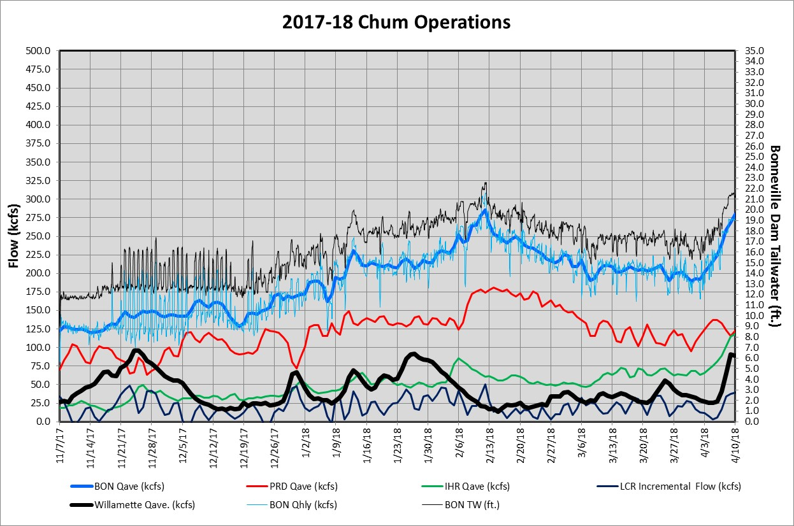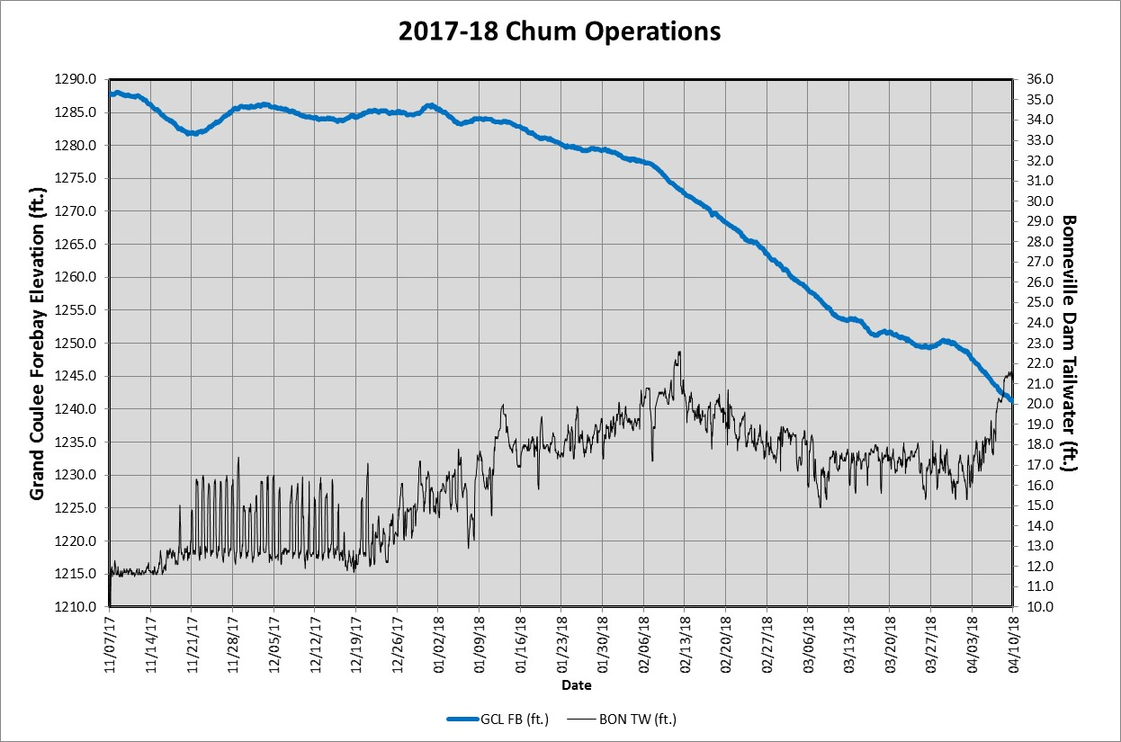

Chum survey data gathered at the Ives/Pierce Island Complex will be summarized in the table below. Data from all Chum survey areas, including the Ives/Pierce Island Complex, are provided by the Fish Passage Center and available on the following website:

http://www.fpc.org/spawning/spawning_surveys.html

Table 9. Chum Data from Surveys of the Ives/Pierce Island Complex
Date | Lives | Dead^{i} | Redds^{ii} | Visibility (feet)
19-Sep-17 | 0 | 0 | 0 | 6
21-Sep-17 | 0 | 0 | 0 | 5
25-Sep-17 | 0 | 0 | 0 | 6
28-Sep-17 | 0 | 0 | 0 | 7
2-Oct-17 | 0 | 0 | 0 | 6
5-Oct-17 | 0 | 0 | 0 | 7
12-Oct-17 | 0 | 0 | 0 | 6
16-Oct-17 | 0 | 0 | 0 | 7
19-Oct-17 | 0 | 0 | 0 | 3
23-Oct-17 | 0 | 0 | 0 | 1.5
26-Oct-17 | 0 | 0 | 0 | 1
30-Oct-17 | 0 | 0 | 0 | 5
2-Nov-17 | 4 | 0 | 0 | 4.5
6-Nov-17 | 8 | 0 | 2 | 7
9-Nov-17 | 19 | 0 | 4 | 3.5
14-Nov-17 | 72 | 0 | 18 | 7
17-Nov-17 | NC | 2 | NC | 6
21-Nov-17 | 83 | 1 | 26 | 2.5
28-Nov-17 | 100 | 1 | 49 | 2.5
1-Dec-17 | NC | 3 | NC | 4
week of 12/5 | NC | NC | NC
15-Dec-17 | 8 | 0 | 12 | 4.5
19-Dec-17 | 3 | 0 | 0 | 3.5
29-Dec-17 | 0 | 0 | 0 | 5
9-Jan-18 | 0 | 0 | 0 | 4
- Dead are newly samply fish only.
- Redds are an instantaneous count for the day, not cumulative.
  - Vernita Bar/Hanford Reach Fall Chinook Protection Program Operations (Non-BiOp Action)

The Hanford Reach Fall Chinook Protection Agreement (Agreement) establishes the obligations of the Parties with respect to the protection of fall Chinook in the Hanford Reach of the Columbia River. The Parties agree that during the term of the Agreement these flow regimes address all issues in the Hanford Reach with respect to fall Chinoook protection and the impact of operation of the six dams operating under Mid Columbia Hourly Coordination, including the obligations of Grant, Chelan, and Douglas under any new licenses issued by the Federal Energy Regulatory Commission (FERC).

Beginning in mid-October, under the terms of the Agreement, river flows are reduced every Sunday morning (day of lowest power demand) to the Priest Rapids Dam minimum operating discharge of 36,000 cubic feet per second (ft³/s). This allows the Agency and Utility Party Monitoring Team to manually survey for redd distribution at Vernita Bar just downstream of Priest Rapids Dam. These drawdowns occur every Sunday morning until the initiation of fall Chinook spawning has been set both above and below the 50,000 ft³/s flow elevations. A final drawdown is conducted on the Sunday prior to Thanksgiving to establish the minimum critical flow needed to protect pre-emergent fall Chinook. Given the previously described limitations, this weekly reduction in river flow affords the best viewing conditions for aerial flights. Aerial flights are therefore scheduled to be conducted concurrent with the Sunday morning drawdowns, when possible.
Date | Summary
October 9, 2017 | Operations to support the Hanford Reach Fall Chinook Protection Program will begin on October 15, 2017. Reverse Load Factoring will begin at 000 hours on Sunday October 15 and continue through the end of the Spawning Period. The Spawning Period is scheduled to end at 24:00 on November 20, 2017 (last Sunday prior to Thanksgiving), but may be extended if spawning activity is observed during the redd survey on that day.  During Reverse Load Factoring, Priest Rapids Outflows (as measured at the USGS gauge) must remain between 55 and 70 kcfs during daylight hours.  Reduced daytime flows (38 kcfs) below Priest Rapids Dam on Sundays during the Spawning Period will be required to support redd counts on Vernita Bar. The first redd count will be conducted on Sunday, October 22. Specific details for operational support during Vernita Bar redd counts will be updated throughout the season and be provided in individual flow requests.
October 16, 2017 | On Sunday, October 22, 2017 the first Vernita Bar spawning ground survey will take place. The spawning ground surveys require that flows measured at the USGS gauging station be near 38 kcfs. Please schedule Priest Rapids Dam discharge to be approximately 38 kcfs from 0500 to 1500 hours. The redd count will begin at approximately 0900 hours. When crews have completed the survey and are off Vernita Bar they will contact Dispatch.  This will be the first ground redd survey this year as required by the 2004 Hanford Reach Fall Chinook Protection Program Agreement. This redd count will be used to help determine this year’s initiation of spawning date.
October 22, 2017 | On Sunday, October 22, 2017 representatives from Grant PUD, Washington Department of Fish & Wildlife, and BPA conducted the first 2017 Vernita Bar spawning ground survey. No redds were observed on Vernita Bar. Five redds are required for the Initiation of Spawning, therefore the date for the Initiation of Spawning has not been set. A second spawning ground survey will be conducted next Sunday, October 29.
October 29, 2017 | On Sunday, October 29, 2017 representatives from Grant PUD and Washington Department of Fish & Wildlife conducted the second 2017 Vernita Bar spawning ground survey. A total of 49 redds were observed on Vernita Bar (Table 1). Thirty-six redds were counted below the 36 kcfs and 13 redds were counted in the 36-50 kcfs elevation zone. No redds were counted above 50 kcfs. Five redds are required for the Initiation of Spawning, therefore the date for the Initiation of Spawning has been set for the below 50 kcfs zone but not for the above 50 kcfs zone. A third spawning ground survey above the 50 kcfs elevation will be conducted Sunday, November 5.
November 5, 2017 | On Sunday, November 5, 2017 representatives from Grant PUD and Washington Department of Fish & Wildlife conducted the third 2017 Vernita Bar spawning ground survey. Flows during the survey were approximately 48 kcfs. Only the area above the 50 kcfs elevation was surveyed. Three redds were observed on Vernita Bar above the 50 kcfs elevation zone (Table 1). Five redds are required for the Initiation of Spawning, therefore the date for the Initiation of Spawning above the 50 kcfs elevation has not been established. During last week’s survey 49 redds were observed below the 50 kcfs elevation, establishing the Initiation of Spawning date as October 25 for the below 50 kcfs elevation.
November 19, 2017 | On Sunday, November 19, 2017 representatives from Grant PUD and Washington Department of Fish & Wildlife conducted the fifth 2017 Vernita Bar spawning ground survey. Flows during the survey were approximately 48 kcfs. Only the area above the 50 kcfs elevation was surveyed. A total of 87 redds were observed on Vernita Bar above the 50 kcfs elevation (Table 1). Results of this survey are provided in Table 1 below.  Based on the increased numbers of redds compared to last week (40) and observations of continued spawning activity on Vernita Bar, the survey team has decided to conduct a supplemental survey next Sunday, November 26. We are requesting that the Spawning Period flows continue until that time.
November 26, 2017 | On Sunday, November 26, 2017 representatives from Grant PUD and Washington Department of Fish & Wildlife conducted the sixth 2017 Vernita Bar spawning ground survey. Flows during the survey were approximately 48 kcfs. Only the area above the 50 kcfs elevation was surveyed. A total of 166 redds were observed on Vernita Bar above the 50 kcfs elevation (Table 1). Results from this survey are provided in Table 1 below. Based on the results from the November 26 survey the Critical Elevation and Protection Level Flow will be 60 kcfs for the 2017-2018 season. During the survey it was determined that spawning had ended and that November 26 be the End of Spawning date. Reverse Load Factoring will end on November 26.
December 12, 2017 | We are still projecting Hatch below the 50 kcfs elevation to occur on December 7. Until then, we are in the Pre-Hatch Period. During Pre-Hatch Period, Priest Rapids Outflow may be less than the Critical Elevation for up to 8 hours on weekdays and 12 hours on weekends, with no two consecutive low flow periods. Once Hatch below the 50 kcfs elevation occurs, Priest Rapids Outflow can be no less than 15 cm below the 50 kcfs elevation. Post-Hatch above the 50 kcfs elevation is projected to occur on January 1, 2018 and will require no less than 15 cm below the Critical Elevation (60 kcfs).
December 26, 2017 | We are currently in the Post-Hatch below the 50 kcfs Period. Post-Hatch below the 50 kcfs elevation requires no less than 15 cm below the 50 kcfs elevation. Post-Hatch above the 50 kcfs elevation is projected to occur on January 2, 2018 and will require no less than 15 cm below the Critical Elevation (60 kcfs).
January 2, 2018 | We are currently in the Post-Hatch below the 50 kcfs Period. Post-Hatch below the 50 kcfs elevation requires no less than 15 cm below the 50 kcfs elevation. Post-Hatch above the 50 kcfs elevation is projected to occur on January 3, 2018 and will require no less than 15 cm below the Critical Elevation (60 kcfs).
February 22, 2018 | We are projecting that the Emergence and Rearing Periods will begin on 3/22/2018 (average start date = 3/17). The Emergence and Rearing Periods require flows above the Critical Elevation (60 kcfs) and flow fluctuation constraints based on inflow from Rock Island Dam. The projected date may change based on river temperatures.
March 16, 2018 | We are projecting that the Emergence and Rearing Periods will begin on 3/23/2018 (average start date = 3/17). The Emergence and Rearing Periods require flows above the Critical Elevation (60 kcfs) and flow fluctuation constraints based on inflow from Rock Island Dam. The projected date may change based on river temperatures.
March 22, 2018 | The Emergence and Rearing Periods will begin tomorrow, 3/23/2018 (average start date = 3/17). The Emergence and Rearing Periods require flows above the Critical Elevation (60 kcfs) and flow fluctuation constraints based on inflow from Rock Island Dam.
April 23, 2018 | Beginning this Saturday (4/28) the enhanced, or CJAD II, weekend minimum flow requirements will begin. This flow constraint requires that Priest Rapids Outlflow be maintained to at least a minimum flow calculated as the average of the daily hourly minimum flow from Monday through Thursday of the current week. This flow requirement will continue for four consecutive weekends, ending on Sunday, May 20th.
May 14, 2018 | The Emergence Period, which requires a minimum flow above the Critical Elevation (60k), will end on 16 May at 2400 (average end date = 11 May). The Rearing Period, which limits flow fluctuations from Priest Rapids Dam, is projected to end on 17 June (average end date = 13 June). This weekend (5/19-5/20) will be the last weekend of the enhanced minimum flow requirements (CJAD II).
May 31, 2018 | We are projecting that the Hanford Reach flow protections will end on 15 June (average end date = 13 June).
June 13, 2018 | Based on current river temperature we are projecting that the Rearing Period will end on 15 June at 24:00 (average end date = 13 June). This will conclude flow protections for the 2017-2018 season.
  - Snake River Zero Generation (Non-BiOp Action)
According to the Lower Snake projects’ operating manuals, from December 1 through February 28, "zero" minimum project discharge is permitted on a limited basis. Under an agreement between the Corps of Engineers and the fishery agencies, zero river flow is allowed for water storage during low power demand periods (at night and on weekends) when there are few, if any, actively migrating anadromous fish present in the Snake River. Water stored under zero river flow conditions may maximize power production from the Columbia River Basin system, but zero river flow operations are not recommended at Lower Snake projects when fish are actively migrating in the Snake River.”

Salmon Managers submitted System Operations Request (SOR) 2005-22 Snake River Zero Nightime and Weekend Flow, to the Action Agencies (AA) on December 6, 2005. The SOR may be found on the following website.

http://pweb.crohms.org/tmt/sor/2005/2005-22.pdf

In the SOR the Salmon Managers provided the AAs with the following table to clarify the criteria of “… few, if any …” prior to the implementation of the Zero Generation Operation.

The few migrating adult criterion trigger will be defined on a sliding scale outlined in the following table. The table applies to both “wild” and “total” categories of returning adult steelhead.

Run to date># | Run to date< # | Few criteria< #
0 | 30,000 | 10
30,000 | 60,000 | 20
60,000 | 100,000 | 35
100,000 | 150,000 | 50
150,000 | 200,000 | 65
200,000 | 250,000 | 80
250,000 |  | 100

The AAs will implement the Snake River Zero Nightime Generation Operation on the Lower
Snake River during winter of 2017/2018 in coordination with the TMT.

December 6, 2017, TMT Meeting.
BPA, and NOAA, discussed the trigger for zero nighttime generation at the Lower Snake River projects. This year’s triggers will be a three-day running average of fewer than 35 total steelhead and fewer than 10 wild steelhead. Current counts show 135 steelhead and 44 wild steelhead. If the triggers are realized between now and the next TMT meeting, Paul will email TMT members and will report back at the December 20 TMT meeting.

December 8, 2017.
On December 8, 2017, NOAA Fisheries notified the BPA and the Corps that according to the criteria set in SOR #2005-22 which established the criteria defining "few steelhead passing " has been met based on the current spteelhead passage data for Lower Granite. The most recent running 3 day running average is 30 steelhead total and 6.7 wild steelhead. The criteria defining "few" for this years run size was 35 steelhead total and 10 wild steelhead. Based on this notification the Corps notified the Lower Snake River project that effective December 8, 2017 through February 28, 2018, the four lower Snake River projects could operate to a minimum discharge of 0 cubic feet per section (zero generation).
  - Minimum Operating Pool (MOP)
In accordance with NOAA Fisheries 2014 Supplemental BiOp (Reasonal Prudent Alternative 5) the the Action Agencies operate the Lower Snake River projects (Lower Granite, Little Goose, Lower Monumental and Ice Harbor Dams) at MOP (unless adjusted to meet authorized project purposes, primary navigation) from April 3 through August 31. MOP is defined as the minimum 1 foot operating range in the forebays of Lower Snake River projects. Project specific MOP operations based on operational limitations are further clarified in the 2018 Spring and Summer Fish Operations Plans (http://pweb.crohms.org/tmt/documents/fpp/2018/). MOP ranges at Lower Snake River Projects are found in Table 9 below.

Table 9. MOP Elevation Ranges for Lower Snake River Projects
Project | MOP (feet)
Lower Granite | 733.0 - 734.0
Little Goose | 633.0 - 634.0
Lower Monumental | 537.0 - 538.0
Ice Harbor | 437.0 - 438.0

As described in the 2018 Fish Operations Plans the following is a summary of adjustments to MOP that occurred at Lower Snake River projects.

Lower Granite Dam. The 2018 Summer FOP (Page FOP-10) provides the following clarification on MOP operations, “However, at flows below 120 kcfs, the Lower Granite forebay must be operated higher in order to maintain the navigation channel depth, as follows:

• Inflow 80-119 kcfs = Lower Granite forebay operating range 734.0 - 735.0 feet (MOP+1);
• Inflow 50-79 kcfs = Lower Granite forebay operating range 734.5 - 735.5 feet (MOP+1.5);
• Inflow below 50 kcfs = Lower Granite forebay operating range 735.0 – 736.0 feet (MOP+2).”

The Corps and BPA operated the Lower Granite Dam forebay in accordance with the guidance above as described in the 2018 Summer FOP. The following graph was coordinated during the April 18, 2018, TMT meeting shows the different MOP levels at various inflows.

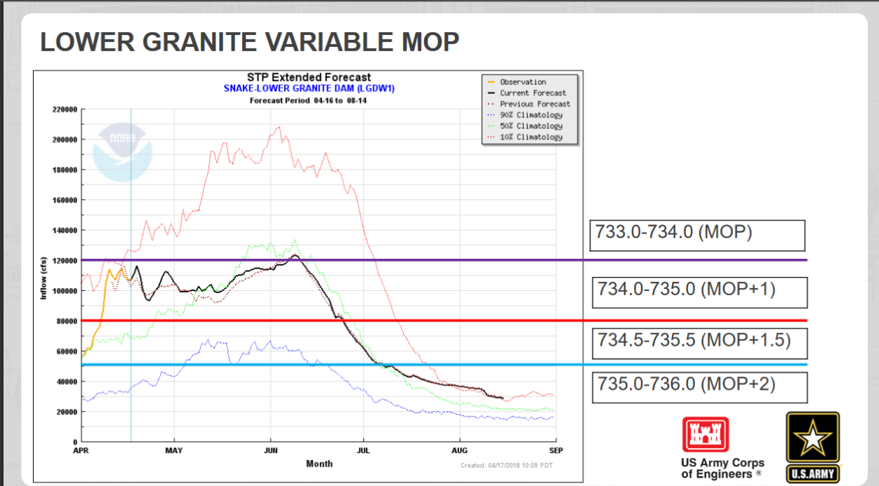

Lower Granite Dam operated at various MOP elevation throught the spill season. A summary of Lower Granite Dam forebay elevations vs inflows is included below from April 3 though August 31, 2018.

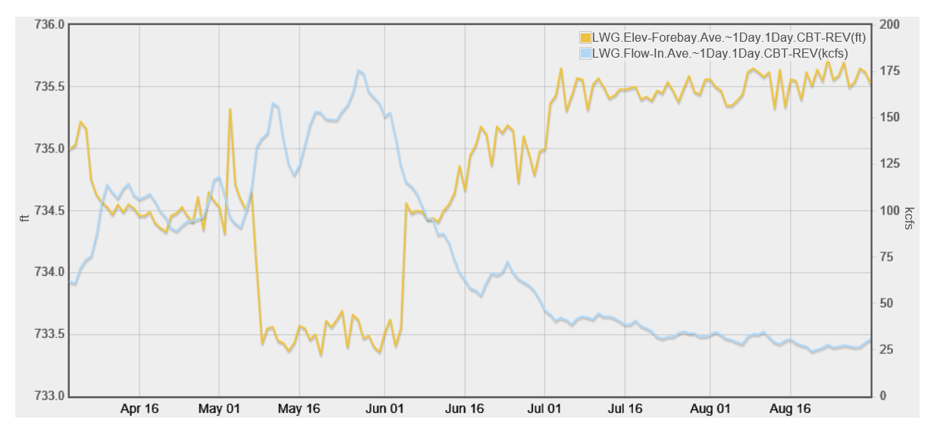

Lower Granite Dam started spill season on April 3 with inflow (day average) of 63 kcfs and the project was operating at MOP+1.5 feet (734.5 to 735.5 feet). By May 6 project inflow peaked at 176 kcfs and Lower Granite was operating at MOP (733.0 to 743.0 feet). The last day of spill season was August 31 and inflow was 31 kcfs and Lower Granite was operating at MOP +2 (735.0 to 736.0 feet).

Little Goose Dam. The 2018 Summer FOP (Page FOP-10) provides the following clarification on Little Goose Dam MOP operations, “As addressed in the 2014-2018 IP, adjustments to forebay elevations at Little Goose and Ice Harbor of up to 1.0 foot above the MOP range may be necessary to accommodate safe entrance to the upstream navigation locks at Lower Granite and Lower Monumental dams.”

As described in the 2018 Summer FOP above, the Corps increased the Little Goose Dam forebay operating range to MOP+1 (634.0 to 635.0 feet) for navigation safety on June 29. The operational adjustment was made to maintain the minimum depth (633.0 feet) at the downstream entrance to the naviation lock at Lower Granite Dam. This operation was coordinated with the TMT via email notification on June 29, and during the July 11 and 18 TMT meetings. The graph below shows despite the increase to MOP+1 the Lower Granite Dam tailwater elevation continued to at or below the reqired Lower Granite Dam tailwater elevation of 633.0 feet (see Lower Granite Dam, tailwater elevation, June 29 - 632.9 feet @ 2300 hours).

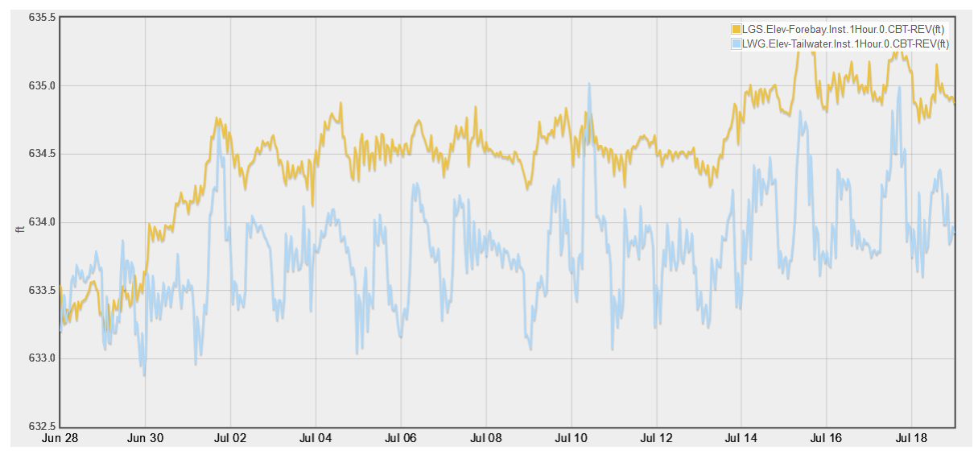

Due to the continued low Lower Granite Dam tailwater elevation (see July 4 at 633.1 feet) despite the MOP+1 operation the Corps increased the Little Goose Dam forebay up to MOP+1.5 (634.5 to 635.5 feet) on July 13 for navigation safety. The TMT was notified of this operational via email on July 13 and coordinated during the July 18 TMT meeting. Little Goose Dam continued to operate at MOP+1.5 through August 31.

Lower Monumental Dam. The 2018 Summer FOP (Page FOP-10) provides the following clarification on Lower Monumental Dam MOP operations. “Short-term adjustments in spill or MOP may be required at any of the fish passage projects to address navigation safety concerns. This may include changes in spill patterns, reductions in spill, short-term spill curtailment, or operating above MOP.” The following summarize the various adjustments to MOP and the associated rational.

- Increased Forebay Operating Range for Navigation Safety.

  - Increased Forebay Operating Range for the Lower Monumental Dam Forebay Navigation Lock Exit. As described in the 2018 FOP above, the Corps expanded the Lower Monumental Dam forebay operating range from MOP (537.0 to 538.0 feet) to the lowest forebay operating range of 1.5 feet (537.0 to 538.5 feet) in order to provide safe navigation conditions (required to operate above 537.0 feet for the Lower Monumental Dam Forebay Navigation Lock Exit) on April 13. The BPA and Corps were unable to maintain MOP due to challenges associated with mulitiple fixed blade units at LMN (Units 2, 3, and 4). When the flexibily of adjusting unit outflow is not possible because unit blades are in the fixed position, BPA and the Corps are unable to adequalely adjust unit outflow(s) in order to maintain MOP. This operation was coordinated via email notification on April 13 and during the April 18, TMT meeting. This expanded forebay operating range of 1.5 feet continued until August 15 when it was no longer needed based on real time conditions.

  - Increased Forebay Operating Range for the Little Goose Dam Tailwater Navigation Lock Entrance. As discussed above, once the expanded forebay operating range of 1.5 feet ended on August 15, and Lower Monumental Dam returned to MOP, the Corps realized it was not possible to maintain the Little Goose Dam tailrace navigation lock entrance depth requirement (15 feet). In oder to provide the required tailrace elevation at Little Goose Dam the BPA and Corps increased the Lower Monumental MOP operation to MOP+0.5 feet (537.5 to 538.5 feet). The BPA and Corps operated Lower Monumental Dam at MOP+0.5 feet from August 15 though August 31 for navigation safety.

A summary of the Lower Monumental Dam forebay elevations from April 3 through August 31, 2018 is included below.

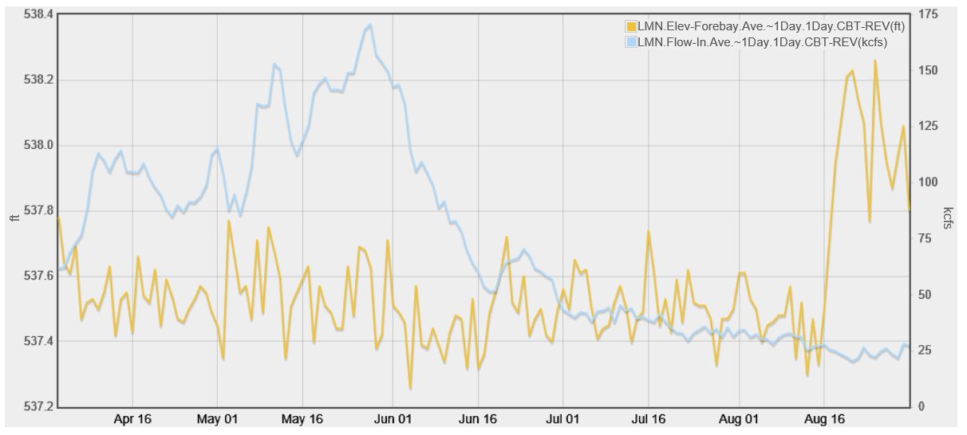

Ice Harbor Dam. The 2018 Spring FOP (Page FOP-10) provides the following clarifications on Ice Harbor Dam MOP operations.

1. “For instance, some flow conditions may require a 2 ft. operating range at Ice Harbor to accommodate barge traffic in order to provide conditions for navigation safety at the Ice Harbor forebay navigation lock exit.”

2. “As addressed in the 2014-2018 IP, adjustments to forebay elevations at Little Goose and Ice Harbor of up to 1.0 foot above the MOP range may be necessary to accommodate safe entrance to the upstream navigation locks at Lower Granite and Lower Monumental dams.”

As described above in the 2018 Spring FOP the Corps increase the Ice Harbor Dam forebay MOP operating range (437.0 to 438.0 feet) on May 8, to and operating range of 1.5 feet (437.0 to 438.5 feet) in order to proved the required depth (15 feet) at the Ice Harbor Dam forebay navigation lock sill. The operation was coordinated with the TMT via email on May 8 and during the May 9 TMT meeting. The Corps maintained this operation from May 8 until August 10, when the operation was no longer necessary for the Ice Harbor Dam forebay requirement based on real time conditions.

On August 10 the Corps increased by 0.5 feet the operating range of 1.5 feet from 437.0 to 438.5 up to 437.5 to 439.0 feet. The Corps increased the forebay elevation range in order to provide the required depth (15 feet) at the Lower Monumental Dam tailrace navigation lock sill. The operation was coordinated with the TMT via email on August 13 and during the August 15 TMT meeting.

A summary of Ice Harbor Dam forebay elevation from April 3 through August 31, 2018 is included below.

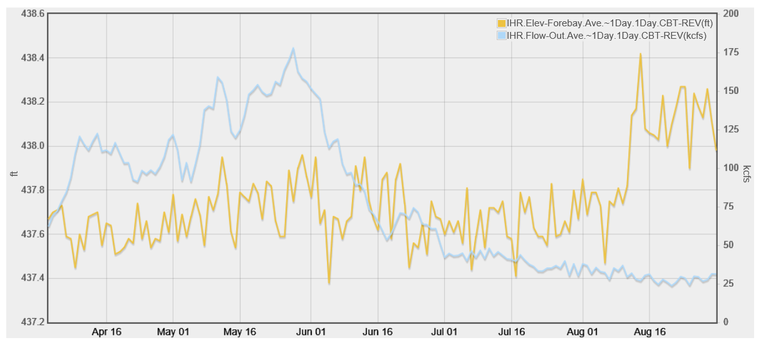

John Day Dam. From April 10 to September 30, the John Day Dam forebay is operated within a 1.5 foot range (262.5 to 264.0 feet) of the minimum elevation that provides irrigation pumping. The initial range is 262.5 to 264.0 feet. The minimum elevation may be adjusted upward as necessary to facilitate irrigation pumping.

  - Spill for Juvenile Fish Passage
The 2018 Spring Fish Operations Plan (2018 Spring FOP) describes the U.S. Army Corps of
Engineers’ (Corps) planned operations for fish passage at its four lower Snake River and four
lower Columbia River dams during the 2018 spring fish migration season, generally April 3 through June 20.

The following summary 2018 spring spill table may be found in the 2018 Spring FOP on the following website.

http://pweb.crohms.org/tmt/documents/fpp/2018/final/FPP18_AppE.pdf

Table 2. Summary of 2018 spring spill levels at lower Snake and Columbia River projects.
PROJECT | 2018 SPRING SPILL ^{1, 2, 3}
Lower Granite | 120/115% Gas Cap⁴
Little Goose | 120/115% Gas Cap⁵  (modified north unit priority)⁶
Lower Monumental | 120/115% Gas Cap  (uniform spill pattern)
Ice Harbor | 120/115% Gas Cap
McNary | 120/115% Gas Cap
John Day | 120/115% Gas Cap⁷
The Dalles | 120/115% Gas Cap⁸
Bonneville | 120% Gas Cap⁹  (no downstream forebay)
1. Uncertainty remains about how the system will respond to these new operations, therefore existing adaptive management processes will be employed to help address any unintended consequences that may arise in-season as a result of implementing these proposed spill operations.
2. Spill may be temporarily reduced at any project if necessary to ensure navigation safety
or transmission reliability.
3. 120/115% Gas Cap spill is spill to the maximum level that meets, but does not exceed, the TDG criteria allowed under state law.
4. If adult delay at Lower Granite is observed, existing adaptive management processes will be used to address the issue (e.g. reducing daytime spill to 40–45% for eight hours daily (0400-
1200 hours)).
5. If adult delay at Little Goose is observed, existing adaptive management processes will be used to address the issue (e.g., reduce daytime spill to 30% for 8 hours daily (0400-1200 hours) to provide adequate adult passage).
6. Additional modeling of Little Goose unit priority and spill patterns will occur December 4
-8, 2017 at ERDC.
7. Unless constraints/concerns identified during physical model observations.
8. Gas cap fish passage spill restricted to spillbays 1-8.
9. Spill to the 120% Gas Cap, not to exceed 150 kcfs.

The following are summaries of Lower Snake River and Lower Columbia River operations data (spill, outflow, and forebay elevations) during the spring and summer spill operations (April 3 through August 31, 2018). Operations data queries for other project data paramaters may be found on Data Query 2.0 that is availible on the following website.

http://www.nwd-wc.usace.army.mil/dd/common/dataquery/www/

1. Lower Granite Dam - Operations Data (forebay elevation, outflow, and spill) April 3 through August 31, 2018.
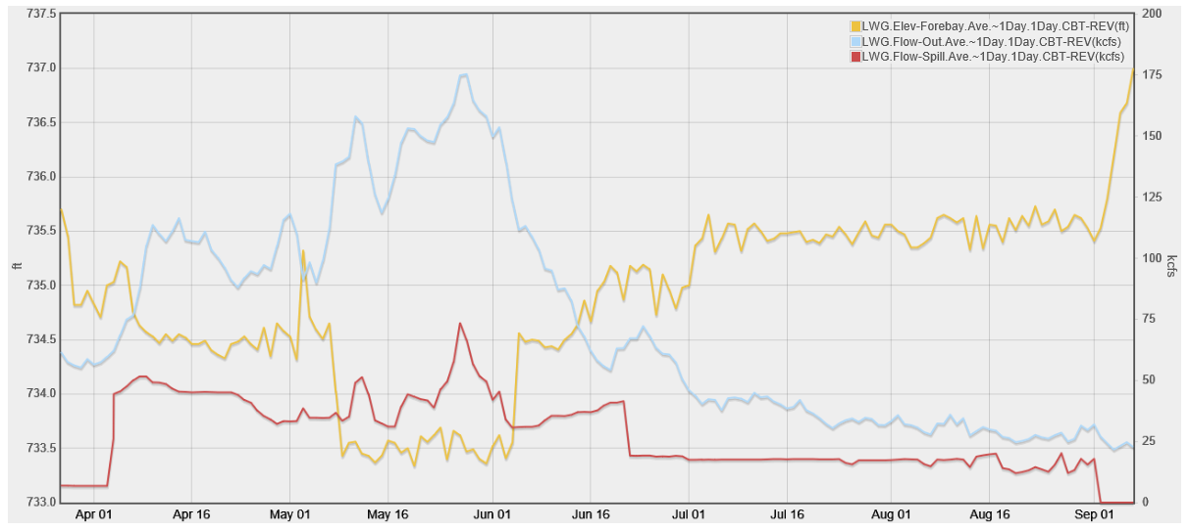

2. Little Goose Dam - Operations Data (forebay elevation, outflow, and spill) April 3 through August 31, 2018.

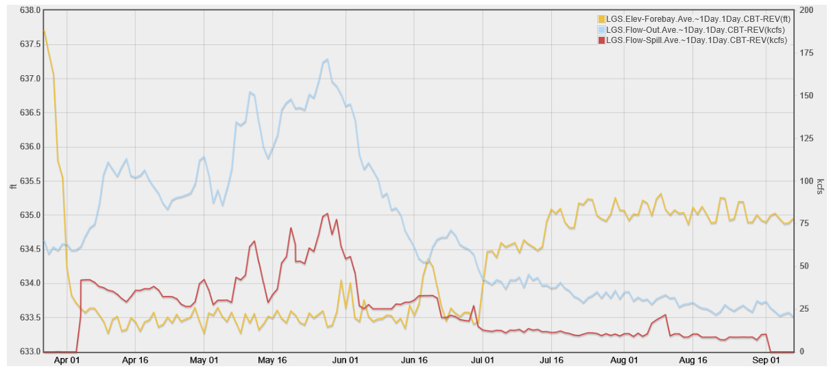

3. Lower Monumental Dam - Operations Data (forebay elevation, outflow, and spill) April 3 through August 31, 2018.

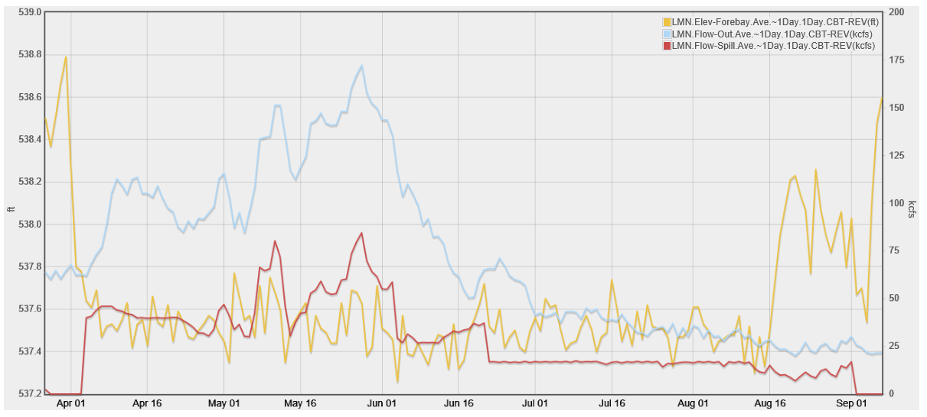

4. Ice Harbor Dam - Operations Data (forebay elevation, outflow, and spill) April 3 through August 31, 2018.

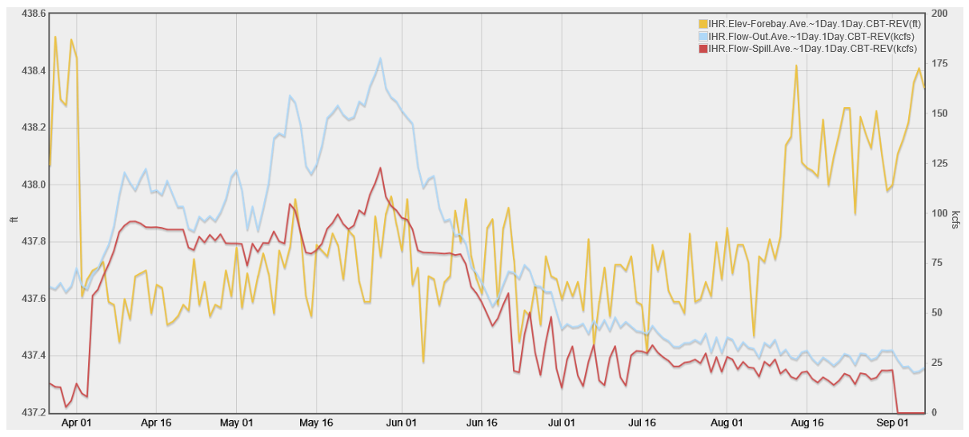

5. McNary Dam - Operations Data (forebay elevation, outflow, and spill) April 3 through August 31, 2018.

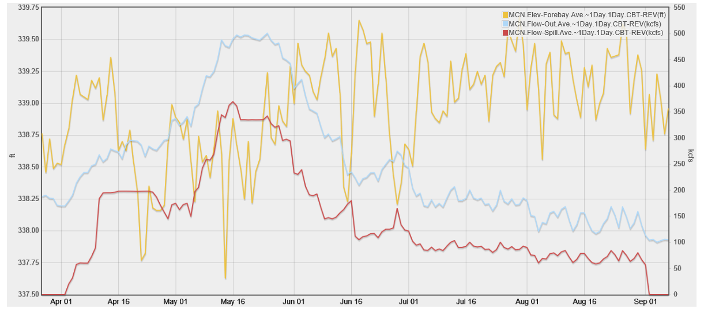

6. John Day Dam - Operations Data (forebay elevation, outflow, and spill) April 3 through August 31, 2018.

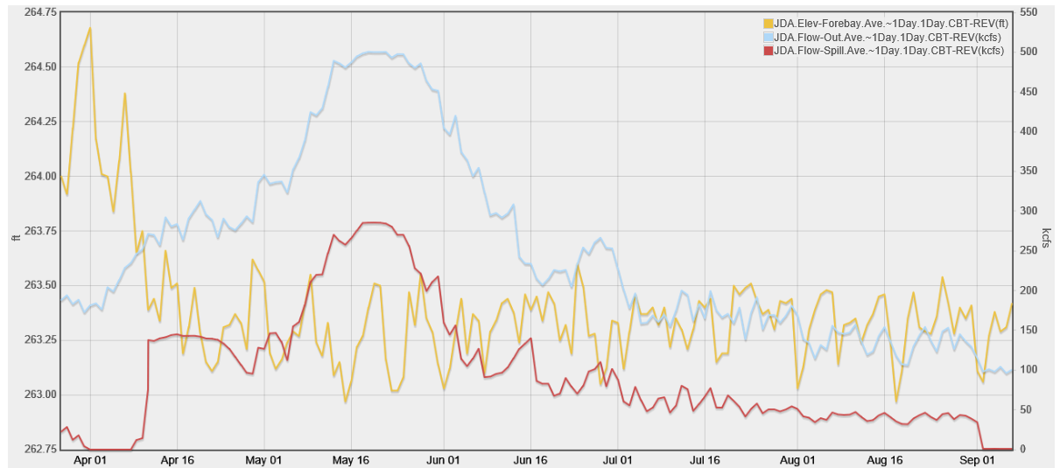

7. The Dalles Dam - Operations Data (forebay elevation, outflow, and spill) April 3 through August 31, 2018.

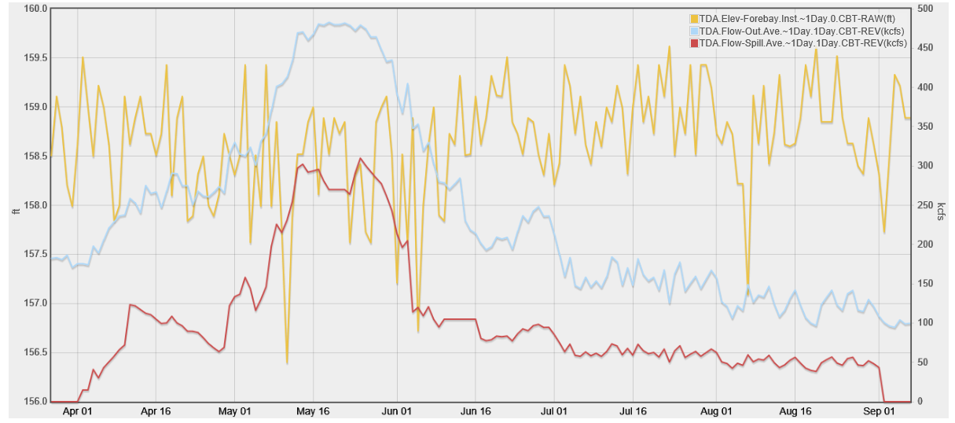

8. Bonneville Dam - Operations Data (forebay elevation, outflow, and spill) April 3 through August 31, 2018.

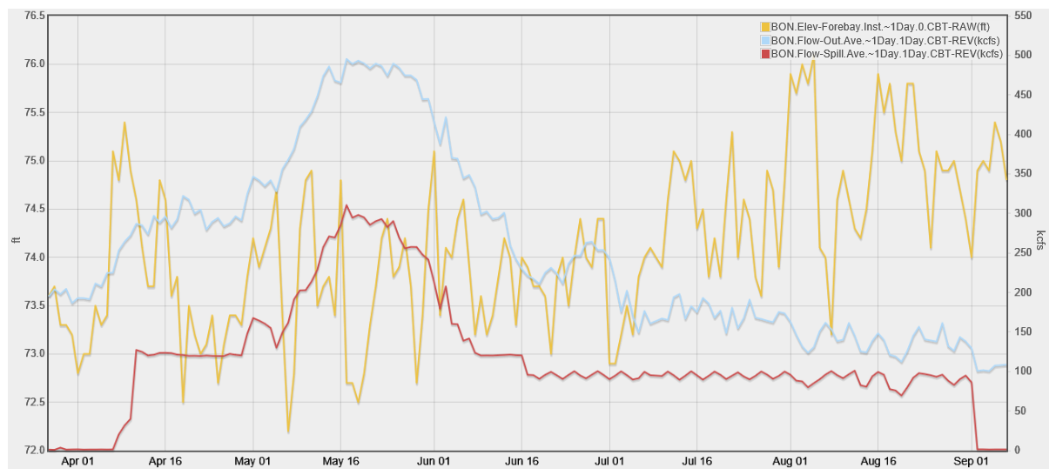

9. Libby Dam - Operations Data (forebay elevation, outflow, and spill) 2018 WY.
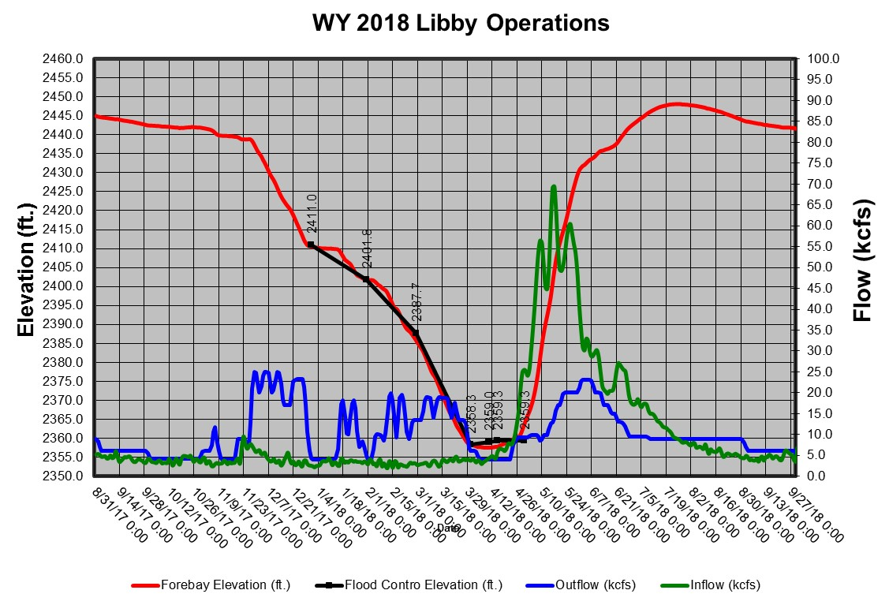

10. Hungry Horse Dam - Operations Data 2018 WY.
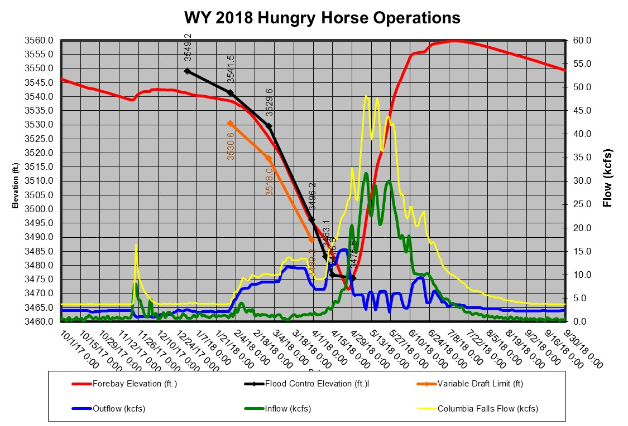

11. Dworshak Dam - Operations Data 2018 WY.
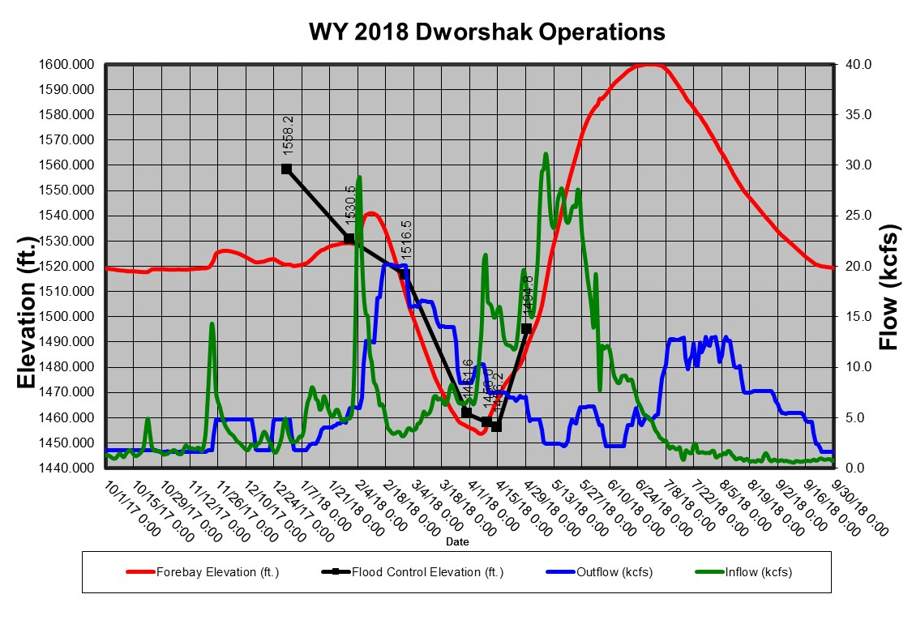
12. Albeni Falls Dam - Operations Data 2018 WY.
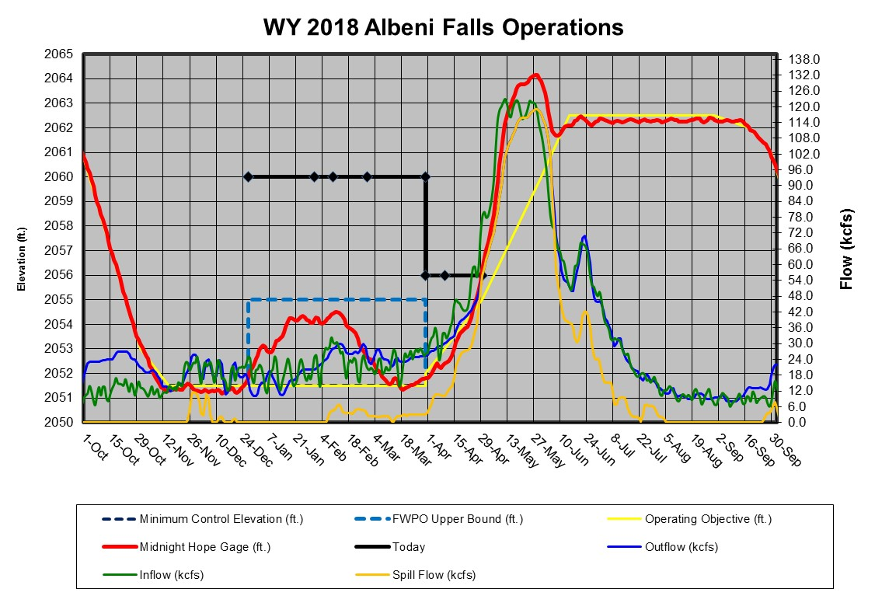
Grand Coulee Dam - Operations Data 2018 WY.
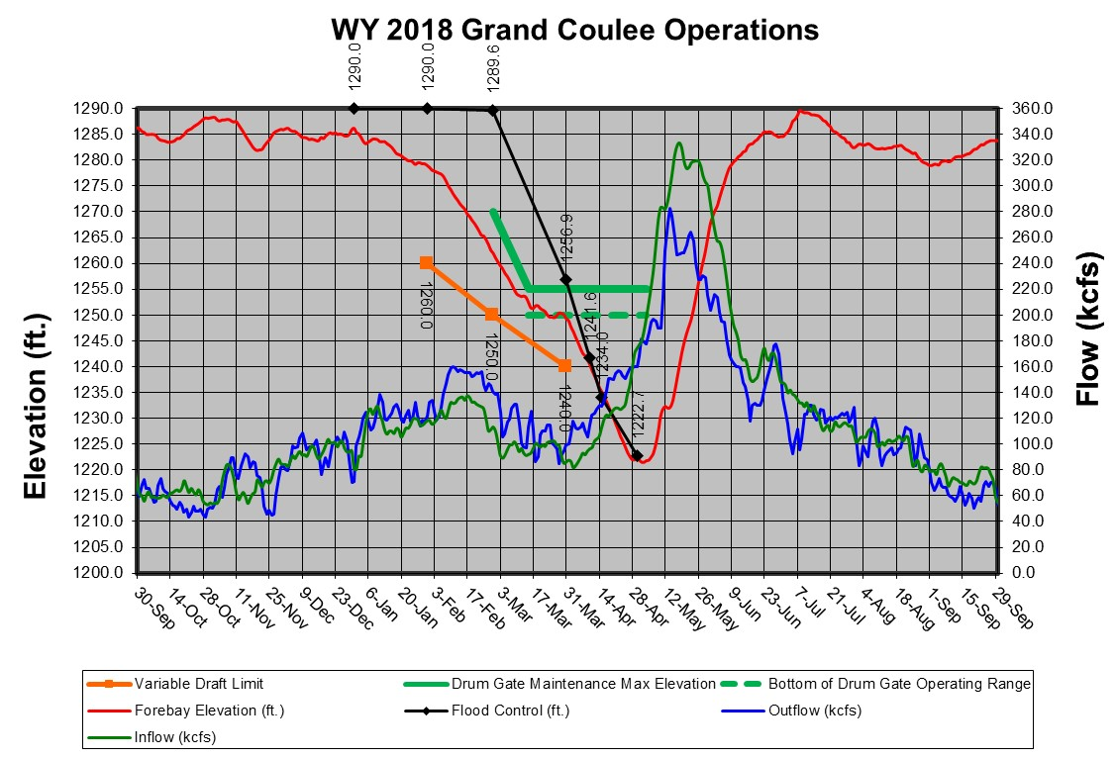

  - Juvenile Fish Trasportation Program
The 2018 Spring Fish Operations Plan indicated the collection of fish at lower Snake River projects for transportation will commence no later than May 1. Barging of fish will begin the following day and collected juvenile fish will be transported from each facility on a daily or every-other-day basis (depending on the number of fish) throughout the migration season. Transportation operations will be carried out at each project in accordance with all relevant FPP operating criteria. In 2018 the collection for the juvenile fish transportation program began on April 23, at Lower Granite, Little Goose, and Lower Monumental Dams, with the first barge departed Lower Granite Dam on April 24. This operation was coordinated during the April 4, TMT meeting, and meeting minutes may be found on the following website.

http://pweb.crohms.org/tmt/agendas/2018/

  - Little Goose Dam Spill Operations for Fish Passage
May 29 TMT Meeting.
TMT members met via conference call for an unscheduled meeting to discuss Little Goose operations. NOAA, reviewed adult fish passage data relating to Little Goose and referred to several Adult PIT-Tag monitoring Tools (the data and tools are attached in the agenda for this conference call). NOAA noted that the cumulative counts of fish for Lower Monumental Dam and Little Goose Dam show a disparity between the actual counts and expected counts for Little Goose, and that there were 6000-7000 fewer fish than expected at Little Goose.

Additionally, the year-to-date conversion rate is 65%, which compared to the ideal conversion rate of 90-100%, suggests adult delay.

The Salmon Managers conferenced prior to this TMT meeting to discuss implementation of the following change of operation at Little Goose to improve passage of adult fish:

• 4 AM -12 PM - operate to maintain 30% spill; store remaining inflow in the Little Goose pool above the 1-foot MOP range of 633-634 feet as necessary depending on inflows;
• 12 PM – 4 PM – increase spill to pass inflow. Little Goose may be above MOP;
• 4 PM - 4 AM - increase spill as necessary to draft back to MOP while remaining under 130% TDG (approximately 125 kcfs spill).

TMT members discussed how best to increase spill after the period of 30% spill to avoid high TDG while drafting back to MOP. NOAA indicated that the Salmon Managers were concerned with keeping TDG below 130%. The Corps estimated that spill could be increased up to 120- 125 kcfs and stay under 130% TDG. To meet this objective, the Corps will set a maximum spill level of 125 kcfs from 4 PM to 4 AM. It is likely that spill will remain well below this level based on the current inflow forecast and project turbine capacity.

The Corps, noted that screen cleaning is scheduled for 5/29 and 5/30 at Little Goose. While the screen cleaning is considered a priority over the 30% spill operation, the Corps will determine whether there is flexibility regarding the cleaning and will attempt to perform the work after the 30% spill operation, to the extent possible.

TMT members were polled regarding their support for the operation noted above:

Colville: No objection
ID: Supports the operation
Nez Perce: Supports the operation
OR: No objection
MT: No objection
USFWS: No objection
WA: No objection
BPA: No objection
NOAA: Supports the operation
Corps: Supports the operation

Umatilla was not present at this conference call; however Salmon Managers indicated that he did not voice any objections during the Salmon Manager’s conference call immediately before this meeting.

The Corps noted this operation will be effective for three days, Wednesday, May 30, through Friday, June 1. The group will check in on this operation at the Face-to-Face TMT meeting on Wednesday, May 30 and again on Friday, June 1.

May 30 TMT Meeting.
NOAA presented analyses performed over the past week using the FPC and the DART adult PIT-tag monitoring tools. Supporting documents are available on the TMT web site. For the past two days the FPC Daily Adult Passage Report notes delay as compared to ‘expected’ fish passage. DART’s data produces a similar result, with conversion falling below expected levels. At Lower Monumental Dam, 1,834 spring Chinook adults were observed on 5/29, with a similar pattern at Ice Harbor Dam. However, issues with delay are still occurring at Little Goose Dam: the 3-day average differential for fish transiting from Lower Monumental Dam upstream to Little Goose Dam indicates conversion below the 85% threashold. Some fallback also may be occurring. Because of this delay, TMT took action at its unscheduled meeting on May 29 to reduce spill to 30% during peak adult fish passage hours of 4 am to noon. Notes will be posted on the TMT web site.

The Corps reported that hourly data show that the TMT coordinated operation at Little Goose, which reduces spill to 30% from 4 am to noon in order encourage adult fish passage at the project, began today and will continue through June 1. The Corps noted that the project reduced spill to 38 kcfs (29.7% spill) at 4 am today. A second day of screen cleaning as originally planned will not be needed because all screen cleaning was completed in one day on 5/29. The Corps will continue with 30% spill from 0400 to 1200 hours, then increase spill to pass inflow from 1200 to 1600. From 1600 to 0400, they will increase spill in order to draft the pool back to MOP. The upper limit for spill is not to exceed 125 kcfs, which would result in TDG levels beyond the preferred upper limit, at 130%. Data also show the system effects of how spill operations at Little Goose Dam may have affected the downstream projects at Ice Harbor and Lower Monumental Dams. The last day of the operation is currently scheduled on Friday (6/1).

ACTION: TMT will hold an unscheduled meeting at 12:00 on Friday, June 1, to review the Little Goose operation and see whether to extend it through the weekend.

June 1, TMT Meeting.
NOAA presented analyses performed over the past week using the FPC and the DART adult PIT- tag monitoring tools. Supporting documents are available on the TMT website. For the past two days the FPC Daily Adult Passage Report notes an upward trend at Little Goose and Lower Monumental Dams. NOAA reported that, as of the start of the May 30th through June 1 operation at Little Goose (reduction of spill to 30% in order encourage adult passage at the project), an increase in adult spring Chinook passage was observed. As far as hours of peak entry and passage timing, there is some discrepancy between the counts and DART; according to DART, the majority of the PIT-tagged fish were detected entering the ladder between 8:00-10:00am, whereas hourly counts show peak passage later in the day. Regardless, the fish are moving past the project, with 2,692 on the first day (May 30th) and 2,892 yesterday (May 31st).

NOAA shared the Salmon Managers’ consensus recommendation to continue the 30% spill operation at Little Goose for an additional day, through June 2nd, at which point the river is forecasted to drop down to 130 kcfs. Salmon Managers expect that, at 130 kcfs, naturally declining in-river conditions will reduce high levels of involuntary spill that should support continued passage. NOAA noted that they will expect to see the migration passage trend decrease as time goes on. NOAA also clarified that, if there is a significant decrease in adults passing before expected, there may be a need to revisit the operation. When questioned as to whether they should continue the operation through the weekend to ensure adult passage success, Salmon Managers pointed to the balance between helping alleviate adult delay, while still facilitating juvenile downstream passage. The USFWS, shared that from his agency’s perspective, there are emergency adult delay situations, (for example the 2015 sockeye delay); however, because they do not see that the current spring Chinook delay as an emergency, they want to err on the side of caution and provide equal benefit for adults and juveniles.

The Corps reported that the Corps will implement TMT’s recommendation and continue the 30% spill operation at Little Goose on June 2nd from 0400 to 1200 hours, then increase spill to pass inflow from 1200 to 1600, then increase spill as necessary to draft back to MOP from 1600 to 0400. The operation is scheduled to end on Saturday, June 2.

• ACTION: The COE will continue the above stated Little Goose operation through Saturday, June 2nd.

June 6, TMT Meeting.
NOAA updated the group on current data. Both the FPC passage indicator and the DART tool are showing that adult conversion is good in the system, at an 87% rate according to the DART tool. However, several questions remain. However, fallback rates have increased, especially at Lower Monumental Dam. It is unclear why this occurred, and whether it results from several fish falling back once or one fish falling back several times. Tools are being developed to address these and other matters, and salmon managers hope to have a more complete picture by winter.

• ACTION: Salmon Managers will review passage data and bring TMT any conclusions or relevant findings.

June 13, TMT Meeting
NOAA updated the group on current data. NOAA noted that the FPC passage indicator shows that fish passage is tracking within expectations, at 70% of the predicted interval. With regard to data from DART Adult PIT-Tag Reach Distribution and Delay, NOAA noted that the daily data shows an overall 89% conversion rate. Passage decreased to 50% during a two-day interval on June 8 and 10, and then increased to 71%. NOAA attributed the increase to changing the elevation of the adjustable surface weir (ASW) at Little Goose, from low crest to high crest (which means less flow over the ASW). NOAA explained that when flows are below 85 kcfs, operating the ASW at low crest can contribute more to the eddy that can lead to adult delay at Little Goose. By operating the ASW at high crest, spill is spread out more at lower flows which can reduce the eddy. NOAA and other fish managers agreed that the change in operation appeared to address the decrease in passage. NOAA indicated that the fish managers will continue to observe passage and alert TMT if there is a need for an unscheduled meeting.

July 25, TMT Meeting.
NOAA and ID reported on adult sockeye passage. NOAA noted that the run is winding down in the Columbia River, which is expected for this time of the season. ID shared that on the Snake River, fish counters at Ice Harbor noted that of the 17 sockeye counted since last Thursday afternoon, 13 were unclipped, and 4 were clipped (Note: the majority of Snake River fish are clipped and mid-Columbia fish are not clipped). The proportion of clipped versus unclipped fish tracks well with numbers expected from estimates, which is another indicator that there are likely mid-Columbia sockeye at Ice Harbor.

ID shared that there is approximately a 100 fish differential between Lower Monumental and Little Goose, which is concerning. The cause of the differential is uncertain, as the counts are not absolute, and/or these fish could be mid-Columbia sockeye that have come up to Lower Monumental. ID noted that Little Goose tailrace conditions can become unstable at low flows, and there is the possibility that an eddy in the tailrace could be delaying Snake River adult sockeye passage. After some TMT discussion and a Salmon Manager caucus, the region agreed to implement an interim two-day operation at Little Goose to assess whether the tailrace hydraulics are causing a passage delay of Snake River sockeye. The operation is as follows: From 4 AM to 4 PM on July 26 and 27, close the Little Goose Adjustable Spillway Weir (ASW) and shift the planned spill to deep spillbays with the uniform no ASW pattern defined in the Fish Passage Plan.

It was important for Salmon Managers to note that there are many uncertainties in this situation; for example, uncertainties in the adult counts, as well as the benefit of the ASW to juveniles at this time in the season versus the potentially negative impact of the ASW on tailrace hydraulic conditions at these lower flows. Despite the uncertainties, there were no objections to the interim operation: If these are endangered Snake River sockeye trying to pass at Little Goose, they are a priority run, and encouraging their passage at this time is important.

TMT Members present were polled regarding their support for this proposal:

Colville: supports;
Corps: supports;
Reclamation: does not object;
BPA: supports.
ID: supports;
MT: supports;
Nez Perce: supports;
NOAA: supports;
OR: does not object;
Umatilla: does not object;
USFWS: supports;
WA: does not object;

- ACTION: The Corps will implement the following operation: from 4 AM to 4 PM on July 26 and 27, close the Little Goose ASW and shift the planned spill to deep spillbays with the uniform no ASW pattern in the Fish Passage Plan.
- ACTION: At the request of the Salmon Managers, the Corps will coordinate with the project to request approximately 5 minutes of video footage of the tailrace hydraulics with the ASW open versus the ASW closed after tailrace conditions have stabilized, and will provide this footage to TMT members.
- ACTION: TMT members will meet for an unscheduled conference call on Friday, July 27, 2018, at 3 PM to check-in on the operation and fish counts. If there is no improvement observed, the meeting may be cancelled at the request of Salmon Managers.

July 27, TMT Meeting
The Corps reported on conditions at Little Goose Dam. Several supporting materials are posted to the agenda for today’s meeting on the TMT website. The current hourly project data show outflow is 36.6 kcfs, with 10.5 kcfs of spill through spillbays 2, 4, 6, 7, and 8 (the ASW in bay 1 is closed). The target spill level today is 11 kcfs based on yesterday’s average outflow below 32 kcfs, which is part of the low flow spill operation included in the Fish Operations Plan (FOP) that switches from 30% to a fixed spill of 11 kcfs when the previous day’s outflow is between 28 and 32 kcfs. Per the Fish Passage Plan (FPP) criteria, the ASW will be closed on or after August 1 when inflows drop below 35 kcfs to aid adult and juvenile fish passage during low flows. The current inflow forecast for August 1 is around 30 kcfs, so the ASW will be closed on that day if inflows come in as forecasted. Forebay water temperature at 5 meters is about 70 degrees F.

The group watched video footage taken of the Little Goose tailrace, both with and without the ASW on. The Corps Walla Walla, provided a description of what he noticed in the videos with some context of what was seen in the models at ERDC. When the ASW is on, there is a two-stage, clockwise eddy in the downstream end of the tailrace. When the ASW is off, there does not appear to be an eddy in the tailrace and the egress current does not appear to be as strong. OR, recalled that, from earlier model runs at ERDC, the eddy on the south shore does not go away completely when the ASW is off, it is simply more subsurface. OR also noted that, although he agrees with the Corps description of the eddy that appears with the ASW, it is not necessarily causing adult delay.

NOAA, reported on sockeye passage. NOAA noted that 1 sockeye passed Little Goose on July 25; 6 passed on July 26, the first day of the operation to close the ASW, 5 of which were counted between noon and 2pm. NOAA noted that at around noon, the project switched from operating one unit to two units. As of 1:00 pm on July 27, no sockeye had passed.

NOAA shared that Salmon Managers had differing perspectives as to how to move forward. Some wanted to continue the special operation in an attempt to provide better passage conditions for sockeye; others did not see any benefit to sockeye passage and were concerned that juvenile passage might be impeded with closure of the ASW. It was noted that changing operations causes fish to pause in their migration, which may be why they are not seeing any sockeye passage until noon, even though the operation had been closing the ASW at 4:00 am.

suggested that the interim operation coordinated at TMT on July 25th, which closes the Little Goose ASW between 4:00 am-4:00 pm and shifts the planned spill to deep spill gates with a uniform pattern, continue to be implemented through the rest of the season until the ASW is closed due to flows below the 35 kcfs FPP criteria on or after August 1.

TMT members present were polled regarding their support for this proposal:

Corps: supports;
BPA: supports;
ID: supports;
Nez Perce: does not object;
NOAA: supports;
OR: objects, not going to elevate to RIOG at this time;
USFWS: objects, not going to elevate to RIOG at this time;
WA: does not support, does not object, not going to elevate to RIOG at this time.

Salmon Managers who were not in favor of continuing the interim operation noted that they do not see data to support the hypothesis that the Little Goose tailrace hydraulics are causing an adult sockeye passage delay and that closing the ASW improves sockeye passage. They support keeping the ASW in operation to aid outmigration of juvenile fall Chinook. It was noted that although members who object to the operation to close the ASW do not plan to elevate to the RIOG at this time, the elevation process is cumbersome and time-consuming, and should be revisited, so that the process is not an impediment to action when needed.

The Corps explained that due to the polling results, the Corps will need to confer with their legal and policy representatives before deciding how to move forward. The Corps will send an update to TMT members by the close of business today (7/27). [Facilitator’s Note: via email on July 27th, the Corps shared that the Corps will continue the operation to close the Little Goose ASW and shift to the Uniform No ASW pattern in the 2018 Fish Passage Plan daily from 4 am-4 pm through Wednesday, August 1. The Corps will re- open the ASW per the spill pattern in FPP each day from 4 pm-4 am.] TMT will check in on the operation at their regularly scheduled meeting on August 1, 2018.

ACTION: The Corps will implement the following operation: Close the Little Goose adjustable spillway weir (ASW) and shift to the Uniform No ASW pattern in the 2018 Fish Passage Plan Table LGS-10 daily from 4 am-4 pm through Wednesday, August 1. The Corps will re-open the ASW per the spill pattern in FPP Table LGS-8 each day from 4 pm-4 am to provide surface passage.

August 1, 2018, TMT meeting.
The Corps described operations at Little Goose Dam. Currently the project is discharging 34.9 kcfs, with 24.0 kcfs generation and 10.5 kcfs spill. The Corps noted that on Friday, July 27, after the TMT call, the Corps sent an email to TMT detailing the operation that they planned to implement. The operation consisted of closing the Little Goose adjustable spillway weir (ASW) and shifting to the Uniform No ASW pattern in the 2018 Fish Passage Plan (Table LGS-10) daily from 4am-4pm through Wednesday, August 1. Between the hours of 4pm-4am, the Corps would re-open the ASW per the spill pattern in FPP (table LGS-8) each day from 4 pm-4 am to provide surface passage. The Corps explained that because of a component malfunction, the Corps could not operate the ASW from 4pm Saturday, July 28 through 4pm Tuesday, July 31, and thus the ASW was left in the closed position. The ASW was brought back in service and opened at 1630 hours on July 31st.

Today, August 1 at 4:00pm, the interim operation noted above will be complete and the project will return to normal FPP operations, until, per the FPP criteria, the ASW is closed on or after August 1 when inflows drop below 35 kcfs and are projected to stay below 35 kcfs for 3 days. Once the ASW is closed for the season, the FPP states that it will stay closed. This however, is a rollover from previous years, when a crew was needed to open/close the old TSW. Now the ASW is automated and can be opened and closed from the control room (when functioning) and so if desired, could be opened back up. This would involve coordination through FPOM.

NOAA noted that sockeye continue to pass Lower Granite, however, there was not a significant increase in passage at Little Goose as a result of the ASW closure. It remains uncertain what factors explain the differential between sockeye counts present at Little Goose and Lower Monumental dams, and there are a number of hypothesis that were shared, including: upper Columbia overshoots, re-ascension, fish passing through the locks, shad or other species being counted as sockeye, or a temperature differential in the ladders causing a passage block. USFWS offered a perspective that water temperatures in the fish ladders could be causing passage issues for adult Snake River sockeye. USFWS pointed to temperature data and a preliminary assessment which he agreed to provide to ID for review. ID noted that IDFG specialists have been looking into the sockeye passage situation and available information and have concluded that the fish in question are most likely Upper Columbia overshoots. ID pointed to the Ice Harbor window counts of unclipped fish (see July TMT summaries). Additionally, ID noted that IDFG estimates 282 Snake River sockeye returns based on PIT-tag detections at Bonneville. ID noted that this is a rough estimate based on a small number of PIT-tagged fish. USFWS and ID were encouraged to continue this conversation offline. It was suggested that a post season analysis of sockeye passage could be provided at the TMT Year End Review.

  - Lower Monumental Dam Spill Operations for Fish Passage

July 18, TMT Meeting
NOAA and ID reported on adult sockeye passage. The year-to-date totals at Bonneville are 189,987 which is 60% of the 10-year average. The passage numbers are declining which is expected at this time in the run.

NOAA and ID noted that while 600 sockeye were counted at Ice Harbor, only 219 were counted at Lower Monumental. With regard to PIT-tag data, 110 PIT-tagged Upper Columbia sockeye were detected at Bonneville; and none were detected at Ice Harbor. Eight PIT-tagged Snake River sockeye were detected at Bonneville with five of these fish observed at Ice Harbor and Lower Granite. ID observed that while the PIT-tag data shows those fish are on course, the count data raises questions about what happening with fish between Ice Harbor and Lower Monumental. ID noted that a lot of sockeye were tagged at the Adult Fish Facility at Bonneville and the vast majority of those were mid-Columbia fish. Most of those fish have continued up the Columbia and only one was detected at Ice Harbor. ID also noted that there is a low proportion of PIT-tagged Snake River sockeye, which makes the accuracy of estimations more uncertain; and that the estimates based on PIT tags appear to fit the counts at LOMO better than they fit the counts at ICH.

The group discussed possible reasons for the differences in the counts including whether there were errors in identifying the fish during counts (i.e. whether summer Chinook jacks were counted as sockeye?), whether these were mid-Columbia fish that were misdirected and whether a temperature differential in the fish ladder or a change in operations at Lower Monumental might impact fish movement.

Concern was expressed that the count difference between Ice Harbor and Lower Monumental may be an indication of delay of Snake River sockeye. Corps has asked the fish count contractor thru July 23 to observe whether fish are clipped or unclipped (the majority of Snake River fish are clipped and mid- Columbia fish are not clipped). This may help with the determination of whether some of the fish counted at Ice Harbor are mid-Columbia strays.

It was noted that Lower Monumental is not using the same unit and spill pattern as this time last year, which leads some to think that there current configuration could be creating unfavorable hydraulics for passage. Normally, Unit 1 would be operating and would push out any eddies that result from the RSW.

This year Unit 1 is out of service, and Unit 2 is first priority, it is hydro-locked and operating at the lower 1 % and Unity 5 is second priority.

The group discussed a proposal for an interim two-day operation at Lower Monumental to assess whether the tailrace hydraulics are causing a passage delay of Snake River sockeye. The operation is as follows: from 4 AM to 2 PM on July 19 and 20, close the RSW and shift the spill pattern to a uniform, flat spill pattern to be determined at the Corps’ discretion, while maintaining spill operation to 17 kcfs.

Fish managers raised concerns that closing the RSW may impact sub-yearling Chinook that are passing and that juvenile use of the RSW is considered the highest route of survival.

TMT Members were polled regarding their support for this proposal:

NOAA: Supports;
WA: Does not support, but does not object;
Colville: Does not object; Nez Perce: Does not object; Umatilla: Does not object;
ID: Supports;
USFWS: Does not object;
BOR: Does not object;
Corps: Supports;
BPA: Supports.

- ACTION: The Corps will implement the following operation from 4 AM to 2 PM on July 19 and 20: Close the RSW and shift the spill pattern to a uniform, flat spill pattern to be determined at the Corps’ discretion, while maintaining spill operation to 17 kcfs. The Corps will post the pattern on the TMT website. The Corp will shift back to the current operation between 2 PM and 4 AM (RSW open, bulk spill, as outlined in the Fish Passage Plan).
- ACTION: TMT members will meet for an unscheduled conference call on Friday, July 20, 2018 at 3 PM to check-in on the operation and fish counts.

July 20, TMT Meeting.
NOAA and ID reported on adult sockeye passage. They noted that on July 19, only 3 sockeye were counted passing Lower Monumental, and as of 3 PM on July 20, 5 sockeye had passed. At Ice Harbor Dam, 10 sockeye were counted: 7 were unclipped and 3 were clipped (note: the majority of Snake River fish are clipped and mid-Columbia fish are not clipped). At the Lower Granite trap, 35 sockeye were counted and of those, six were unclipped. The proportion of clipped versus unclipped tracks well with what would be expected based off of estimates, which is another indicator that there are mid-Columbia sockeye at Ice Harbor.

Fish managers agreed that, given the small number of sockeye actually passing, there was no need to continue the interim two-day modified spill operation that was agreed to at the July 18, 2018 TMT meeting and was at the time of the meeting complete. Fish managers noted that there is still uncertainty as to why the counts were so high at Ice Harbor and hypotheses ranged from the possibility that these were mid-Columbia fish that had been misdirected to the possibility of a temperature differential in the fish ladders.

ACTION: The Corp will continue operating Lower Monumental with the spill pattern designated in the Fish Passage Plan (RSW open, in a bulk spill pattern) until further notice.

September 14 FPOM Meeting.
On September 1, the Corps discovered there was a human error (Chinook mini-jacks were counted as adult sockeye) associated with Ice Harbor Dam adult sockeye counts (June 8 to July 31, 2018, Ice Harbor Dam adult sockeye initial count was 659 but then later corrected to 371). The count error resulted in the incorrect appearance that the number of adult sockeye was significantly higher (659) than the number of sockeye that actually passed (371) Ice Harbor Dam from June 8 to July 31. The inaccurate count of adult sockeye at Ice Harbor Dam was the primary factor that contributed to the Lower Monumental Dam sockeye passage concerns that were described above during the July 18 and 20 TMT meetings. The revised adult sockeye passage data at Ice Harbor Dam does not demonstrate that there was an adult sockeye passage delay at Lower Monumental Dam that was discussed during the July 18 and 20 TMT meetings noted above. The Ice Harbor Dam adult fish count contractor has updated their training procedures to ensure this type of event does not occur in the future. The Ice Harbor and remaining Lower Snake River Dams sockeye count data (June 1 – July 31, 2018) is included below.

Running Sum Adult Fish Counts
June 1 through July 31, 2018, running sum
Lower Granite Dam | Little Goose Dam | Lower Monumental Dam | Ice Harbor Dam
Sockeye = 259 | Sockeye = 253 | Sockeye - 365 | Sockeye - 371

http://www.fpc.org/environment/home.asp

  - Fish Passage Research in 2018
    - BONNEVILLE DAM
In spring 2018, Pacific Northwest National Laboratory (PNNL) will conduct a system-wide (Lower Granite Dam to Bonneville Dam) acoustic telemetry survival study to better understand the impacts of Gas Cap Spill on juvenile fish. Reach survival estimates will also be assessed from Lower Granite to McNary and from McNary to Bonneville. Fish tagged from the Lower Granite Survival Study (see section 9.2) will be used to estimate survival from Lower Granite to McNary. An additional fish collection, tagging, and release effort will take place at McNary to estimate survival from McNary to Bonneville. In addition, Little Goose will be monitored for passage distribution and tailrace delay to better understand the unintended consequences of Gas Cap Spill. Cabled JSAT hydrophones and receivers will be installed at Little Goose on the upstream face of the dam to monitor the major passage routes. At McNary and Bonneville, autonomous receivers will be deployed in the forebay and tailrace a few kilometers from the dam. This study will require access at Little Goose and McNary dams for fish collection and tagging, maintenance and service of telemetry and associated equipment, and will require assistance from the project to provide power for electronics and water supply for holding fish. Dead fish with JSATs tags will be released into all major passage routes (spill, turbine, powerhouse JBS) at McNary and Bonneville Dams to estimate probability of dead fish detections (false positives) on downstream arrays and researchers will need access to these dams for this purpose.
    - THE DALLES DAM
There are no studies scheduled for The Dalles Dam in 2018.
    - JOHN DAY DAM
There are no studies scheduled for John Day Dam in 2018.
    - MCNARY DAM
      - Evaluation of McNary Dam Adult Fish Ladder Modifications to Improve Pacific Lamprey Passage.
This study will use radio telemetry (RT) and half-duplex (HD) PIT-tag systems to evaluate passage success of adult Pacific lamprey through the lower Columbia River (including McNary Dam). Adult Lamprey will be captured and tagged at Bonneville Dam. This study will continue to require electrical power for electronics and access to maintain and download data from the RT and PIT-tag detection equipment. Maintenance of equipment will occur during the winter maintenance period when adult fishways are dewatered.
      - Juvenile Salmon and Steelhead System Survival (Lower Granite to Bonneville).
In spring 2018, PNNL will conduct a system-wide (Lower Granite Dam to Bonneville Dam) acoustic telemetry survival study to better understand the impacts of Gas Cap Spill on juvenile fish. Reach survival estimates will also be assessed from Lower Granite to McNary and from McNary to Bonneville. Fish tagged from the Lower Granite Survival Study (see section 9.2) will be used to estimate survival from Lower Granite to McNary. An additional fish collection, tagging, and release effort will take place at McNary to estimate survival from McNary to Bonneville. In addition, Little Goose will be monitored for passage distribution and tailrace delay to better understand the unintended consequences of Gas Cap Spill. Cabled JSAT hydrophones and receivers will be installed at Little Goose on the upstream face of the dam to monitor the major passage routes. At McNary and Bonneville, autonomous receivers will be deployed in the forebay and tailrace a few kilometers from the dam. This study will require access at Little Goose and McNary dams for fish collection and tagging, maintenance and service of telemetry and associated equipment, and will require assistance from the project to provide power for electronics and water supply for holding fish. Dead fish with JSATs tags will be released into all major passage routes (spill, turbine, powerhouse JBS) at McNary and Bonneville Dams to estimate probability of dead fish detections (false positives) on downstream arrays and researchers will need access to these dams for this purpose.
    - ICE HARBOR DAM
      - Adult Spring Chinook Passage and Behavior in the Lower Snake River.
In spring 2018, adult spring Chinook salmon will tagged with acoustic transmitters and monitored to evaluate tailrace behavior in relation to gas cap spill and turbine unit priorities at Little Goose Dam. Adult spring Chinook will be collected and acoustically tagged at the Ice Harbor Adult Fish Trap and released above the dam between early April and mid-June 2018. Study fish will be monitored for behavior (3-D) and passage at Little Goose and monitored for passage at Lower Granite. At Little Goose, a combination of cabled and autonomous JSATs acoustic telemetry receiver arrays will be deployed in the tailrace and inside the fishway entrances to study the 3-D behavior and preferred fishway entrance locations in relation to gas cap spill operations and unit priorities. Deployment of the tailrace receiver arrays will require coordination of unit outages and BRZ boat access to install equipment in January–March. Further project coordination may be required in-season to access the BRZ and service the North tailrace autonomous rays located downstream of the earthen portion of the dam. At Lower Granite Dam, a few JSATS receivers will be installed in the junction/transition pool of the adult fishway to monitor tagged fish passage. This study will require access for the collection and tagging of fish at Ice Harbor Dam, to maintain and service telemetry equipment at Little Goose and Lower Granite Dams, and will require assistance from the project to provide power for electronics and associated telemetry equipment. An adult fish transport trailer may be needed from Ice Harbor for the release of adult fish above the dam. The Ice Harbor adult trap will be operated according to FPP protocol.
      - Unit 2 Direct Injury and Sensor Fish Characterization
Juvenile spring Chinook salmon and Sensor Fish will be directly released into turbine unit 2 to evaluate the new fixed-blade runner. The study is expected to require approximately four weeks of total study time. Direct release pipes will be installed in all three intakes of Unit 2 for direct fish and Sensor Fish releases. Release pipes will be installed on the STS frames. Three specific turbine operations will be tested. Project support will be provided for equipment install, removal, and turbine operations. A one-day Unit 2 outage is expected for release pipe install and removal. Another consideration will be river flow and unit priority during the study period. Specific dates for Project support, outages, and operations will be scheduled appropriately with the Project and through FPOM closer to study implementation.
    - LOWER MONUMENTAL DAM
There are no studies scheduled for Lower Monumental Dam in 2018.
    - LITTLE GOOSE DAM
      - Adult Spring Chinook Passage and Behavior in the Lower Snake River.
In spring 2018, adult spring Chinook salmon will tagged with acoustic transmitters and monitored to evaluate tailrace behavior in relation to gas cap spill and turbine unit priorities at Little Goose Dam. Adult spring Chinook will be collected and acoustically tagged at the Ice Harbor Adult Fish Trap and released above the dam between early April and mid-June 2018. Study fish will be monitored for behavior (3-D) and passage at Little Goose and monitored for passage at Lower Granite. At Little Goose, a combination of cabled and autonomous JSATs acoustic telemetry receiver arrays will be deployed in the tailrace and inside the fishway entrances to study the 3-D behavior and preferred fishway entrance locations in relation to gas cap spill operations and unit priorities. Deployment of the tailrace receiver arrays will require coordination of unit outages and BRZ boat access to install equipment in January–March. Further project coordination may be required in-season to access the BRZ and service the North tailrace autonomous rays located downstream of the earthen portion of the dam. At Lower Granite Dam, a few JSATS receivers will be installed in the junction/transition pool of the adult fishway to monitor tagged fish passage. This study will require access for the collection and tagging of fish at Ice Harbor Dam, to maintain and service telemetry equipment at Little Goose and Lower Granite Dams, and will require assistance from the project to provide power for electronics and associated telemetry equipment. An adult fish transport trailer may be needed from Ice Harbor for the release of adult fish above the dam. The Ice Harbor adult trap will be operated according to FPP protocol.
      - Juvenile Salmon and Steelhead System Survival (Lower Granite to Bonneville).
In spring 2018, PNNL will conduct a system-wide (Lower Granite Dam to Bonneville Dam) acoustic telemetry survival study to better understand the impacts of Gas Cap Spill on juvenile fish. Reach survival estimates will also be assessed from Lower Granite to McNary and from McNary to Bonneville. Fish tagged from the Lower Granite Survival Study (see section 9.2) will be used to estimate survival from Lower Granite to McNary. An additional fish collection, tagging, and release effort will take place at McNary to estimate survival from McNary to Bonneville. In addition, Little Goose will be monitored for passage distribution and tailrace delay to better understand the unintended consequences of Gas Cap Spill. Cabled JSAT hydrophones and receivers will be installed at Little Goose on the upstream face of the dam to monitor the major passage routes. At McNary and Bonneville, autonomous receivers will be deployed in the forebay and tailrace a few kilometers from the dam. This study will require access at Little Goose and McNary dams for fish collection and tagging, maintenance and service of telemetry and associated equipment, and will require assistance from the project to provide power for electronics and water supply for holding fish. Dead fish with JSATs tags will be released into all major passage routes (spill, turbine, powerhouse JBS) at McNary and Bonneville Dams to estimate probability of dead fish detections (false positives) on downstream arrays and researchers will need access to these dams for this purpose.
    - LOWER GRANITE DAM
      - Adult Spring Chinook Passage and Behavior in the Lower Snake River.
In spring 2018, adult spring Chinook salmon will tagged with acoustic transmitters and monitored to evaluate tailrace behavior in relation to gas cap spill and turbine unit priorities at Little Goose Dam. Adult spring Chinook will be collected and acoustically tagged at the Ice Harbor Adult Fish Trap and released above the dam between early April and mid-June 2018. Study fish will be monitored for behavior (3-D) and passage at Little Goose and monitored for passage at Lower Granite. At Little Goose, a combination of cabled and autonomous JSATs acoustic telemetry receiver arrays will be deployed in the tailrace and inside the fishway entrances to study the 3-D behavior and preferred fishway entrance locations in relation to gas cap spill operations and unit priorities. Deployment of the tailrace receiver arrays will require coordination of unit outages and BRZ boat access to install equipment in January–March. Further project coordination may be required in-season to access the BRZ and service the North tailrace autonomous rays located downstream of the earthen portion of the dam. At Lower Granite Dam, a few JSATS receivers will be installed in the junction/transition pool of the adult fishway to monitor tagged fish passage. This study will require access for the collection and tagging of fish at Ice Harbor Dam, to maintain and service telemetry equipment at Little Goose and Lower Granite Dams, and will require assistance from the project to provide power for electronics and associated telemetry equipment. An adult fish transport trailer may be needed from Ice Harbor for the release of adult fish above the dam. The Ice Harbor adult trap will be operated according to FPP protocol.
      - Lower Granite Dam Juvenile Bypass System (JBS) Post-Construction Evaluation.
In spring 2018, researchers will conduct a biological post-construction evaluation of the new Juvenile Bypass System (JBS) at Lower Granite Dam. Lab-reared fish, and run-of-river fish if necessary, will be PIT-tagged and released into the gatewell/collection channel and recaptured via the Separation-by-Code (SbC) system to estimate survival, travel time, and fish condition after passage through the new system. Sensor fish will also be released into various sections of the JBS to characterize hydraulic data of the new system. JSATs-tagged fish from the Lower Granite Dam survival study (separate effort described in section 9.2.3) will also provide estimates of survival through the new system. This study will require access to the dam for holding and release of study fish, access to the SbC tanks, JFF wet lab, and most components of the JBS from the gatewell to the JFF. This project will need assistance from the project to provide power for electronics and water supply for holding release and recovery fish.
      - Juvenile Salmon and Steelhead System Survival (Lower Granite to Bonneville).
In spring 2018, PNNL will conduct a system-wide (Lower Granite Dam to Bonneville Dam) acoustic telemetry survival study to better understand the impacts of Gas Cap Spill on juvenile fish. Reach survival estimates will also be assessed from Lower Granite to McNary and from McNary to Bonneville. Fish tagged from the Lower Granite Survival Study (see below) will be used to estimate survival from Lower Granite to McNary. An additional fish collection, tagging, and release effort will take place at McNary to estimate survival from McNary to Bonneville. In addition, Little Goose will be monitored for passage distribution and tailrace delay to better understand the unintended consequences of Gas Cap Spill. Cabled JSAT hydrophones and receivers will be installed at Little Goose on the upstream face of the dam to monitor the major passage routes. At McNary and Bonneville, autonomous receivers will be deployed in the forebay and tailrace a few kilometers from the dam. This study will require access at Little Goose and McNary dams for fish collection and tagging, maintenance and service of telemetry and associated equipment, and will require assistance from the project to provide power for electronics and water supply for holding fish. Dead fish with JSATs tags will be released into all major passage routes (spill, turbine, powerhouse JBS) at McNary and Bonneville Dams to estimate probability of dead fish detections (false positives) on downstream arrays and researchers will need access to these dams for this purpose.

