2024 Water Management Plan
Seasonal Update
May 21, 2024

- Introduction
The annual Water Management Plan (WMP) is developed prior to U.S. Army Corps of Engineers (Corps), Bureau of Reclamation (Reclamation), and Bonneville Power Administration (BPA), collectively referred to as the Action Agencies (AAs), implementation of Columbia River System (CRS) operations identified in the following documents: 1) National Marine Fisheries Service (NMFS) 2020 CRS Biological Opinion (2020 NMFS BiOp); 2) U.S. Fish and Wildlife Service (USFWS) 2020 CRS BiOp (2020 USFWS BiOp); 3) AA’s 2020 CRS Biological Assessment (2020 CRS BA); 4) 2024 Fish Operations Plan (2024 FOP), and; 5) Operations outlined in Appendix B, of the “U.S. Government Commitments in Support of the Columbia Basin Restoration Initiative” (2023 USG Commitments) that were agreed to as part of the December 14, 2023, Memorandum of Understanding.
The WMP is also developed prior to the receipt of any seasonal information that may determine how many of the operation measures are implemented. The Seasonal Update is intended to supplement the WMP with more detailed information on operations as the water year progresses. Each section of the Seasonal Update will be updated when information is available and finalized when no further information is available.

The first update for the primary elements of Fall and Winter will be posted by November 1 of each year. The first update for the primary elements of Spring and Summer will be posted by March 1 of each year. The elements and operations included in the Seasonal Update are generally the same as have been previously presented in the Fall/Winter and Spring/Summer Updates to the WMP. The change to update in this manner is intended to present better continuity for tracking operations as they change throughout and across each season. The elements and operations described in the Seasonal Update and the approximate schedule for updates and finalization are as displayed in Table 1.

Table 1. Schedule for update and finalization of seasonal update elements and operations
Section | Element | Begins | Finalized | Last Updated
2.1 | Current Conditions (e.g., WSF, Streamflows) | October | July | April 16, 2024
2.2 | Seasonal Flow Objectives | April | August | -
2.3 | Flood Control | January | June | April 16, 2024
2.4 | Storage Project Operations | September | September | April 5, 2023
2.5 | Water Quality (Spill Priority Lists) | January | December | April 16, 2024
 | Specific Operations | Start Date | End Date | Last Updated
2.6 | Burbot spawning temperature management (Libby Dam) | November | December 30 | -
2.7 | Lake Pend Oreille Kokanee (Albeni Falls Dam) | September 1 | December 30 | -
2.8 | Upper Snake Flow Augmentation | April 1 | August 31 | -
2.9 | Chum Flows (Bonneville Dam) | November 1 | April 10 | April 16, 2024
2.10 | Hanford Reach Fall Chinook Protection | November | June | April 16, 2024
2.11 | Snake River Zero Generation | December | February | -
2.12 | Navigation Safety and Minimum Tailwater Elevations | April 3 | - | April 16, 2024
2.13 | Lower Snake River Projects – Updates on Tailwater Elevation Monitoring Data and Lower Granite Dam Spill Pattern | Continuous | Continuous | April 16, 2024
2.14 | Minimum Irrigation Pool | April 10 | June 1 | April 16, 2024
2.15 | Spill Operations | April 3 | August 31 | April 16, 2024
2.16 | Juvenile Transportation | April 24 | - | April 16, 2024
2.17 | Fish Passage Research | March | October | April 16, 2024
- Seasonal Update Elements and Specific Operations
  - Current Conditions

Water Supply Forecasts – NWRFC
The final water supply forecast (WSF) is defined as the forecast posted on NOAA’s Northwest River Forecast Center (NWRFC) website at 5:00 pm Pacific Standard Time on the 3rd business day of the month. NWRFC water supply forecasts are available on the following website. http://www.nwrfc.noaa.gov/ws/

Table 2. The Dalles Dam Final Water Supply Forecasts
Forecast Issue Date | January-July 2024 |  | April-August 2024
Forecast Issue Date | Volume (MAF) | % of 30-year (1991-2020) Average (103.7 MAF) | Volume (MAF) | % of 30-year (1991-2020) Average (89.2 MAF)
January 4, 2024 | 82.7 | 80% | 69.0 | 77%
February 5, 2024 | 81.0 | 78% | 68.0 | 76%
March 5, 2024 | 87.4 | 84% | 74.0 | 83%
April 3, 2024 | 84.9 | 82% | 71.7 | 80%
May 3, 2024 | 81.2 | 78% | 68.3 | 77%
June 5, 2024
July 3, 2024

Table 3. Grand Coulee Dam Final Water Supply Forecasts
Forecast Issue Date | January-July 2024 |  | April-August 2024
Forecast Issue Date | Volume (MAF) | % of 30-year Average (61.7 MAF) | Volume (MAF) | % of 30-year Average (58.2 MAF)
January 4, 2024 | 48.0 | 78% | 55.9 | 96%
February 5, 2024 | 48.8 | 79% | 55.7 | 96%
March 5, 2024 | 53.0 | 86% | 60.8 | 104%
April 3, 2024 | 51.2 | 83% | 59.1 | 102%
May 3, 2024 | 47.6 | 77% | 43.0 | 74%
June 5, 2024
July 3, 2024

Table 4. Lower Granite Dam Final Water Supply Forecasts
Forecast Issue Date | April-July 2024 |  | April-August 2024
Forecast Issue Date | Volume (MAF) | % of 30-year Average (1991-2020) (19.9 MAF) | Volume (MAF) | % of 30-year Average (1991-2020) 21.1 MAF)
January 4, 2024 | 16.2 | 81% | 17.3 | 82%
February 5, 2024 | 15.4 | 77% | 16.6 | 79%
March 5, 2024 | 17.7 | 88% | 19.0 | 90%
April 3, 2024 | 17.5 | 88% | 18.7 | 89%
May 3, 2024 | 17.6 | 89% | 18.9 | 89%
June 5, 2024
July 3, 2024

Table 5. Dworshak Dam Final Water Supply Forecasts
Forecast Issue Date | April-July 2024
Forecast Issue Date | Volume (KAF) | % of 30-year (1991-2020) Average (2,474 KAF)
December 4, 2023 | 2,128 | 86%
January 5, 2024 | 1,881 | 76%
February 5, 2024 | 1,740 | 70%
March 3, 2024 | 1,894 | 77%
April 3, 2024 | 1,865 | 75%
May 3, 2024 | 1,677 | 68%
June 3, 2024

Water Supply Forecasts - Corps
The Corps’ Seattle District produce the following volume inflow forecast for Libby and they are available on the following website.

https://www.nwd.usace.army.mil/CRWM/Forecasts/

Table 6. Libby Dam Water Final Supply Forecasts
Forecast Issue Date | April-August 2024
Forecast Issue Date | Volume (KAF) | % of 78-year (1991-2020) Average (6,080 KAF)
December | 5,642 | 93%
January | 5,440 | 89%
February | 4,743 | 78%
March | 5,261 | 87%
April | 5,036 | 83%
May | 5,129 | 84%
June

Water Supply Forecasts – Reclamation
Water supply forecasts for Hungry Horse Dam are produced by Reclamation.

Table 7. Hungry Horse Dam Final Water Supply Forecasts.
Forecast Issue Date | April-August 2024 |  | Date-July 2024 |  | May-September 2024
Forecast Issue Date | Volume (KAF) | % of 30-year Average (2,070 KAF) | Volume (KAF) | % of Average | Volume (KAF) | % of 30-year Average (1,835 KAF)
January | 1,490 | 73% | 1,670 | 75% | 1,270 | 72%
February | 1,440 | 70% | 1,600 | 74% | 1,176 | 66%
March | 1,561 | 76% | 1,595 | 76% | 1,302 | 73%
April | 1,504 | 74% | 1,450 | 73% | 1,279 | 72%
May | 1,378 | 67% | 1,050 | 63% | 1,142 | 64%
June

Weekly Weather and Precipitation Retrospectives
Week | Weekly Weather / Precipitation Retrospective
October 2, 2023 | Temperatures: Warmed to well above average, with a few record highs Friday-Sunday.  Precipitation: Above average initially in US Basins, then temporarily dried out. Well below average in BC and western MT.  Streamflow: Mostly flat.
October 9, 2023 | Temperatures: Above average, with unusually warm nights and high snow levels. Precipitation: Slightly above average.  Streamflow: Mostly flat, except for tiny, brief rises in headwater areas.
October 16, 2023 | Temperatures: Well above average, with unusually warm nights and high snow levels.  Precipitation: Well above average above Arrow, BC and NW WA; below average elsewhere.  Streamflow: Brief, but significant flow spikes in the upper Columbia Wed-Fri which quickly receded and were mostly captured by Grand Coulee. Small flow increases also noted in side streams both above and below Bonneville Dam and in the Willamette headwaters. Mostly flat elsewhere.
October 23, 2023 | Temperatures: Started slightly above average, dropping to much below average. Mountains saw some of their first significant snow fall.  Precipitation: Significant basin wide precipitation to start the week then drying out as week progressed and into the weekend.  Streamflow: Mostly flat and receding. Most precipitation in the basin fell as snow.
October 30, 2023 | Temperatures: Warmed to well above average. Unusually high snow levels with a couple of record highs.  Precipitation: Increased to well above average (150-300% of normal).  Streamflow: Minor, but widespread flow increases on most headwaters/tributaries as heavy rains fell on October’s mountain snow. Mainstem Willamette, lower Snake and lower Columbia flows rose above average for this time of year.
November 6, 2023 | Temperatures: Above average.  Precipitation: Slightly above average north; below average south.  Streamflow: Elevated flows across the system peaked on Wed, followed by rather quick recessions.
November 13, 2023 | Temperatures: Cooled to near average.  Precipitation: Below average, but with the first, rather significant snows at pass levels of the fall.  Streamflow: Flat or receding. Lower Columbia and Willamette flows drifting well below normal for this time of year.
November 20, 2023 | Temperatures: Cooled to below average.  Precipitation: Mostly dry in what is normally a wet time of year, except in the upper Snake were significant snow fell Wed-Thu before they also dried out.  Streamflow: Flat or receding. Lower Columbia and Willamette flows well below normal for this time of year.
November 27, 2023 | Temperatures: Below average initially, especially in valleys, then turning warmer this past weekend.  Precipitation: Dry initially, then flipping to well above average by this weekend, especially US Basins.  Streamflow: Flat for most of the week, then minor rises developing in the lower Columbia and Willamette starting this past weekend but mostly early this week
December 4, 2023 | Temperatures: Record warmth and unusually high snow levels Mon-Thu before cooling to near average.  Precipitation: Well above average basinwide (200-300% of normal), with several rainfall records northwest half.  Streamflow: Moderate flow increases throughout the basin as rain fell on snowpacks, especially in the Kootenay, Pend Oreille, Spokane, mid-Cs and lower Columbia. Sharp flow increases in the Willamettes Mon-Tue leveled off, but remained unusually high for early December. Moderate/major flooding and several landslides in western Washington and the Oregon Coast/Coast Range, but those did not impact system operations
December 11, 2023 | Temperatures: Slightly above average.  Precipitation: Below average.  Streamflow: Basinwide recessions
December 18, 2023 | Temperatures: Above average  Precipitation: Below average, expect closer to average this weekend west of the Cascades.  Streamflow: Mostly flat
December 25, 2023 | Temperatures: Warmed to well above average, with a couple of record highs Fri-Sat.  Precipitation: Well below average, with intensifying snow drought conditions across the basin.  Streamflow: Mostly flat. Willamette and lower Columbia flows much lower than usual. A few, small ice jams developed in ID/MT/BC headwaters due to colder overnight lows
January 1, 2024 | Temperatures: Gradually cooled to near average.  Precipitation: Increased to near average, with very welcome mountain snows this weekend.  Streamflow: Mostly flat
January 8, 2024 | Temperatures: Near average initially, followed by cold snap conditions Friday-Monday. Overnight lows as cold as -20˚F across MT and ID this past weekend, and in the teens west of the Cascades.  Precipitation: Well above average US Basins, with significant snowpack gains and low elevation snow. Near average in BC.  Streamflow: Mostly flat. except for scattered, minor ice jams headwater areas, and flows climbing closer to normal in the Willamettes.
January 15, 2024 | Temperatures: Most intense cold snap since January 2004 gradually eased, but temperatures remained well below average until Sunday.  Precipitation: Above average US basins with considerable low elevation snow and ice. Near average in BC.  Streamflow: Willamette flows rose to just above bankfull on Friday due to rapid snowmelt upstream, but has since receded slightly. Elsewhere, flat or receded due to frigid temperatures. Several, minor headwater ice jams also noted
January 22, 2024 | Temperatures: Above average with much higher snow levels.  Precipitation: Above average WA, OR, and southern ID. Below average in BC, northern ID and western MT.  Streamflow: Willamette flows remained near bankfull, with moderate rises in the lower Columbia, and small rises in the Clearwater and Spokane basins. Mostly flat elsewhere with a couple of minor, headwater ice jams.
January 29, 2024 | Temperatures: Near record warmth with unusually high snow levels.  Precipitation: Near average.  Streamflow: Basinwide, low elevation flow increases due to near record warmth and some rain falling on low elevation snowpack. Unregulated flows at Lower Granite jumped from 25kcfs to near 45kcfs, with the Dalles increasing from 70kcfs to near 150kcfs. Flows in the Willamettes peaked last Tuesday before beginning a gradual recession
February 5, 2024 | Temperatures: Near average.  Precipitation: Above average in the Snake Basin; slightly below average elsewhere.  Streamflow: Basinwide recessions
February 12, 2024 | Temperatures: Slightly above average.  Precipitation: Below average north; slightly above average south.  Streamflow: Flat or receding
February 19, 2024 | Temperatures: Above average.  Precipitation: Below average through Saturday, followed by the first major winter storm in several weeks beginning yesterday northwest half.  Streamflow: Mostly flat
February 26, 2024 | Temperatures: Except for a brief temperature spike on Wed, below average with unusually low snow levels.  Precipitation: Wettest week of the water year so far, especially in BC. Well above average (200-300% of normal) with significant snowpack gains.  Streamflow: Moderate rises in the Willamettes, with modest rises in the lower Columbia, lower Snake, Clearwater, Spokane and lower Clark Fork basins which crested on Friday
March 4, 2024 | Temperatures: Well below average initially, then gradually warmed across the week.  Precipitation: Below average initially, followed by above average this weekend.  Streamflow: Flat or receding.
March 11, 2024 | Temperatures: Near average initially, then warmed to record mid-March temperatures this weekend.  Precipitation: Near average initially, then turned much drier.  Streamflow: Mostly flat initially, then small snowmelt rises began on many low elevation streams this weekend due to the record warmth, mostly in the lower Columbia, lower Snake, Clearwater and Spokane basins.
March 18, 2024 | Temperatures: Record warmth through Tuesday, then cooled to near average.  Precipitation: Dry initially, then increased to slightly above average by the end of the week.  Streamflow: Modest snowmelt flow increases, especially in the lower Columbia, lower Snake, Clearwater, Spokane mid-Cs and lower Clark Fork basins. Unregulated flows increased to around 200 kcfs at The Dalles, which is above average for this time of year
March 25, 2024 | Temperatures: Near average.  Precipitation: Slightly above average US basins; below average in BC.  Streamflow: Basinwide recessions as low elevation snowmelt slowed. However, unregulated flows remained slightly above average for late March
April 1, 2024 | Temperatures: Record warmth Mon-Tue, follow by a sharp drop to slightly below average.  Precipitation: Well above average east, especially ID and western MT. Below average west.  Streamflow: Moderate rises in the lower Snake and Clearwater Basins, with minor rises in the Spokane, mid C-s and lower Clark Fork basins. Mostly flat elsewhere. Unregulated flows at Lower Granite crested near 70 kcfs this weekend
April 8, 2024 | Temperatures: Warmed to above average.  Precipitation: Diminished to below average.  Streamflow: Moderate snowmelt rises in the lower Snake and Clearwater Basins, with minor rises in the Spokane, mid-Cs and lower Clark Fork basins. Mostly flat elsewhere. Unregulated flows at Lower Granite leveled off between 80-90kcfs, while rising to around 200kcfs at The Dalles. Both were a little above normal for early April
April 15, 2024 | Temperatures: Below average to start the week, then warmed to above average this weekend but with chilly nights.  Precipitation: Well below average.  Streamflow: Minor snowmelt rises across many low elevation basins earlier in the week, with most locations now in brief recessions due to dry weather and subfreezing low temperatures. Unregulated flows at Lower Granite peaked near 95 kcfs on Wednesday before declining to around 70 kcfs this weekend. Unregulated flows at The Dalles rose to just over 250 kcfs before declining to around 200 kcfs this weekend
April 22, 2024 | Temperatures: Above average initially, then dropped to below average with some late season snow at pass levels.  Precipitation: Increased to above average, especially in BC.  Streamflow: After briefly receding, flows increased this weekend in lower elevation basins, especially in the Snakes. Unregulated flows at Lower Granite declined to around 75 kcfs before climbing near 100 kcfs this weekend, with unregulated flows at The Dalles rising back to around 250 kcfs
April 29, 2024 | Temperatures: Below average, with unusually low snow levels.  Precipitation: Well above average, especially across the south half (150-300% of normal).  Streamflow: Moderate snowmelt flows across the system, but below normal for this time of year. Unregulated flows at Lower Granite hovered around 80 kcfs, and around 200-220 kcfs at the Dalles. More substantial flow increases on the Willamettes this weekend with heavy rain on melting snowpacks.
May 6, 2024
May 13, 2024
May 20, 2024
May 27, 2024
June 3, 2024
June 10, 2024
June 17, 2024
June 24, 2024
July 1, 2024
July 8, 2024
July 15, 2024
July 22, 2024
July 29, 2024
August 5, 2024
August 12, 2024
August 19, 2024
August 26, 2024
September 2, 2024
September 9, 2024
September 16, 2024
September 23, 2024
September 30, 2024
  - Seasonal Flow Objectives
Project | Planning Dates | Seasonal Flow Objectives – (kcfs) | 2024 Season Average Flow (kcfs)
Priest Rapids | Spring 4/10–6/30 | 135
McNary | Spring 4/10–6/30 | 220
McNary | Summer 7/1–8/31 | 200
Lower Granite | Spring 4/3–6/20 | 93
Lower Granite | Summer 6/21–8/31
- Varies according to NWRFC April forecast.
- Varies according to NWRFC June forecast.
  - Flood Control
Flood Control Elevations and April 10 objective elevations per each forecast period are listed in the table below. Forecasted flood control elevations will be calculated beginning in December after the Libby and Dworshak water supply forecasts are available. Subsequent forecasted flood controls will be updated after the final water supply forecasts are available January-April.

Grand Coulee and all Canadian projects will be operated for standard flood control. Hungry Horse and Libby will be operated for Variable Q (VARQ) Flood Control. Beginning in January, the Corps calculates Upper Rule Curve elevations based on the monthly official final forecasts. Projects are operated using these elevations as an upper limit, with the objective of reaching their spring refill elevations. Detailed flood control operations are available at the following website. http://www.nwd-wc.usace.army.mil/report/colsum.

The April 10 elevations shown in the table below are calculated by linear interpolation between the March 31 and April 15 forecasted flood control elevations.

Project | Elevation Date Objective | Dec | Jan | Feb | Mar | Apr
Libby | Dec 31
Libby | Jan 31 |  | 2417.6
Libby | Feb 28 |  | 2415.7 | 2423.0
Libby | March 31 |  | 2413.6 | 2424.3 | 2416.4
Libby | April 10
 | April 15
 | April 30 |  | 2412.2 | 2425.3 | 2415.7 | 2419.9
Hungry Horse | Jan 31 |  | 3550.9
Hungry Horse | Feb 28 |  | 3552.4 | 3553.2
Hungry Horse | March 31 |  | 3554.1 | 3555.2 | 3553.7
Hungry Horse | April 10
Hungry Horse | April 15 |  | 3554.9 | 3556.2 | 3554.4 | 3554.8
Hungry Horse | April 30 |  | 3555.7 | 3557.2 | 3555.2 | 3555.6
Grand Coulee | Jan 31 |  | 1290.0
Grand Coulee | Feb 28 |  | 1290.0 | 1290.0
Grand Coulee | March 31 |  | 1283.0 | 1283.1 | 1283.3
Grand Coulee | Drum Gate April 10
Grand Coulee | April 15 |  | 1281.7 | 1282.6 | 1283.3 | 1283.3
Grand Coulee | April 30 |  | 1283.3 | 1283.3 | 1282.6 | 1283.3
Brownlee | Jan 31 |  | 2077.0
Brownlee | Feb 28 |  | 2060.6 | 2055.7
Brownlee | March 31 |  | 2068.5 | 2064.1 | 2051.6
Brownlee | April 15 |  | 2072.2 | 2067.9 | 2059.5 | 2060.8
Brownlee | April 30 |  | 2076.4 | 2074.4 | 2067.5 | 2068.7
Dworshak | Jan 31 |  | 1557.2
Dworshak | Feb 28 |  | 1561.9 | 1576.6
Dworshak | March 31 |  | 1576.1 | 1582.1 | 1574.0
Dworshak | April 10
Dworshak | April 15 |  | 1586.9 | 1592.1 | 1578.7 | 1580.6
Dworshak | April 30 |  | 1579.5 | 1588.7 | 1578.7 | 1580.6
  - Storage Project Operations

Libby Dam

End of December Flood Risk Management Elevation: The Corps will provide inseason updates to this section.

As described in the 2020 CRS BA (page 2-12), Libby Dam operations follow a variable end-of-December FRM rule curve based on the water supply forecast. In most years, the target elevation is 2,411 feet, but this target may be relaxed up to 2,426 feet when the water supply forecast is below normal (5.9 MAF). The project is operated during the December-through-March period (into April if the start of refill has not been declared) in accordance with the updated VARQ FRM storage reservoir diagram, as shown in Figure 2.5. The drawdown is based on the first of month April-to-August water supply forecast, which then sets the end-of-month draft or drawdown targets. The use of the SRD and the first-of-the-month forecast results in higher water supply estimates that correspond to deeper reservoir drafts and shallower reservoir drafts for years during which water supply is forecasted to be low.

Variable Outflow (VARQ) FRM Elevation: The Corps will provide inseason updates to this section.

Follow updated VARQ FRM procedures. When not operating to minimum flows, the Corps will operate Libby Dam to achieve a 75 percent probability of reaching the elevation objective to provide spring flows (upper FRM rule curve on or about April 10; the exact date will be determined in season, based on the Corps Seattle District Libby Dam April through August forecast of water volume in the Kootenai River Basin of the CRS).

Bull Trout Flows: The Corps will provide inseason updates to this section.

From May 15 to May 31 and during the month of September, a minimum flow of 6,000 cfs will be discharged. Volume to sustain the basal bull trout minimum flow of 6,000 cfs from May 15 through May 31 will be accounted for with sturgeon volumes, and in the fall will be concurrent with the autumn FRM draft. The Action Agencies will provide minimum bull trout flows of 6,000 cfs May 15 through September, and up to 9,000 cfs after the sturgeon pulse through August 31, as determined by Table 9 below. Minimum flows of 4,000 cfs will be provided for the rest of the year.
The May final Libby water supply forecast sets the minimum bull trout releases at 7 kcfs.
Table 8. Minimum bull trout releases from Libby Dam after the sturgeon pulse–August 31, based on May final Libby water supply forecast for April-August period. The May 15–May 31 and all of September minimum is 6 kcfs.
Libby Forecast Runoff Volume (MAF*) | Minimum bull trout flows between sturgeon and salmon flows (kcfs)
forecast < 4.80 | 6 kcfs
4.80 ≤ forecast < 6.00 | 7 kcfs
6.00 ≤ forecast < 6.70 | 8 kcfs
6.70 ≤ forecast | 9 kcfs
*MAF = million acre-feet
(This table has been modified from BA Table 2.3 to clarify implementation details, but there are no modifications to the operation that was consulted on with the Services)
Tiered Kootenai River White Sturgeon Augmentation Volumes: The Corps will provide inseason updates to this section.

Operate to provide tiered Kootenai River white sturgeon augmentation volumes to achieve
habitat attributes for sturgeon spawning/recruitment during all or portions of in April, May,
June, and July (as determined by WSF and sturgeon behavior), shaped by the FPIP team process
in coordination with the Regional Forum including the TMT.

The May final Libby water supply forecast set the sturgeon augmentation volume in Tier 2 at 0.8 maf.

Summer Operations: The Corps will provide inseason updates to this section.

During the summer, the AAs draft Libby Dam within the specified draft limits in the 2020 CRS BA based on flow recommendations coordinated at TMT. The AAs consider a number of factors when developing flow recommendations for TMT to review, such as: the impact of flow fluctuations on bull trout and other resident fish below the project, the status of juvenile salmon outmigration in the lower Columbia River, attainment of flow objectives, water quality, and the effects that reservoir operations will have on other listed and resident fish populations.
Refill: The Corps will provide inseason updates to this section.

Provide for summer flow augmentation; attempt to refill within 5 feet of full (full is 2,459 feet) in July or early August while also managing total dissolved gas and meeting FRM objectives.

End of September Elevation Target: The Corps will provide inseason updates to this section.

Provide summer flow augmentation to provide flow augmentation draft limits for anadromous
fish in the Columbia River as determined by the May Libby water supply forecast. The Corps attempts to draft consistent with the values provided in Table 2.1, and drafts range from 5 to
20 feet from full depending on water supply conditions.

As described below in the 2020 CRS BA (Page 2-13, Table 2.1), the end of September draft is based on the May final Corps Libby Dam water supply forecast from April to August.

The May final Libby water supply forecast set the end of Septembed elevation target to be elevation 2449 feet.

Table 9. End-of-September elevation draft limits for summer flow augmentation at Libby Dam
Local Water Supply  Forecast  (percentile)ª | Minimum | Less than or Equal to 15th  Percentile | 25th  Percentile | 75th  Percentile | Greater than or  Equal to  85th  Percentile | Maximum
End-of-September  elevation target (feet) | 2,439 | 2,439 | 2,449 | 2,449 | 2,454 | 2,454
ª Based on the May final Corps Libby Dam water supply forecast from April to August. The 15th
percentile, or 15% driest years, is currently approximately 4.66 MAF, the 85th percentile is currently approximately 7.33 MAF—both based on the current official 30-year period of 1981 to 2010. These values will be updated based on the next official 30-year period from 1991 to 2020 in early 2021.
Minimum Outflows: From October 1 through May 14, release a minimum of 4,000 cfs for resident fish.
Limit Outflow Fluctuations: Limit outflow fluctuations by operating in accordance with the ramping rates to avoid stranding bull trout.

Hungry Horse Dam

Water Supply Forecast and Minimum Flows: The minimum flow requirements are measured at two locations the South Fork Flathead River below Hungry Horse Dam and the Flathead River at Columbia Falls. The minimum flows will be determined monthly, beginning in January, with the Reclamation’s WSF forecast for Hungry Horse Reservoir for the period of April 1 to August 31. The final flow levels, for the remainder of the calendar year, are based on the March Final forecast. The March 2024 April – August water supply forecast set the Columbia Falls minimum flow at 3390 cfs and the project minimum at 710 cfs.

April 10 and June 30 Refill Objectives: The Reclamation will provide inseason updates to this section.

The Reclamation computes Hungry Horse’s final April 10 elevation objective by linear interpolation between the March 31 and April 15 forecasted flood control elevations based on the March Final WSF.

Summer Draft Limit: The Reclamation will provide inseason updates to this section.

The summer operation will target the reservoir elevation of 3540 feet to 3550 feet (20 feet to 10 feet from full) by September 30 and this will be based on the water supply forecast. The table below shows the end of September targets based of the Hungry Horse May water supply forecast. However, if the project fails to refill, especially during drought years, minimum flow requirements may draft the reservoir below the end of September target elevation.
The May final Hungry Horse water supply forecast set the end of September elevation target to be elevation 3540 feet.
Hungry Horse End of September Elevation Targets
Hungry Horse May-September inflow forecast (KAF) | Hungry Horse forebay target on Sept 30 (ft)
< 1410 | 3540
1410 – 1580 | Interpolate between 3540-3550
> 1580 | 3550

Grand Coulee Dam
April 10 and June 30 Refill Objective: Reclamation will provide inseason updates to this section.

The Reclamation computes Grand Coulee’s final April 10 elevation objective by linear interpolation between the March 31 and April 15 forecasted flood control elevations based on the March Final WSF for The Dalles. The 2024 April 10 refill objective based on the March final water supply forecast was 1282.6 feet. Grand Coulee April 10, 2024 was at elevation 1284 feet.

In 2024 The TMT recommended that Grand Coulee increase outflows from April 11-28 to aid in the migration of juvenile salmon in the Mid-Columbia downstream of Chief Joseph Dam. The request was to target week average flows (Monday-Sunday) of 90 kcfs at Chief Joseph Dam from April 11-28 while limiting the draft of Grand Coulee to 5 feet below the April 30 FRM elevation of 1283.3 feet.

Due to lower streamflows than were forecasted prior to the recommendation from the Salmon Mangers, the limitation on the draft of Grand Coulee lowered the actual outcome to an average flow from Chief Joseph Dam to 75 kcfs during the period April 11-28. The result was an average flow of approximately 5 kcfs higher than would have otherwise occurred had Grand Coulee been operated to end April within 1 foot to of the April 30 FRM elevation.

The Lake Roosevelt Incremental Storage Release Program: The Reclamation will provide inseason updates to this section.

Table 9. Lake Roosevelt releases requested for 2024
“Bucket” | 2024 Releases (acre-feet) | Total Lake Roosevelt Incremental Storage Releases Program (acre-feet)
Odessa
M&I
Instream Flow

Summer Draft Limit: The Reclamation will provide inseason updates to this section.

The Grand Coulee summer draft limit is set by the magnitude of the RFC's July Final April-August WSF at The Dalles Dam.

Drum Gate Maintenance: The April 30 FRM based on the February final forecast was above elevation 1255 feet. No drum gate maintenance in 2024.

Banks Lake: The Reclamation will provide inseason updates to this section.

Dworshak Dam
Flood Risk Management Elevation: The Corps will provide inseason updates to this section.

Operate in accordance with standard FRM criteria; shift system FRM to Grand Coulee Dam when possible, unless modified by procedures under dry-water-year operations. The shift in system FRM space will end by April 30th, such that each project storage will satisfy their respective FRM space requirements

The maximum allowable system FRM space was shifted from Dworshak Dam to Grand Coulee Dam for the months of January and February 2024. The end of month system elevation requirements with the maximum shift were 1,557.2 feet and 1,567.2 feet respectively for these two months. The end of month elevations reached while releasing minimum discharge for January and February were 1,517.7 and 1,528.6 feet, well below the FRM requirements. No shift was implemented for the month of March 2024 because the water supply forecast at Dworshak remained low; therefore, the project would continue on minimum discharge through the end of March regardless of whether or not a shift was implemented. Not implementing the shift in March allowed for optimal operations at each of the two dams.

April 10 Elevation Objective: The Corps will provide inseason updates to this section.

When not operating to minimum flows, operate to reach the upper FRM rule curve on or about
April 10 elevation objective (the exact date to be determined during in-season management), to
increase flows for spring flow management.

Variable Draft Limit: The Corps will provide inseason updates to this section.

Calculate a VDL in season to increase power generation from January to March, while protecting the ability to refill with 95% confidence based on the March 31 FRM upper rule curve.

VDL was not applied January to March 2024 because low water supply forecasts and minimum discharge precluded the use of VDL.

Total Dissolved Gas: The Corps will provide inseason updates to this section.

Provide augmentation flows while not exceeding the state of Idaho TDG water quality standard of 110 percent saturation.

Refill: The Corps will provide inseason updates to this section.

Refill by about June 30 or earlier in dry years (exact date to be determined during in-season
management).

End of August and September Forebay Elevations: The Corps will provide inseason updates to this section.

Draft no lower than an elevation of 1,535 feet by the end of August and to an elevation of
1,520 feet (80 feet from full) by the end of September, unless modified per the agreement
between the United States and the Nez Perce Tribe for water use in the Dworshak Reservoir.

Outflows for Lower Granite Dam Tailwater Regulation: The Corps will provide inseason updates to this section.

Regulate outflow temperatures to attempt to maintain water temperatures in the Lower Granite Dam tailwater at or below 68°F, typically from July 1 through the end of September.
  - Water Quality
Spill Priority Lists
The AAs have coordinated the following spill priority lists with the TMT to date, and they may be found on the following website.

http://pweb.crohms.org/tmt/documents/spill-priority/
  - Burbot Spawning Operations
Provide the lowest discharge temperatures available in the reservoir forebay through use of Libby Dam’s selective withdrawal system to aid burbot migration and spawning in the Kootenai River in Idaho (October through February). An international interagency Memorandum of Understanding Concerning the Kootenai River/Kootenay Lake Burbot Conservation Strategy was completed in June 2005. Use of VARQ FRM procedure and implementation of the variable end-of-December FRM target elevation may increase the effectiveness of this operation in years with below average runoff forecasts (low flows / colder river temperature at Bonners Ferry).
  - Lake Pend Oreille Kokanee Elevation (Albeni Falls Dam)
Albeni Falls Dam drafted Lake Pend Oreille to within 0.5’ of its winter control minimum elevation for Kokanee spawning on 11 November. This half of foot band lasted until the end of Kokanee spawning on 31 December.
  - Upper Snake Flow Augmentation
The Reclamation will provide inseason updates to this section.
  - Chum Operation
The BPA and Corps will provide inseason updates to this section. The following summarizes the 2022/2023 TMT coordinated chum operation. Additional information on the TMT coordinated chum operation may be found in the TMT meeting minutes on the following website.
http://pweb.crohms.org/tmt/
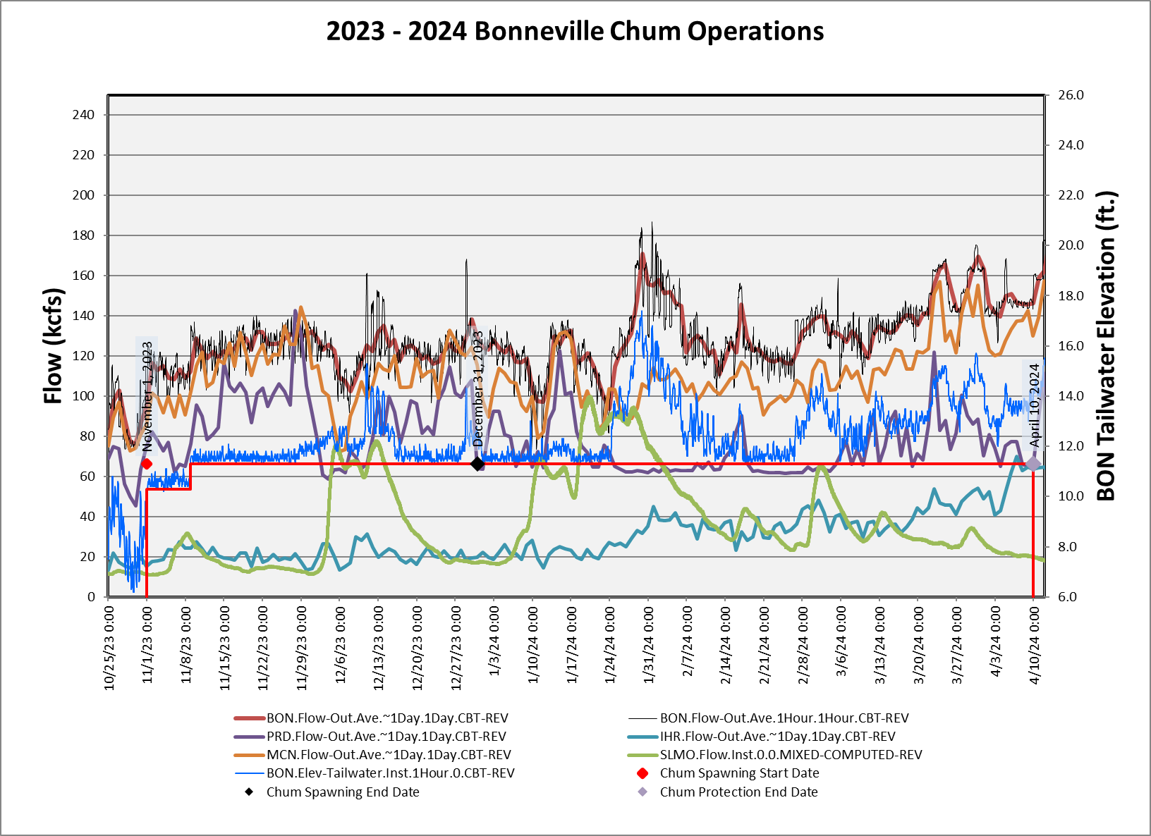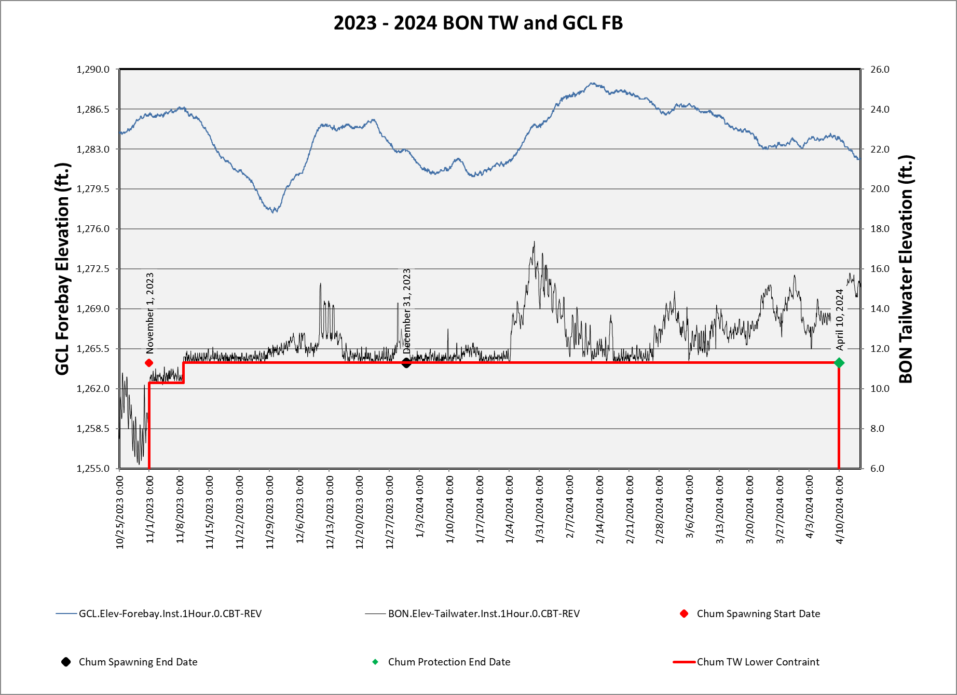

Date | TMT Coordination Summary
October 25, 2023 | The Corps, reported on current conditions at Bonneville Dam. Outflows today are averaging 90 kcfs with a project tailwater elevation of 8.7 feet. The NWRFC inflow forecasts for the next three days are around 80 kcfs, increasing to 130 kcfs on November 1. The Corps noted that the increase in Bonneville Dam outflows is reflecting assumptions of Grand Coulee outflows associated with the start of the chum operation, rather than a result of current precipitation in the forecast.  The 10-day meteorological forecast shows precipitation and cooling temperatures in the Columbia River Basin. Forecasted snow levels will drop over the next 5 days down to near sea level. Although there is projected rain and precipitation over the next 10-day period, the 10-day QPF shows some divergent effects: below average precipitation in the upper Columbia, and average to above average precipitation in the south and mid-Columbia. The 5-day QPF shows most precipitation falling into southern and southeastern ID, and the upper Columbia in OR and WA are well below average.  Climate forecasts for the next 6-10 days show a probability of below average temperatures throughout the Columbia Basin with variability in precipitation; a probability of above average in the western basin, near normal in the central portion, and below average in the east. The 30-day outlook shows a probability of above average temperatures and equal chances for precipitation.  Joel Fenolio, Reclamation, noted that any opportunity to save water now, given the dry fall and anticipated dry and warm winter, could help mitigate a need for abandoning chum later on in the winter. Tony responded that the real savings in draft is the delay in starting the 11.3 feet elevation operation, saving 4-5 feet by the end of November from start of chum operations on November 1. Erick Van Dyke, OR, noted that from Oregon’s perspective, this operation is about water management and should be considered as such, rather than an operation for chum. Kelsey Swieca, NOAA, noted the need to balance the chum operation with spring flow augmentation out of Grand Coulee, emphasizing that the situation is dynamic and TMT may seek a more conservative approach to water management given the start of this water year.  Charles Morrill, WA, noted that chum surveys are not relevant at this point, as there is no access to the Ives Pierce area. WDFW does not expect to count chum until the tailwater elevation is raised. Charles walked through a draft operation (posted on the TMT website). The draft proposes to start the chum operation at Bonneville Dam, on November 1 at 0600 hours, in the following order of operating ranges as project outflow increases:  1) All hours operate project outflow to provide a tailwater range between 10.3 – 11.2 feet.  2) If necessary to increase outflow, operate to provide a tailwater range between 11.3 – 13.0 feet. If this elevation is not achieved by November 13 at 2359 hours, operate to provide a tailwater between 11.3 – 13.0 feet, effective November 14 at 0001 hours.  3) If necessary to increase outflow, tailwater may be operated up to 16.5 feet during nighttime hours (1700- 0600), concentrating highest elevations around 2400 hours.  4) If necessary to increase outflow, tailwater may be operated up to 18.5 feet during nighttime hours.  5) If increasing river flow precludes the ability to manage the tailwater in the above steps, operate to provide a tailwater range between 13.0 – 16.5 feet during daytime hours (0600-1700) and up to the maximum within project 24-hour ramp rate limits during nighttime hours.  Charles noted that operating to an elevation of 10.3 feet actually provides an elevation of about 10.5 feet. The key operational change from past years is starting at 10.3 feet elevation, instead of 11.3 feet. WA will be monitoring spawning grounds and will provide an update to FPAC and TMT. There were no objections on the proposed operation from TMT members.  Tony Norris, BPA, noted that real time operations teams will need guidance on outcomes that could trigger the need to transition to the typical 11.3 operating range, if there is a temporary exceedance of the 10.3 – 11.2 feet operating range prior to November 13, so that fish aren’t stranded upstream after having temporary access to higher habitat. FPAC needs further discussion on an acceptable duration of exceedance before transitioning to a higher tailwater elevation; they will add this to their October 31 meeting agenda.  ¬ ACTION: Next Tuesday, FPAC will further discuss criteria for the duration of exceedance above a tailwater elevation of 11.2 feet. Details on actions for exceedance of 11.2 feet will be finalized at the November 1 TMT.  ¬ ACTION: AAs will move forward with plans to implement the coordinated chum operation, starting to target a tailwater range of 10.3 – 11.2 feet on November 1, looking to increase up to 11.3 – 13.0 feet on November 14.
November 1, 2023 | Lisa Wright, Corps, reported on current conditions at Bonneville Dam. The chum operation started this morning at 0600 hours, with a project tailwater elevation of 10.3 feet at hour ending 0500. Current outflows range between 117-125 kcfs. Inflows are forecasted to rise over the next 10 days, likely due to increasing outflows from Grand Coulee and incoming atmospheric rivers starting tonight and through the weekend that should increase runoff in the system.  The 10-day meteorological forecast shows an atmospheric river moving in this evening, hitting western Washington and moving throughout the entire Columbia River Basin starting tomorrow. Lisa noted that snow levels are high so most precipitation will fall as rain. Friday will dry out some, with rain in western Washington and Oregon. A stronger system will move in on Saturday bringing rain through the early part of next week before drying out next Wednesday.  Precipitation forecasts are showing 150%+ of average throughout much of the Columbia Basin except parts of the upper Columbia and Snake Basins and in Canada; a similar trend is projected in the 5-10-day forecast. Climate forecasts for the next 6-10 days show a likelihood of above average temperatures and precipitation throughout the Columbia River Basin, with similar outcomes for the 8-14 and 30-day outlooks.  In response to a query asking if current forecasts might change the Grand Coulee water supply outlook and justify changes to the coordinated chum operations, Tony Norris, BPA, noted that large tidal swings and inflow increases to the Willamette are expected to decrease the amount of water needed out of Bonneville Dam to meet tailwater elevations for chum, potentially saving some incremental draft from Coulee (although not modeled yet). Forecasts can change rapidly at this time of year though. Eric Rothwell, Reclamation, added that in addition to monitoring forecasts, determining potential water savings and impacts to flows from current and incoming weather systems is prudent before making adjustments to the operation, especially as the region comes out of a very dry period.  Kirk Truscott, Confederated Tribes of the Colville Reservation, agreed with Reclamation’s suggested pragmatic approach of monitoring the system’s response to the atmospheric river. The potential for reduced flow augmentation out of Coulee as a a result of the wet period might be more a function of localized precipitation affecting the tailwater below Bonneville; the water year above Coulee still appears to be on the dry side. NOAA, and the Confederated Tribes of the Umatilla Indian Reservation agreed that continuing with the previously coordinated plan (Oct 25 TMT meeting) and modifying via adaptive management was the best path moving forward. Erick Van Dyke noted that from Oregon’s perspective, this operation still is not based in a concern for chum, rather a pragmatic approach to managing water.  Tony confirmed that BPA plans to operate to the lower tailwater range (10.3-11.2 feet) as coordinated and requested criteria from Fish Managers to further clarify how to manage following potential exceedances of 11.2 feet. If the tailwater exceeds 11.2 feet for a given amount of time, should the project transition to the typical lower tailwater range? Fish Managers did not feel that assigning specific criteria for an exceedance of 11.2 feet was needed, and instead wanted to wait and see what conditions look like on November 3 and 6 when WDFW is in the field, and then adaptively manage the operation as needed. They were okay with the operation teletype clarifying that hourly exceedances were acceptable given the current uncertainty about water supply, and if 11.2 feet is exceeded for multiple hours, operators should slowly back down to the 10.3-11.2 feet operating range.  If Action Agencies’ projections and WDFW field observations show that tailwater elevation exceedances over 11.2 feet will be longer-term, for instance more than 24 hours, the TMT will reconvene to discuss and decide on a modified operation. WDFW, NOAA, and BPA will monitor the situation and precoordinate any modifications needed prior to an unscheduled TMT meeting on November 8.  ACTION: FPAC will notify TMT after their Tuesday meeting if an unscheduled meeting is necessary on November 8.
November 15, 2023 | The Corps, updated the TMT on the current chum operation (posted on the TMT website) that started at Bonneville Dam on November 1 at 0600 hours with a coordinated project outflow to maintain the tailwater within an elevation range of 10.3 – 11.2 feet (if necessary to increase project outflow, maintain the tailwater within a range of 11.3 – 13 feet). The operation was revised on November 6 to transition to an elevation range of 11.3 – 13 feet by November 9 at 0001 hour. Current project tailwater elevation at 0700 hours this morning was 11.6 feet.  RFC inflow forecasts over the next 10 days show a spike of 156 kcfs on November 16, then back down and around 125 kcfs for the remainder of the 10-day period. The 10-day meteorological forecast shows incoming precipitation today, ranging from ¾ up to 1 inch in northern Idaho, with freezing levels dropping to near sea level in the upper Columbia River Basin. Things start to dry out on Thursday and Friday, with light precipitation forecasted for Thursday in central Idaho and northwest Montana. Saturday will have localized precipitation west of the Cascades and more towards the end of the 10-day period. The Corps noted that although some precipitation is forecasted, the 10-day QPF (and 5-day QPF) throughout the entire Columbia River Basin remains well below average.  Climate forecasts for the next 6-10 days show a probability of above average temperatures and near-tobelow-normal precipitation. The 8-14-day outlook is similar, while the 6-14 day shows a probability of above average temperatures and variability for precipitation. In the western basin there is a probability of below to near normal precipitation. The 30-day outlook shows a probability of above average temperatures and precipitation.  The Corps reported that an unscheduled meeting was added for November 29, per the request of Salmon Managers. If the meeting is not needed, Tom Lorz, FPAC Chair/Confederated Tribes of the Umatilla Indian Reservation, will notify the Corps to cancel the meeting.  Tony Norris, BPA, noted discrepancy in the RFC, STP and BPA forecasts, as BPA is not expecting a 2-day peak in inflows as RFC has projected in the 10-day forecast. BPA expects to continue to support the chum operation which is expected to draft Grand Coulee across November; BPA expects to recover Grand Coulee’s pool elevation in December. Charles Morrill, WA, noted that WDFW corroborated this expectation.  Aaron Marshall, Corps, clarified that this discrepancy is commonly seen with STP forecasts during the chum operation, with Grand Coulee forecast to draft deeper than what is typically observed; STP inflow traces tend to be dryer. Tony added that November and December are typically the wettest months in the region. Jonathan Ebel, ID, wondered why the STP forecasts were used in part to justify the delay in normal chum operations, if the STP is currently considered less accurate. Tony responded that the STP in mid-October was worth considering prior to the change in conditions seen recently. The start of the chum spawning operation was a success from BPA’s perspective, saving some water and then transitioning to a higher elevation range as soon as conditions changed, the need to augment from Grand Coulee was reduced.  Joel Fenolio, Reclamation, noted that the operation potentially saved water heading into an El Niño year, and agreed it was a successful operation overall from Reclamation’s perspective. Jonathan emphasized a desire to be more cautious when considering water supply. Charles noted that for future operations like this, WA will do better to coordinate with Idaho. Kelsey Swieca, NOAA, highlighted the nuances in different forecasts used at TMT, with the reminder that some forecasting methods are publicly available, and some are not, and that Salmon Managers might find it helpful to have assumptions and any additional data included with future forecasts to help make better rounded decisions in managing the system for fish and water.  Tony highlighted observations from a memo on the 2023 chum spawning operation that was sent out earlier this week and can be viewed on the TMT website. Monday saw a significant increase in Hamilton Springs and Creek flows, Kelsey emphasized that the uptick in flow out of Hamilton Springs contributed water into the habitat and is an important component of habitat availability in that region; the timing was very beneficial. Dave Swank, USFWS, noted that his observations of the Hamilton Creek area on November 3 saw a slight decrease in water levels; he saw 4-5 chum in Hamilton Creek. He noted the Ives Islands/breaks area at that time was lower than normal, as expected at that elevation.  Kelsey reported on the chum portion of counts at Bonneville Dam, noting that 450 chum have been counted over the project so far which is higher than normal (most seen since 1998). Updated spawning surveys should be coming soon (most recent is from November 9). November 6 and 9 saw live chum and redd formation in the region (Ives/Pierce, Multnomah, Horse Tail areas). Charles noted pretty good numbers at the Ives/Pierce complex, recent data show 461 live chum on November 13. Chum are present in the areas being monitored, and he noted that the timing of the chum operation appears to have provided water for the chum when needed.  In response to Charles’ video footage of observed conditions at chum spawning sites, Jonathan asked if there were observed impacts of the 10.5 feet elevation tailrace on chum use in the area at the arrival and beginning of the spawning period? A more complete review will be available at the end of the operation, Charles noted that it appears the operation made the best use of what water was available, and timely precipitation benefitted flows out of Hamilton. Kelsey added that NOAA, BPA, and WDFW are exploring options for how to best document this operation and quantify the benefits as best possible to provide to the TMT.
November 29, 2023 | The Corps, updated the TMT on the current chum operation (posted on the TMT website). The Bonneville Dam tailwater elevation at 0700 hours this morning was 12 feet. The Corps reminded the TMT that there are two phases of the coordinated chum operation: the spawning phase, and the incubation phase. Coordination for the incubation phase includes setting a minimum tailwater protection level based on surveyed elevations of redds; planning for the incubation phase will occur at the December 20th TMT meeting.  RFC inflow forecasts at Bonneville Dam over the next 10 days show a range of 116-156 kcfs. The 10-day meteorological forecast shows lowering of snow levels, cooling, and increased precipitation throughout the Columbia River Basin. The 10-day QPF (and 5-day QPF) show about 4 inches of precipitation west of the Cascades is expected, which will likely increase flows in the Willamette River and result in less flow needed from Bonneville and Grand Coulee to support the chum tailwater.  The Corps pointed out that there is some variation between forecast precipitation in the upper Columbia River Basin and Oregon/SE Idaho – the upper basin is expected to have below average precipitation, whereas Oregon/SE Idaho are forecast to be above average. Climate forecasts for the next 6-10 days show a probability of above average precipitation. The 30- day outlook shows an equal chance of above or below average temperatures and precipitation.  The Corps reviewed the water year precipitation table, specifically:  • The Snake River above Ice Harbor Dam is 82% of average,  • The Upper Columbia River above The Dalles Dam is 70% of average, and,  • The Willamette above Portland is 78% of average.  Tony Norris, BPA, noted that he will be in the field tomorrow (11/30) with surveyors to measure the elevation of redds ahead of the planned December 20th incubation phase coordination. Once coordinated, the incubation tailwater elevation will be the minimum constraint to until April 10, 2024. Kirk Truscott, Colville Tribes, noted that in the Upper Basin conditions are dry and that the TMT will need to watch conditions upstream and locally to adaptively manage the operation. Tony anticipated that there will be some filling of Grand Coulee if the localized precipitation that is forecasted occurs.  However, Tony noted that last week’s conditions at Ives Island and Hamilton Creek/Springs were challenging for chum. Water levels were low, and chum were having difficulties moving upstream above the log in Hamilton Spring. WDFW surveyors moved some sandbags to support passage and there may be an opportunity next summer to modify this location to improve passage for future dry conditions. That said, it is positive that they’ve counted over 600 chum passing through Bonneville Dam so far this year. If flows come up, there may be another pulse of chum.
December 20, 2023 | The Corps, updated the TMT on the current chum spawning operation (posted to the TMT website). The Bonneville Dam tailwater elevation at 0600 hours this morning was 11.3 feet, at the bottom of chum spawning range (11.3-13.0 feet). Total outflows were 116 kcfs.  RFC inflow forecasts at Bonneville Dam over the next 10 days show a range from 121-124 kcfs. The 10-day meteorological forecast shows a mix of precipitation: starting with light precipitation in the upper Columbia Basin and high snow levels, then a drop in forecasted snow levels. The end of the 10-day forecast calls for a warming trend. The Corps noted that although precipitation is forecasted, the 10-day QPF is expected to be well below average precipitation throughout the basin. The 5-day shows warm temperatures and below average precipitation. Monthly average precipitation is above average in parts of the basin, but temperatures have also been above average, limiting snowpack. The Corps pointed out that it is early in the season and there is time to catch-up.  Climate forecasts for the next 6-10 days (and 8-14 days) show a probability of above average temperatures, and a variability of precipitation: a probability of above average in the western portion of the basin, near normal in the central, and below average in the east. The 30-day outlook shows a probability of above average temperatures and a probability of above average precipitation.  Tony Norris, BPA, provided an update on redd data collected from November 30 (slides posted to the TMT website), noting that monitoring crews have not been able to collect data since then due to weather conditions and poor visibility. With the period of significant precipitation after November 30, daytime tailwater has been up to 13 feet, likely with more fish moving in. Redds have been observed in the usual places: Woodard and McCord Creeks, the Breaks, Ives Channel and Pocket (more after rains), and Strawberry (not many observed as previous years). Redds measured on November 30 were generally deep and would likely be inundated at a lower tailwater (10.5 feet) as well. BPA is not seeing significant streamflow response to the recent precipitation and expects to be running Grand Coulee close to chum while continuing to recover the pool from when the project drafted to 1,277 feet the last week of November prior to stream flow responses. Grand Coulee is currently passing inflow at about 1,285 to support chum, and a few more feet of fill is likely through December and moving into an uncertain January-March period. BPA expects to preserve as much water as possible heading into a potential dry year through emergence.  TMT discussed setting date and elevation for the incubation phase of the chum operation. Tony shared input from Charles Morrill, WDFW, who was not present, however, precoordinated that WDFW would prefer setting an 11.5 foot minimum during the incubation phase. TMT members present expressed interest in conserving water by keeping the 11.3 foot minimum tailwater and noted a need for more information regarding redds and conditions. Kelsey Swieca, NOAA, reiterated that survey crews have not been able to get on site to determine the appropriate elevation level due to weather conditions. NOAA recommended transitioning to the incubation phase on December 31, with a tailwater elevation of 11.5 feet until more information is available to inform the operation. If conditions warrant, the operation can and will be modified.  ACTION: NOAA, WDFW, and BPA will continue to gather information and coordinate adjustments as needed.  ACTION: Unless otherwise coordinated, the Action Agencies will transition from the chum spawning to incubation phase on December 31, with a minimum elevation of 11.5 feet.  ACTION: NOAA will notify AAs/The Corps via email by COB December 29, either to continue the operation as coordinated today or to make an adjustment.
January 10, 2024 | The Corps, updated the TMT on the current chum operation (posted to the TMT website). The Bonneville Dam tailwater elevation at 0700 hours this morning was 11.7 feet, with a total outflow of 106.9 kcfs. The chum incubation phase is planned to continue through April 9 at midnight. April 10 at hour 0001 will signify the end of the chum operation and the start of spring spill, unless otherwise coordinated at TMT.  RFC inflow forecasts at Bonneville Dam over the next 10 days show a low today of 98 kcfs, peaking on January 16 around 120 kcfs. Doug highlighted the current active weather front, with significant precipitation on day 1 of up to an inch in the Cascades, with forecasted snow levels dropping. The trend of significant precipitation and cool temperatures is forecast throughout the 10-day, however, is not basinwide. The 10-day QPF shows robust precipitation in Oregon and Southern Idaho, with the Upper Columbia Basin well below average. The 5-day QPF is similar, with well above average precipitation in southern portion of the Columbia Basin, and well below average in the north.  Climate forecasts for the next 6-10 days show a probability of below average temperatures and above average precipitation. The 8-14-day outlook shows a similar pattern for temperatures with some variability; near normal in the west and below average in the east. The 30-day outlook shows equal chances of above or below average temperatures in the eastern portion of the basin, with equal chances of above or below average precipitation in the NE basin, and above average in the SW basin. From a water year perspective, water conditions have been primarily below average, with some improvement starting in December. The Corps noted that the Corps will continue to monitor conditions for the chum operation, and an additional meeting has been added to the calendar for January 17 to check in on conditions. If it seems that the meeting is not necessary, TMT will be informed ASAP.  Scott Bettin and Tony Norris, BPA, provided an update on redds, reviewing data from site visits on November 30, 2023 and January 4, 2024. Redds were observed at Ives Channel and Pocket on January 4. The highest redd in the Channel was at 11.6 feet and at least one was higher than the water elevation although no eggs were found; redd elevations at the Pocket were deeper and less fish were observed than normal. Tony noted that most fish seemed to come in and spawn early, prior to December’s significant precipitation, and mostly at McCord Creek which is seeing more and more fish every year. During the January 4 site visit, no new redds were observed at Woodard Creek, the Breaks, or Strawberry.  With the difference between Corps’ and BPA forecasts, BPA will continue monitoring conditions and does not expect a change is currently needed in the current chum operation. In response to a query regarding the difference between BPA’s projections and the STP, Tony emphasized that incremental streamflow does not match up with observations in the SPT. Tony also noted that while there is below average snowpack on the north portion of the basin, there is some small incremental rise in the water supply forecast. Additionally, due to the incoming extreme cold weather, wind front throughout the region, and increases forecasted for the Willamette River, it’s possible the Bonneville tailwater may rise above the 11.3-12-foot range. A lot of uncertainty remains over the next 5 days and BPA is prepared if emergency conditions arise. Erick Van Dyke, ODFW, emphasized the importance of working to support productivity of listed species in ways that increase and maintain natural spawning areas. Tony added that maintaining a level of caution when considering lowering tailwater protection levels is due to potential impacts to downstream spawning areas, which are not monitored as closely. NOAA and WDFW didn’t have anything to add regarding chum and noted that internal coordination will continue.
January 24, 2024 | The Corps, provided an update on the current chum operation (posted to the TMT Website). The Bonneville Dam tailwater elevation at 0700 hours this morning was 11.7 feet, with a total outflow of 104 kcfs. The chum incubation phase is planned to continue through April 9 at midnight, with the start of spring spill on April 10, unless otherwise coordinated at TMT.  RFC inflow forecasts over the next 10-days show a low today of 116 kcfs, peaking at 150 kcfs at the end of the 10-day period. A trend of persistent precipitation is forecast across the entire 10-day period in the Columbia Basin, mostly in the Cascades, with higher levels in the western portion of the basin. Cool temperatures with a snow level ranging between 2,000-5,000 feet will begin the 10-day, with a warming trend and higher snow elevations before temperatures cool back down. The 10-day QPF shows above average precipitation in the western and southern parts of the Columbia River Basin and below average in the upper Columbia, Idaho and western Montana. The 5-day QPF shows a similar trend. Climate forecasts for the next 6-10 days show a probability of above average precipitation and temperatures. The 8-14-day outlook is similar with some variability for temperatures. The Corps highlighted that the RFC water supply forecast for The Dalles, April to August is 71 maf, or 79% of average.  Tony Norris, BPA, reported that the Willamette River is forecasted to remain elevated, resulting in lower flows needed from Bonneville Dam to maintain the chum incubation operation; as a result, some flow has been preserved at Grand Coulee Dam. Due to local and upstream inflows, operations may shift back and forth between operating to the chum minimum and Hanford Reach minimum for this next period.  Jonathan Ebel, ID, asked if the NWRFC forecasts are being driven by low elevation snow melt and Tony noted that he could not speak to the assumptions used in NWRFC’s forecast specifically. In response to a query from Erick Van Dyke, OR, he clarified that when the Willamette is running high the backwater effect reduces the flow required out of Bonneville to maintain a specific Bonneville Dam tailwater elevation. When there is enough water elsewhere in the system (including natural stream flows) to meet the chum minimum Grand Coulee will be operated to meet the Hanford Reach minimum which could result in a higher Bonneville Dam tailwater. The lowest Action Agencies can reduce discharge is to meet the Hanford Reach minimum flow.  NOAA and WDFW didn’t have anything new to add; there have been no chum over Bonneville since the new year and there are no new observation data from the Ives Pearce area.
February 7, 2024 | The Corps reviewed the Water Year observed precipitation and percentage of normal: the Snake River above Ice Harbor Dam observed 9.2 inches of precipitation, or 88% of normal; the upper Columbia above Arrow observed 20.5 inches, or 80% of normal; the Columbia mainstem above The Dalles observed 11 inches, or 83% of normal; and the Willamette above Portland observed 39.3 inches, or 103% of normal.  The Corps highlighted that temperatures across the October 1 through February 6 period have been warm throughout the Columbia River Basin: the Snake River above Ice Harbor Dam has been 2.2 degrees F above average across the season, and 6.4 degrees F above normal for the current month. The upper Columbia River above Arrow, has been 1.7 degrees F above average for the season and 8.6 degrees F above for the current month. The Columbia mainstem above The Dalles has been 2.0 degrees F above average across the season, and 6.4 degrees F above average for the current month. The Willamette above Portland has been 1.9 degrees F above average across the season.  The Bonneville Dam tailwater elevation at 0700 hours this morning was 12.6 feet, with a total outflow of 131.2 kcfs. Below average precipitation values with above average temperatures are prevalent throughout the Columbia River Basin. Snotel Sites in British Columbia are predominantly in the 50-75% of average for SWE; the upper Columbia and Snake are below average as well.  RFC inflow forecasts at Bonneville Dam over the next 10 days are around 122 kcfs. Forecasted precipitation over the next 10 days is well below average throughout the Columbia basin, with a minor exception in the upper Snake; the 5-day QPF is similar with predominantly well below average precipitation throughout the Columbia Basin with exceptions in Idaho.  The 6-10 day climate outlook shows a probability of below average temperatures in the eastern Columbia basin and near normal in the west with a probability of below average precipitation. The 8-14 day outlook reflects the same pattern of variability in temperatures with a probability of below average in the eastern basin, near normal in the central, and above average in western Oregon and Washington, with a probability of below average precipitation. The 3-4 week outlook continues to show above average temperatures and below average precipitation.  The chum incubation operation of an 11.3 feet minimum tailwater elevation at Bonneville Dam will continue through April 9 with the start of spring spill on April 10, unless otherwise coordinated at TMT. Tony noted that streamflow increases over the last several days have allowed Grand Coulee to reduce discharge down to Hanford Reach minimums and the project will continue to target its refill objective while meeting chum and Hanford Reach obligations. Chris added that as Bonneville flows come down, the project will start augmenting for chum flows. It was emphasized that quite a bit of uncertainty still remains, and that impacts to the chum operation and Grand Coulee elevations will continue to be closely monitored; adjustments can be made as needed.  Thomas Starkey, WA DOE, asked what a low water year means for spill season. The Corps noted that TMT has coordinated through dry water years in the past and operations will continue as identified in the December 2023 MOU, although proportions of spill may be different depending on water supply.
February 21, 2024 | The Corps, provided an update on the current chum operation (posted to the TMT website). RFC inflow forecasts at Bonneville Dam over the next 10-day period show a low of 117 kcfs today, peaking at a high of 128 kcfs on February 28. Bonneville inflows will likely remain low for the remainder of the chum operation, which will conclude on April 9 at midnight unless otherwise coordinated at TMT.  The Corps noted that the low inflows are predominantly a result of below average precipitation and above average temperatures. The Snake River above Ice Harbor Dam has observed 10.3 inches for the season, or 91% of normal; the Columbia River mainstem above The Dalles has observed 11.9 inches, or 83% of normal. Regarding seasonal temperatures, the Columbia River mainstem above The Dalles has observed higher than average temperatures throughout October, November, and December, although January did see below average temperatures (0.5 degrees F below average). The seasonal temperature departure has been 1.8 degrees F above average.  BPA, NOAA, Reclamation, and Washington did not have additional updates on the chum operation.

March 6, 2024 | The Corps reported that RFC inflow forecasts at Bonneville Dam over the next 10 days show a low of 113 kcfs on March 11, and a high of 130 kcfs on March 13. The chum incubation operation of an 11.3 feet minimum tailwater elevation at Bonneville will continue through April 9 with the start of spring spill on April 10, unless otherwise coordinated at TMT.  The Corps highlighted the recent improvements to precipitation throughout the Columbia River Basin since the last TMT meeting. The Snake River Basin above Ice Harbor Dam is 100% of normal for the water year, with 12.4 inches observed. The Columbia River Basin above The Dalles is 90% of normal, at 14 inches; the Willamette River Basin above Portland is 109% of normal, at 48.7 inches.  Also noteworthy are the current cool temperatures throughout the basin for the month of March: The Snake River Basin above Ice Harbor is 7.3 degrees F below average for the month of March, although the seasonal temperature departure is still 1.7 degrees F above normal. The Columbia River Basin above The Dalles is 7.3 degrees F below average, still 1.5 degrees F above average for the water year.  Kelsey Swieca, NOAA, reiterated that NOAA is closely monitoring the chum operation and will continue to do so moving forward through the start of spring spill, working to maintain the 11.3 feet tailwater minimum at Bonneville while also monitoring the elevation at Grand Coulee. Tony Norris, BPA, added that BPA expects to be able to maintain the chum elevation at Bonneville through April 10 while also achieving Grand Coulee’s refill objective. Charles Morrill, WA, noted that heavy precipitation forecasted for this weekend in the Cascades may increase Willamette River outflow and continue to relieve pressure off of Grand Coulee; Chris added that the Coulee has only drafted 0.9 feet since February 7, another positive reflection for water storage.
March 13, 2024 | The Corps, reported that RFC inflow forecasts at Bonneville Dam over the next 10-day period show a low of 133 kcfs on March 17, and a high of 146 kcfs on March 22. Within the 10-day weather forecast, days 1-7 show a warming trend (forecasted snow levels reaching up to 8,000 feet in the Cascades) while the remainder of the 10-day shows cooling with a significant drop in freezing levels.  The 10-day precipitation forecast (QPF) shows predominantly well below average precipitation in the Columbia Basin, with the exception of normal to above average in the upper portion of the basin later in the forecast period. The 5-day QPF also shows well below average precipitation throughout the entire Columbia Basin.  Tony Norris, BPA, reported that BPA expects to maintain the chum tailwater minimum at Bonneville Dam and achieve the April 10 refill objective at Grand Coulee Dam. Charles Morrill, WA, noted that WDFW will continue to watch and monitor chum, and that he will provide an update next week with emergence/immigration data from Hamilton Springs. NOAA and Reclamation had nothing further to report regarding chum and there were no questions or comments from TMT.
March 20, 2024 | – Charles Morrill, WA, reported that there are more than adequate flows to maintain the established chum protection level. Chum are beginning to emerge from Hamilton Springs, although still in the very early stages, which is expected at this time. He noted that this is not an accurate representation of fry emergence in the Ives/Pierce spawning area due to differences in water temperatures, but it’s an indicator that chum are emerging from the gravel and leaving the Ives/Pierce area. Once available, Charles will provide an update on the number of adults in Hamilton Springs this year.  NOAA echoed that conditions should allow for BPA to maintain the chum tailwater minimum at Bonneville Dam through the start of spring spill, without any risk to the elevation target at Grand Coulee Dam.

March 27, 2024 | Lisa Wright, Corps, provided an update on current conditions and forecasts for the  remainder of the chum operation. Bonneville Dam inflows are currently 140 kcfs, while the 10-day forecast shows a high of 160 kcfs on March 30 and a low of 130-140 kcfs by the end of the 10-day forecast.  Today there is rain throughout the entire basin, with some snow in higher elevations, 2,000 feet and above in the western Cascades and above 3,000 feet in the eastern portion. The Central portion of the Basin is expected to be dry towards the end of the 10-day period. Precipitation is well below average for the 10-day period, with the 5-day reflecting today’s rain event. Regarding the current water supply forecast at The Dalles, the April through August runoff volume is 80% of normal, and is expected to remain low compared to recent years.  Charles Morrill, WA, expressed appreciation that there has been enough water to maintain protection levels for chum, noting that there is adequate water in the Ives/Pierce area. WDFW, NOAA, and the AAs will continue to watch water supply and forecasts; at this point no issues are expected while maintaining  protection levels through the final 2 weeks of the chum operation.
April 3, 2024 | The Corps, reported that RFC inflow forecasts at Bonneville Dam over the  next 10-day period show a low of 131 kcfs today April 3, and a high of 195 kcfs on April 7. Recent dry conditions and warmer temperatures will shift to precipitation; the 10-day weather forecast shows 1-1.5 inches in central Idaho, with a reduction in snow levels in western WA and OR (1-2,000 feet elevation). The trend of precipitation and lower forecasted snow levels continues through day 4, tapering off drier conditions by day 5 and through the remainder of the period. Doug summarized that forecasted precipitation is fairly localized; the 10-day QPF shows precipitation to central Idaho (lower than winter volumes), eastern Oregon, and southeast Washington, with above average values for this time of year to ease up entering the spring months. The 5-day QPF shows a similar pattern.  The chum operation will continue as coordinated to date at TMT, ending on April 10 (at 0001 hours) with the start of spring spill at Bonneville Dam.  Charles Morrill, WA, added that weather conditions have been favorable enough to meet chum protection levels throughout the operation (without needing to draw down at Grand Coulee) despite the initial poor outlook for flows. NOAA and Reclamation echoed the appreciation for the ability to protect chum while keeping Grand Coulee refilling.

Dates | Chum Water Management Summary
October 31, 2023 | Prior to the start of the chum spawning operation Grand Coulee was filled to elevation 1286 feet.  Very low streamflows in the system prompted TMT to consider starting chum operation at a lower TW. Some precipitation had occurred in the basin to start Hamilton Creek flowing at least 1 foot over the gauge.
Nov 1-8 | Operated to the lower BON TW range of 10.3-11.2 feet. The lower operating range preserved some storage behind Grand Coulee which generally passed inflow across this period with a slight fill to 1286.5 feet.
Nov 9-29 | West side precipitation was forecasted and the BON TW range was increased to the normal range of 11.3-13.0 feet. The Willamette River and Snake River flows increased above their fall base flows contributing to lowering the among of augmentation needed from storage to meet the chum minimum.  During this period Grand Coulee was drafted to elevation 1278 feet to support the chum spawning operation.
Nov 30-Dec 23 | Significant precipitation resulted in the Willamette increasing to 60-70 kcfs which minimized the augmentation required from Grand Coulee which was able to refill to elevation 1285.5 feet during this period.  Less than 10 days during his period required reverse load factoring to maintain the day-time TW operating range.
Dec 24-31 | Grand Coulee drafted ~3 feet during this period to support the minimum TW. Grand Coulee was at elevation 1282.5 at the end of spawning phase of the operation.
Jan 1-Feb 14 | Precipitation hitting the west side and snake basins increases Willamette River and Snake River flows allowed Grand Coulee to nearly full at elevation 1288.8 feet at the end of this period.  The higher flows from the Willamette and Snake resulted in BON TW elevations well above the minimum TW.  During this period the northern part of the basin did not receive much precipitation. Also, notable during this period the region experience a historically cold snap. With water supply forecasts trending very low there was very little power flexibility while maintaining a high April 10 refill probability. BPA purchased ~$300m in power to maintain the forebay elevation to protect April 10 refill probability and region power system reliability. Several adjacent balancing authorities declared power system emergency and were supported by BPA within the available BiOp power flexibility.  In spite of west side precipitatin that boosted Cascade and Upper Snake snow pack computed FRM elevations based on the February WSF were near the maximum elevations with an end of March FRM elevation of 1283 feet.
Feb 15-26 | Streamflows receded during this period resulting in the BON TW tracking closer to the minimimum with releases from Grand Coulee tracking the minimum for the Hanford Reach fall chinook incubation flows. The average flow from PRD was ~67 kcfs during this period. Grand Coulee drafted to ~1286 to support the Hanford Reach flow due inflow to Grand Coulee averaging 53 kcfs during this period.  With Grand Coulee tracking the Hanford Reach minimum variability

Feb 27-Mar 10 | During this period releases from Grand Coulee generally passed inflow while tracking the minimum at Hanford Reach. The outflow from Grand Coulee during this period averaged 61 kcfs with average inflow at 60 kcfs.
Mar 11- 31 | The March final WSF resulted in an end of March FRM elevation of 1283.3 feet. Outflow from Grand Coulee during this period targeted the minimum flow for the Hanford Reach and a draft of Lake Roosevelt to the end of March FRM elevation. The draft of Lake Roosevelt and increase in flow in the Snake River produced Bonneville TW elevations well above the minimum.
April 1-10 | During this period releases from Grand Coulee generally passed inflow while tracking the minimum at Hanford Reach. The outflow from Grand Coulee during this period averaged 60 kcfs with average inflow at 65 kcfs. The April 10 elevaton at Grand Coulee came in at 1284 feet. This was ~0.7 feet above the official April 10 refill objective of 1283.3 feet.  The Bonneville TW elevation remained the minimum due to flow in the Snake River at ~60 kcfs.

Additional chum water management notes that will be updated in-season:

Chum survey data gathered at the Ives/Pierce Island Complex will be summarized in the table below. Data from all Chum survey areas, including the Ives/Pierce Island Complex, are provided by the Fish Passage Center and available on the following website.

https://www.fpc.org/spawning/spawning_surveys/ODFW_reports/2023spawning.htm

Table 10. Chum Salmon Spawning Ground Surveys Below Bonneville Dam, 2023-2024

Survey Area
Ives/Pierce Island Complex

Date | Lives | Dead^{i} | Redds^{ii} | Visibility (feet)
11-Sep-23 | 0 | 0 | 0 | 6 ft.
21-Sep-23 | 5 | 0 | 0 | 10 ft
25-Sep-23 | 7 | 1 | 1 | 12.5 ft.
2-Oct-23 | 2 | 0 | 0 | 10 ft.
6-Oct-23 | No survey | - | - | too windy
10-Oct-23 | 4 | 1 | 1 | 12.5 ft.
13-Oct-23 | 2 | 0 | 1 | 12.5 ft.
16-Oct-23 | 0 | 0 | 1 | 12.0 ft.
20-Oct-23 | 0 | 0 | 0 | 12.5 ft.
23-Oct-23 | 0 | 0 | 0 | 8 ft. windy/poor vis.
27-Oct-23 | 0 | 0 | 0 | 8.5 ft.
30-Oct-23 | No survey |  |  | Too windy
6-Nov-23 | 61 | 0 | 10 | 6 ft.
9-Nov-23 | 106 | 1 | 29 | 6 ft. windy
13-Nov-23 | 461 | 1 | 99 | 8 ft.
20-Nov-23 | 422 | 40 | 83 | 6 ft. windy
29-Nov-23 | 362 | 49 | 93 | 5 ft. poor conditions/visibility
5-Dec-23 | 140 | 18 | 24 | 2 ft. Tribs made water muddy
12-Dec-23 | 52 | 17 | 8 | 3 ft. High water, High wind
20-Dec-23 | 20 | 0 | 4
- Dead are newly samply fish only.
- Redds are an instantaneous count for the day, not cumulative.
NC = No Count

  - Vernita Bar/Hanford Reach Fall Chinook Protection Program Operations (Non-BiOp Action)

The Corps will provide inseason updates to this section.

The Hanford Reach Fall Cinook Protection Agreement (Agreement) ebstablishes the obligations of the Parties with respect to the protection of fall Chinook in the Hanford Reach of the Columbia River. The Parties agree that during the term of the Agreement these flow regimes address all issues in the Hanford Reacth with respect to fall Chinoook protection and the impact of operation of the seven dams operatin under Mid’Columbia Hourly Coordination, including the obligations of Grant, Chelan, and Douglas under any new licenses issued by the Federal Energy Regulatory Commission (FERC).

Beginning in mid-October, under the terms of the Hanford Reach Fall Chinook Protection Program Agreement, river flows are reduced every Sunday morning (day of lowest power demand) to the Priest Rapids Dam minimum operating discharge of 36,000 cubic feet per second (ft³/s) [1000 cubic meters per second (m³/s)]. This allows the Agency and Utility Party Monitoring Team to manually survey for redd distribution at Vernita Bar just downstream of Priest Rapids Dam. These drawdowns occur every Sunday morning until the initiation of fall Chinook spawning has been set both above and below the 50,000 ft³/s (1,416 m³/s) flow elevations. A final drawdown is conducted on the Sunday prior to Thanksgiving to establish the minimum critical flow needed to protect pre-emergent fall Chinook. Given the previously described limitations, this weekly reduction in river flow affords the best viewing conditions for aerial flights. Aerial flights are therefore scheduled to be conducted concurrent with the Sunday morning drawdowns, when possible.
Date | Summary
October 22, 2023 | Spawning Surveys:  On Sunday, October 22, 2023 representatives from Grant PUD and the Washington Department of Fish & Wildlife conducted the first 2023 Vernita Bar spawning ground survey. No completed redds were found during the survey. A second spawning ground survey will be conducted next Sunday, October 29 to count redds above and below the 50 kcfs elevation.  Flow Request for Sunday, October 29, 2023:  For October 29, please schedule Priest Rapids Dam discharge to be less than 40 kcfs from 0700 to 1500 hours. The redd count will begin at 0900 hours. This will be the second redd survey this year as required by the 2004 Hanford Reach Fall Chinook Protection Program Agreement. Accompanying Grant PUD staff will be a Washington Department of Fish & Wildlife representative.
November 26, 2023 | Spawning Surveys:  On Sunday, November 26, 2023 representatives from Grant PUD and the Washington Department of Fish & Wildlife conducted the fourth 2023 Vernita Bar spawning ground survey. The intent of this week’s survey was to determine the Critical Elevation for the 2023-2024 protection season and to determine if spawning has ended.  The results from today’s redd count are provided below in Table 1. As described in the Hanford Reach Fall Chinook Protection Program Agreement, if there are fewer than 15 redds above the 65 kcfs elevation, then the Critical Elevation will be the first 5 kcfs elevation above the elevation containing the 16th highest redd. Therefore, using today’s data, the Critical Elevation for the 2023-2024 Protection Season is 60 kcfs. Additionally, based on observations during the survey it was determined that Spawning Period has ended today, November 26 (average end date = Nov. 22).  Protection Periods:  Starting on Monday, November 27, we will be in the Pre-Hatch Period. During the Pre-Hatch Period Priest Rapids Outflow may be reduced below the Critical Elevation for up to 8 hours on weekdays and 12 hours on weekends with no two consecutive periods below 60 kcfs. We are projecting that the Post-Hatch Period for the below 50 kcfs elevation will occur on December 4. During this period, flows must remain no less than 15 cm below the 50 kcfs elevation at all times. We are projecting that Post-Hatch for the above 50 kcfs elevation will occur on December 27. During this period, flows must remain no less than 15 cm below the 60 kcfs elevation at all times. I will continue to provide email updates as the season progresses.
February 14, 2024 | We are projecting that on February 19, 2024 the Emergence and Rearing Periods will begin. During these periods, daily flow fluctuation below Priest Rapids Dam will be limited and the water level at Vernita Bar must be no less than the Critical Elevation (60 kcfs) at all times.  See the attached memo for additional details regarding the completed, current, and projected dates of each of the flow constraint Periods as described in the Hanford Reach Fall Chinook Protection Program Agreement. I will continue to provide email updates as the season progresses.
March 27, 2024 | We continue to be in the Emergence and Rearing Periods. This Period requires no less than the Critical Elevation (60 kcfs) at all times and flow fluctuation constraints from Priest Rapids Dam. The enhanced weekend minimum flow constraints (CJAD II) are predicted to begin on Saturday, April 6. The enhanced weekend constraints will continue for four consecutive weekends ending on Sunday, April 28. During the CJAD II weekends, the minimum flow below Priest Rapids Dam must be no less than the average of the daily hourly minimum from Monday through Thursday of the current week.
  - Snake River Zero Generation
Zero Generation Operations as described in the 2020 CRSO EIS ROD will no longer commence as early as October 15, and will instead commence once the previously defined implementation trigger of “few, if any” actively migrating anadromous fish (as described in SOR 2005-22) has been met. This trigger will be implemented in relation to both date (implementation will be limited to periods between December 1 and through February 28) and abundance.
Salmon Managers submitted System Operations Request (SOR) 2005-22 Snake River Zero Nighttime and Weekend Flow, to the Action Agencies (AA) on December 6, 2005. The SOR may be found on the following website:
http://pweb.crohms.org/tmt/sor/2005/2005-22.pdf
In the SOR, the Salmon Managers provided the AAs with the following table to define the criteria of “… few, if any …” prior to the implementation of the Zero Generation Operation. The few migrating adult criterion trigger will be defined on a sliding scale outlined in the following table. The table applies to both “wild” and “total” categories of returning adult steelhead.
Table 12: The Few Migrating Adult Criterion Trigger (SOR 2005-22)
Run to date># | Run to date< # | Few criteria< #
0 | 30,000 | 10
30,000 | 60,000 | 20
60,000 | 100,000 | 35
100,000 | 150,000 | 50
150,000 | 200,000 | 65
200,000 | 250,000 | 80
250,000 |  | 100

System Operations Request 2005-22 defined “few” migrating adults; this SOR has guided operations through 2019. Over time, these criteria have been slightly modified to include:

- The number of adults migrating per day is defined as the number of upstream counts minus the number of downstream counts, as reported on the Fish Passage Center’s website (https://www.fpc.org/currentdaily/HistFishTwo_7day-ytd_Adults.htm).
- A three-day moving average will be used to determine if the few migrating adult criterion has been met.
- The criteria apply to both “Unclipped” and “total” categories of returning adult steelhead. “Unclipped” and “total” returns will be calculated separately. Only one of the categories is necessary to show that more than a few adults are migrating.
- The run to date is defined as the cumulative number of adult steelhead in the “Unclipped” and “total” categories passing Lower Granite Dam since July 1st of the return year.

The timing of “nighttime” and “dawn” changes throughout the year. Based on the hours of actual Civil Twilight at Lower Granite Dam, the following hour ranges were coordinated during the October 21, 2020, TMT meeting to be consistent with the criteria identified in the 2020 CRS BA:

DATES “NIGHTTIME” HOURS FOR ZERO GEN

December 1-14 1800-0600

December 15 - January 31 1800-0600 + up to 3 daytime hours

February 1-28 1900-0600 + up to 3 daytime hours

Sources for definitions and computation of nighttime hours: https://www.esrl.noaa.gov/gmd/grad/solcalc/glossary.html
https://www.esrl.noaa.gov/gmd/grad/solcalc/calcdetails.html
2023-2024 Zero Gen Operations:
The abundance criteria was met on November 29, 2023. NOAA notified the Action Agencies that zero generation flexibility was available starting December 2, 2023 to allow time for fish to pass that may have been impacted by the powerhouse outage at Little Goose Dam.

From December 2 through February 28 th zero generation flexibility was used for 7.4% of available hours and 22.5% of available days averaged over all 4 projects.

 | LWG | LGS | LMN | IHR
Hours Used | 7 | 118 | 141 | 111
Days Used | 2 | 25 | 30 | 23 | % of Available Used
% of Available Hours Used | 0.6% | 9.3% | 11.1% | 8.7% | 7.4%
% of Available Days Used | 2.2% | 28.1% | 33.7% | 25.8% | 22.5%

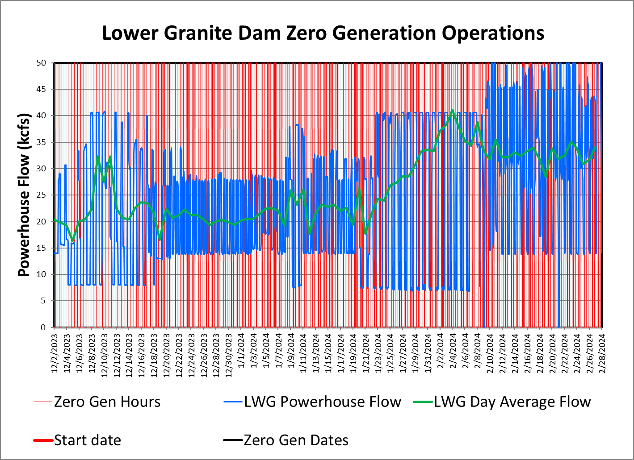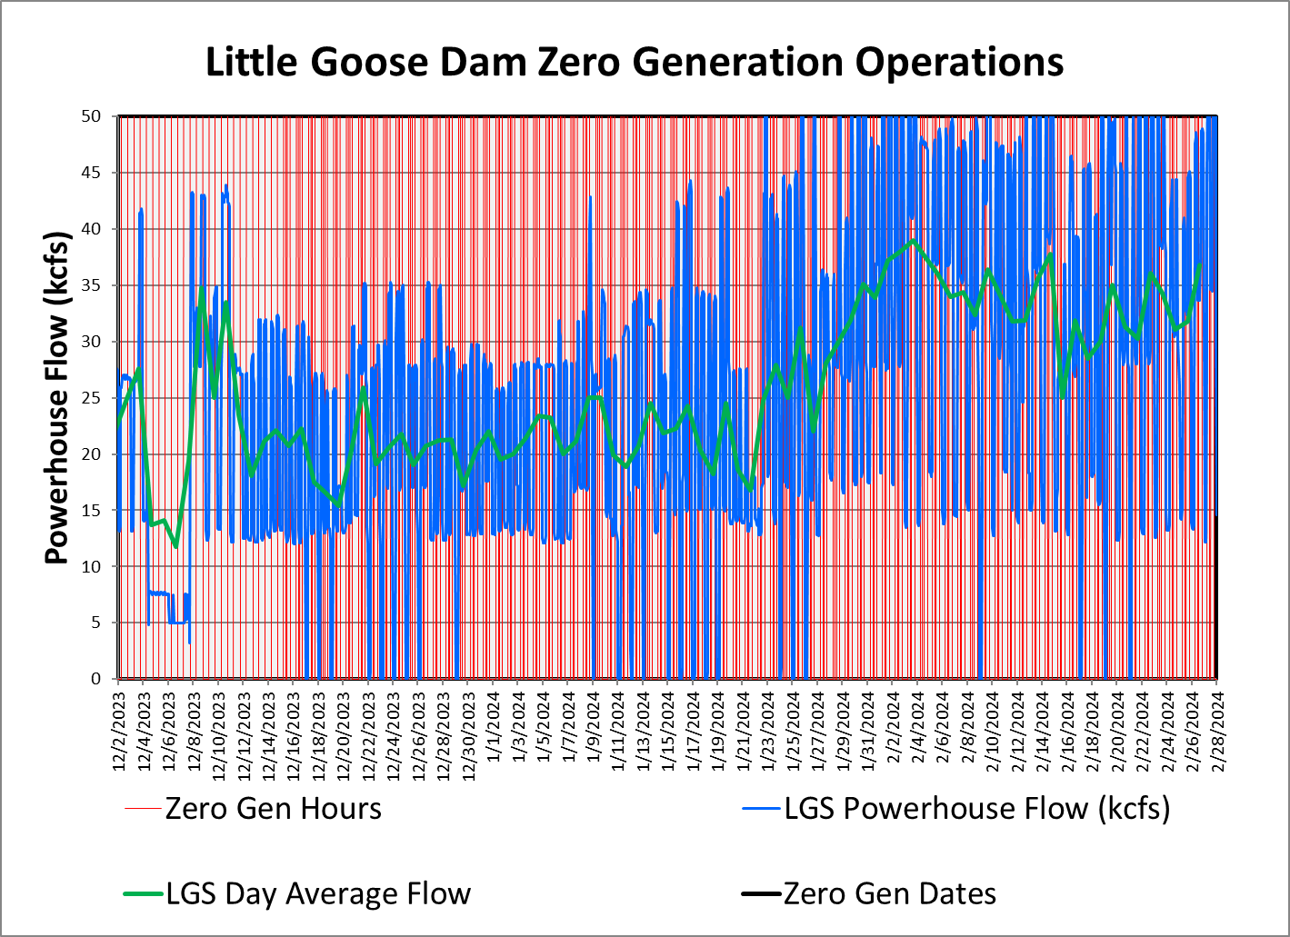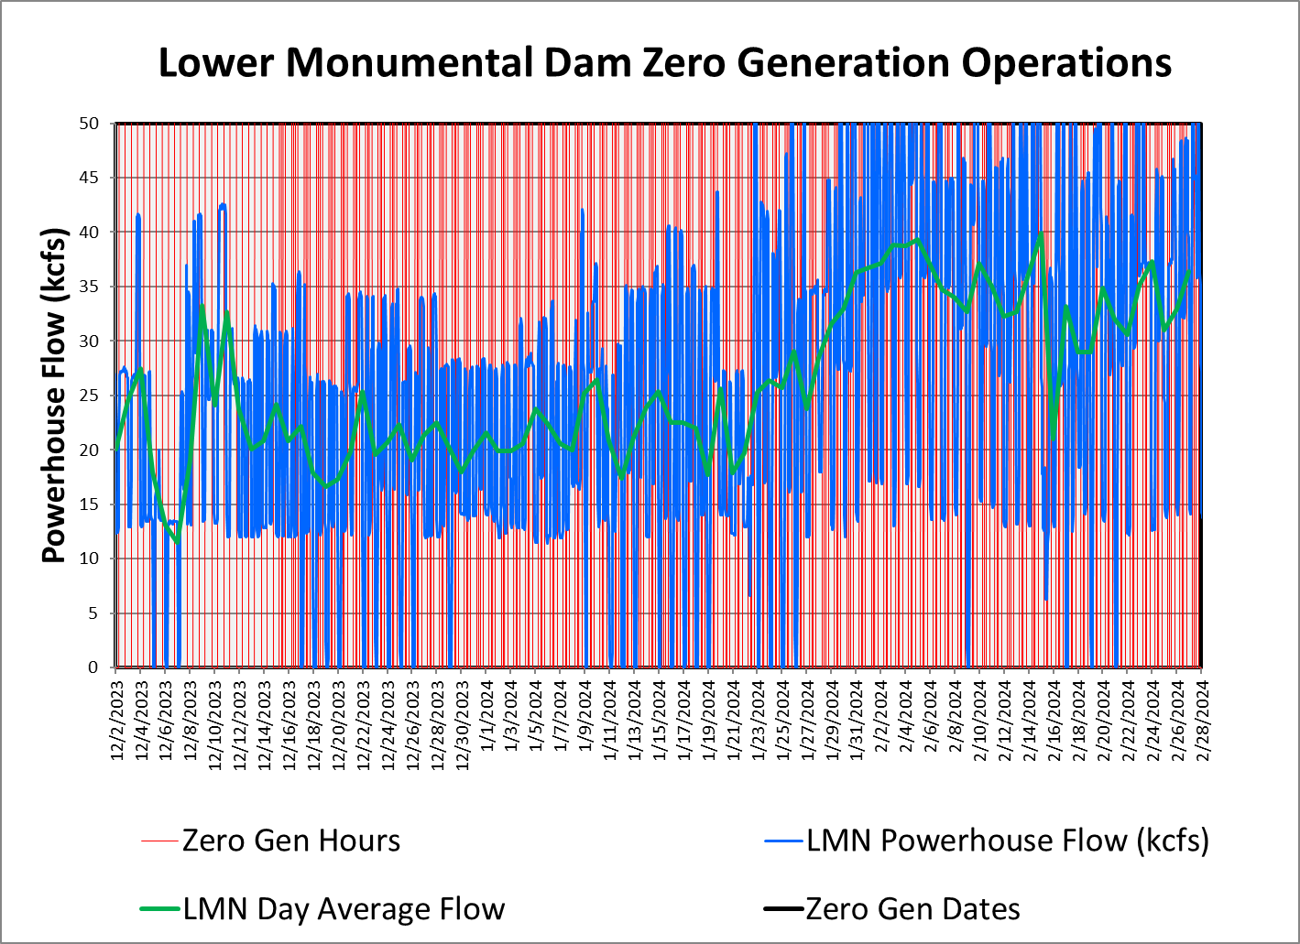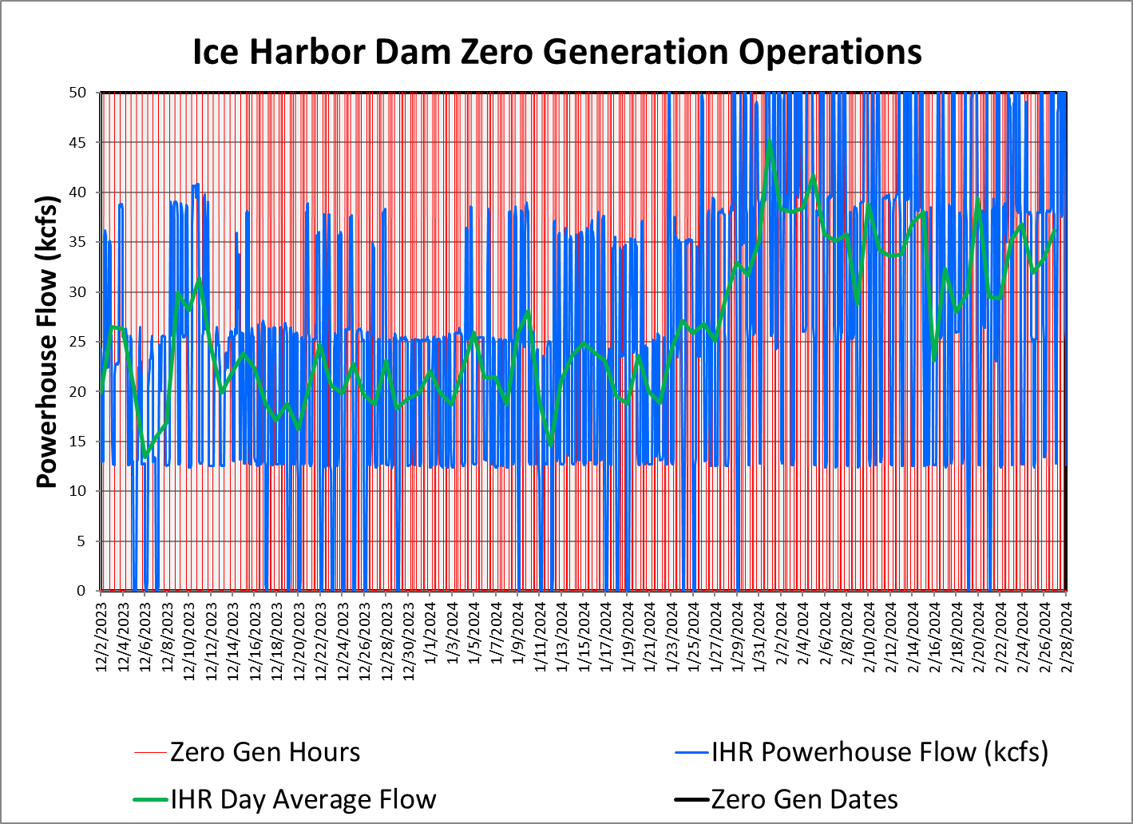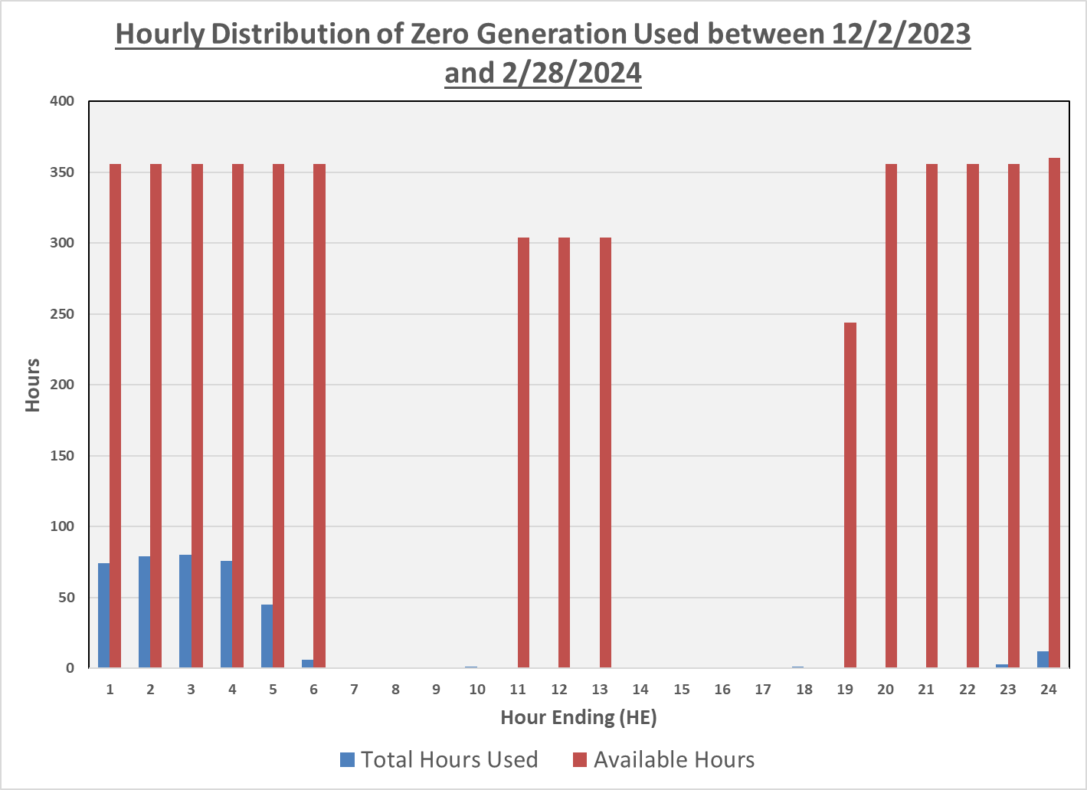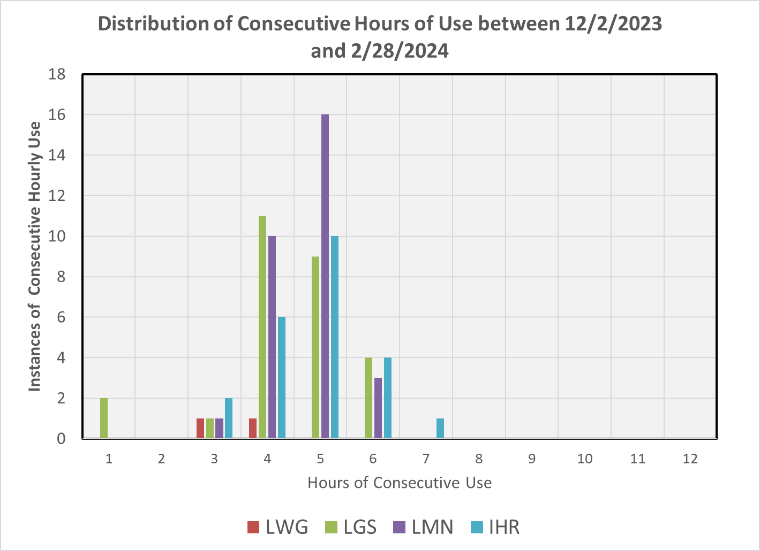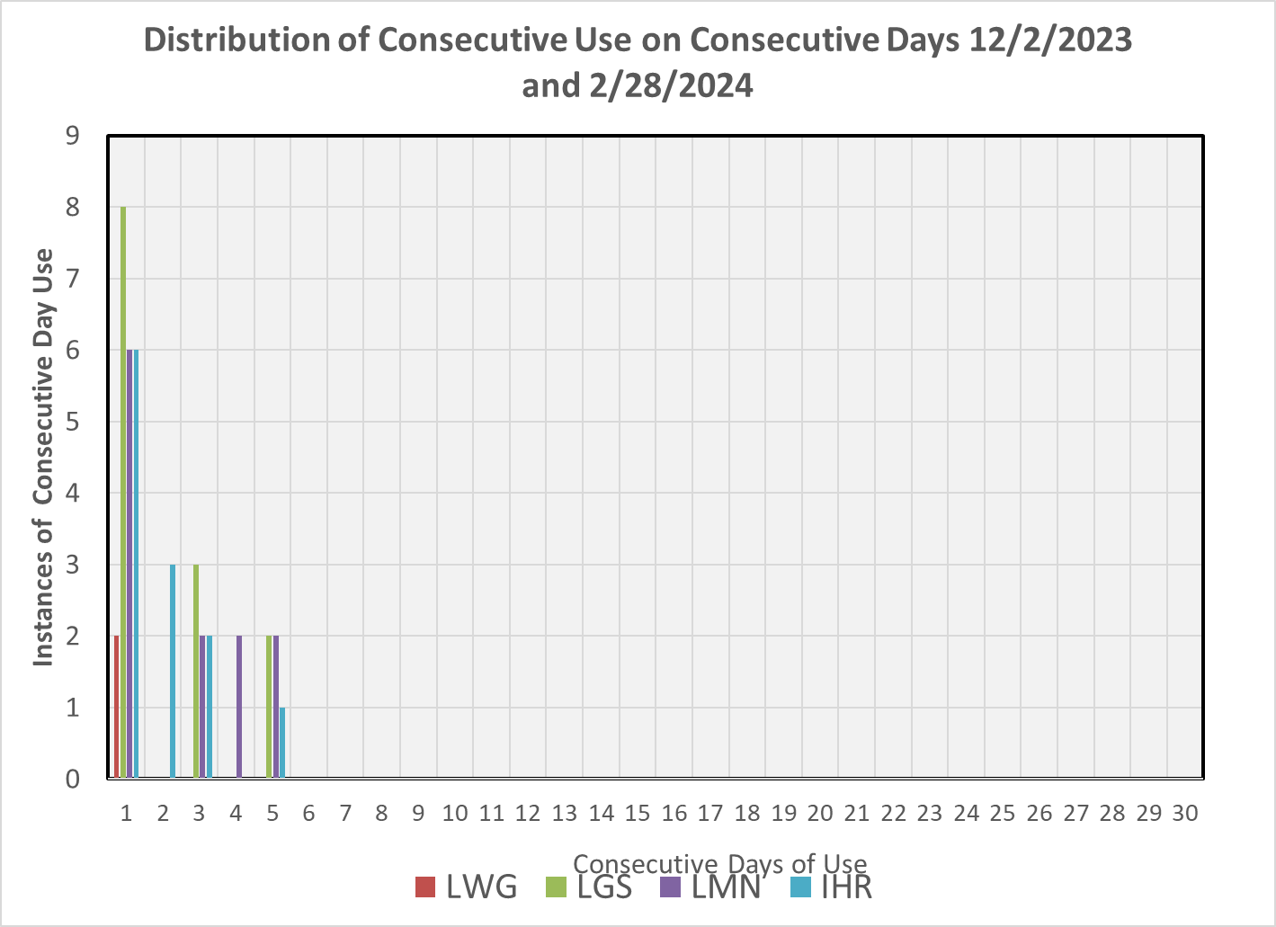

  - Navigation Safety and Minimum Tailwater Elevations
Short-term adjustments in spill or minimum operating pool (MOP) elevations may be required at any of the fish passage projects to address navigation safety concerns. This may include changes in spill patterns, reductions in spill, short-term spill curtailment, or operating above MOP. Adjustments to MOP may also be required to meet minimum tailwater elevations (Table 2). Current spill operations for fish passage result in complex downstream hydraulics that cause large fluctuations in tailwater elevations. The 2020 BiOps describe MOP at the lower Snake River projects as a 1.5-foot range above the minimum forebay elevation (Table 2). To clearly communicate the implementation of this operation, the term “MOP” will refer to the 1.5-foot operating range above the minimum forebay elevation at the lower Snake River projects (i.e., “MOP” is a 1.5-foot operating range).

The Corps will operate Lower Granite Dam at MOP with a 1.5-foot forebay operating range and a 1.0-foot range to the extent possible (referred to operationally as a “soft constraint”) from April 3 until August 31, unless adjusted on occasion to meet authorized project purposes, primarily navigation, except as noted below. Little Goose, Lower Monumental and Ice Harbor dams will operate at MOP with a 1.5-foot forebay operating range and a 1.0-foot range soft constraint to
the extent possible from April 3 until August 14, unless adjusted on occasion to meet authorized project purposes, primarily navigation, except as noted below.

Table 2.─ Normal and minimum operating pool (MOP) elevation ranges and minimum tailwater elevations for lower Snake River projects. ^{A}
Project | Normal Operating Elevation Range (ft) ^{B} |  | MOP Elevation Range (ft) ^{C} |  | Project Tailwater (ft)
Project | Minimum | Maximum | Minimum | Maximum | Minimum
Lower Granite | 733.0 | 738.0 | 733.0 | 734.5 | 633.0
Little Goose | 633.0 | 638.0 | 633.0 | 634.5 | 537.0
Lower Monumental | 537.0 | 540.0 | 537.0 | 538.5 | 437.0
Ice Harbor | 437.0 | 440.0 | 437.0 | 438.5 | 337.0
- Elevations provided in feet above mean sea level (NGVD29).
- August 15 – April 2, except at Lower Granite (September 1-April 2).
- April 3 – August 14, except at Lower Granite (April 3 – August 31). Projects will be operated within a 1.0-foot range to the extent possible (referred to operationally as a “soft constraint”).

Potential in-season adjustments to MOP, if necessary, will be an expanded forebay operating range (Expanded MOP), raised minimum forebay elevation (Raised MOP), and these operations are discussed in greater detail in the 2024 Fish Operations Plan on the following website on page FOP-14.

https://pweb.crohms.org/tmt/documents/fpp/2024/
  - Lower Snake River Projects – Updates on Tailwater Elevation Monitoring Data and Lower Granite Dam Spill Pattern
For the 2024 Minimum Operating Pool (MOP) period for the lower Snake River projects, the Corps is revising some of the source data for project tailwater elevation monitoring and implementing an alternate spill pattern at Lower Granite in 2024 during low flows.

The tailwater elevation data feeds at each of the lower Snake projects will begin using a median value of multiple project sensors instead of a single sensor value, starting at Lower Granite. These revisions will be applied to all of the GDACS and CBT data but will not affect the nav lock tailwater gage data which will remain as a separate gage and data feed. Below are a few examples of Lower Granite tailwater data paths along with a brief description. Project data queries are availible in Data Query 2.0 that may be found at https://www.nwd-wc.usace.army.mil/dd/common/dataquery/www/

- LWG.Elev-Tailwater.Ave.1Hour.1Hour.GDACS-COMPUTED-REV
Lower Granite tailwater elevation, hourly average of median values for all tailwater gages, transmitted via GDACS. Does not include the nav lock gage.

- LWG.Elev-Tailwater.Inst.1Hour.0.CBT-RAW
Lower Granite tailwater elevation, hourly instantaneous reading of median values for all tailwater gages, transmitted via GDACS. Does not include the nav lock gage.

- LWGW.Elev-Tailwater.Inst.15Minutes.0.GOES-REV
Lower Granite tailwater elevation at the navigation lock entrance, instantaneous value transmitted via GOES satellite every 15 minutes.

For maintaining the minimum tailwater elevation at each of the lower Snake projects, the Corps may allow for some minor and brief excursions below the minimum elevation prior to making an adjustment to the MOP range at the next downstream project. For example, if the tailwater elevation at Little Goose drops to 536.9 feet for a single hourly reading on one day but remains at or above the minimum of 537.0 feet for the remainder of the day, the Corps will likely not raise MOP at Little Goose. However, if there are multiple hourly readings below 537.0 feet and the inflow forecast is decreasing, the Corps will likely respond by raising MOP at Lower Monumental in half-foot increments to maintain the minimum tailwater elevation at Little Goose. At times, low inflows may contribute to challenges meeting the minimum tailwater elevation and a Raised MOP operation may be implemented, however if flows rise (e.g., during the spring freshet) then projects may be returned to MOP. The Corps will use best engineering judgement based on real time conditions to decide if a MOP adjustment is needed.

Specifically for Lower Granite, the first option the Corps will use to attempt to maintain the minimum tailwater elevation is an alternative spill pattern when total spill is less than 15 kcfs (see FPP CH. 9, Table LWG-7-ALT). This alternative spill pattern will be implemented as a first attempt to stabilize the tailwater elevation at low flows, with the intent of avoiding or minimizing the need to raise MOP at Little Goose. The Corps will allow sufficient time to assess the efficacy of the alternative pattern to stabilize the tailwater elevation, assuming the navigation lock remains in criteria. The alternative spill pattern table only applies when the RSW is open and total spill is less than 15 kcfs. This is only expected to occur when total inflows are less than about 30 kcfs with the project operating in a minimum generation/spill the rest condition which is typically in the summer spill period. The alternative spill pattern at Lower Granite will be evaluated after the 2024 summer spill season and if it meets the intent with no adverse impacts (e.g., to navigation), it will become the default low flow spill pattern in Table LWG-7.
  - Minimum Irrigation Pool (MIP)
As described in the 2020 CRS BA (page 2-57), from April 10 – June 1 (or as feasible based on river flows), the John Day reservoir elevation will be held between 264.5 feet and 266.5 feet (an average of 265.5 feet) to deter Caspian terns from nesting in the Blalock Islands Complex. The Action Agencies intend to begin increasing the forebay elevation prior to initiation of nesting by Caspian terns to avoid take of tern eggs; operations may begin earlier than April 10 (when the reservoir is typically operated between 262.0 to 266.5 feet). The operation may be adaptively managed due to changing run timing; however, the intent of the operation is to begin returning to reservoir elevations of 262.5–264.5 feet on June 1, but no later than June 15, which generally captures 95% of the annual juvenile steelhead migration. The results of this action would be monitored and communicated with USFWS and NMFS. During the operation, safety-related restrictions would continue, including but not be limited to maintaining ramp rates for minimizing project erosion and maintaining power grid reliability. Following this operation, the John Day reservoir elevation would return to MIP + 2 ft operation through August 31.

From June 1 through August 31, John Day Dam will be operated to minimize water travel time for downstream-migrating juvenile salmon by operating the forebay within the minimum irrigation pool (MIP) range of 262.5 to 264.5 feet, which is the lowest pool elevation that allows irrigation withdrawals.

This section will be updated throughout the season as new information becomes available.
  - Spill for Juvenile Fish Passage
Table 4 below is a summary of the 2024 spring target spill levels at lower Snake River and lower Columbia River projects, as described in the 2024 Fish Operations Plan (2024 FOP). Additional information on spring spill operations may be found in the 2024 FOP (page FOP-18) on the following website.

https://pweb.crohms.org/tmt/documents/fpp/2024/

Table 4.─ Summary of 2024 spring target spill levels at lower Snake River (April 3 – June 20) and lower Columbia River (April 10 – June 15) projects.
PROJECT | SPRING SPILL DATES | SPRING SPILL OPERATION
Lower Granite ^{A,} ^{C} | April 3 - June 20 | 24 hours/day: 125% Gas Cap
Little Goose ^{B,} ^{C} | April 3 – June 20 | 125% Gas Cap 24 hours/day (until adult criteria met),  then  16 hours/day: 125% Gas Cap  8 hours/day: 30% Performance Standard
Lower Monumental ^{A} | April 3 - June 20 | 24 hours/day: 125% Gas Cap
Ice Harbor | April 3 – June 20 | 24 hours/day: 125% Gas Cap
McNary | April 10 – June 15 | 24 hours/day: 125% Gas Cap
John Day ^{D} | April 10 – June 15 | 40% Daytime 125% Gas Cap Nighttime
The Dalles ^{E} | April 10 – June 15 | 24 hours/day: 40% Performance Standard
Bonneville ^{F} | April 10 – June 15 | 24 hours/day: 125% Gas Cap
- Lower Granite and Lower Monumental Adult Delay Criteria – See Section 7.1.
- Little Goose Adult Criteria –Within 1 business day of when the earliest of the following conditions occurs: (1) a cumulative total of 25 adult spring Chinook salmon (not including jacks) pass Lower Monumental Dam; or (2) a cumulative total of 50 adult spring Chinook salmon (not including jacks) pass Ice Harbor Dam; or (3) April 24, 2024, the Corps will implement performance standard spill at Little Goose Dam for 8 consecutive AM hours (April 3–15 starting at 0500 hours; April 16–June 20 starting at 0400 hours) to target hours of peak adult passage. If lack of load conditions preclude the implementation of performance standard spill during the targeted periods, performance standard spill will begin as soon as practicable during AM hours and continue for up to 8 consecutive hours. If a second block is needed, it will start as soon as load conditions allow, continue for at least two consecutive hours, and conclude no later than 2000.
- During periods of high river flow that exceeds powerhouse hydraulic capacity, implementing 8 consecutive hours of spill as described in Footnotes A and B may result in storing additional inflow in the forebay above MOP. If it is necessary to pond water to achieve the 8-hour block of spill during high inflow, water stored above MOP should be drafted out over the remaining hours by increasing spill to pass inflow from 1200-1600 hours, then increasing spill as necessary from 1600-0400 to draft the pool back to MOP. If it is forecasted that the drafting spill will result in exceeding 130% TDG in the tailrace, all 16 hours will be used to return the pool to MOP. In lack of load conditions performance standard spill blocks will be prioritized at Little Goose, Lower Monumental, and Lower Granite dams, in that order.
- John Day Dam – Daytime hours are defined in FPP Chapter 4, Table JDA-5. Daytime hourly spill target of 40% river flows with ±5% flexibility in river flow for balancing reserves, consistent with current target spill level calculations.
- The Dalles Dam –TDG in The Dalles tailrace may fluctuate up to 125% prior to reducing spill at upstream projects or reducing spill at The Dalles below 40%. Maintain 40% spill for 24 hours at The Dalles and reduce John Day spill below the 125% TDG spill cap as needed for TDG management. Spill above 40%, up to 125% TDG, may occur for TDG management or for carrying reserves.
- Bonneville Dam – Spill for fish passage should not exceed 150 kcfs due to erosion concerns.

Table 5 below is a summary of the 2024 summer target spill levels at lower Snake River and lower Columbia River projects, as described in the 2024 FOP. Additional information on summer spill operations may be found in the 2024 FOP (page FOP-20) on the following website.

https://pweb.crohms.org/tmt/documents/fpp/2024/

Table 5.─ Summary of 2024 summer target spill levels at lower Snake River and lower Columbia River projects.
PROJECT |  | SUMMER SPILL^{A}  (June 21/16 – July 31) (24 hrs/day) | SUMMER SPILL^{A}  (August 1 – August 31)  (24 hrs/day)
Lower Granite ^{B} |  | 18 kcfs | SW flow  (as river flow allows)
Little Goose ^{B,} ^{C} |  | 30% | SW flow or 7 kcfs
Lower Monumental ^{B,} ^{D} |  | 17 kcfs | SW flow or 8 kcfs
Ice Harbor ^{B,} ^{E} |  | 30% | SW flow or 9 kcfs
McNary ^{F} |  | 57% | SW flow or 20 kcfs
John Day |  | 35% ^{G} | SW flow ^{H} or 20 kcfs
The Dalles |  | 40% ^{G} | 30% ^{G}
Bonneville |  | 95 kcfs | 50 kcfs
- Spill may be temporarily reduced below the FOP target summer spill level at any project if necessary to ensure navigation safety or transmission reliability, or to avoid exceeding State TDG standards.
- Late summer spill August 1-August 31 will be through the SW or a constant spill rate through conventional spillbays using the appropriate FPP spill pattern. The SW spill rate is a function of forebay elevation (as pool elevation increases, more water is spilled over the SW), as defined in the FPP. The SWs will be operated per FPP criteria and closed when low flow criteria are met. When the SW is closed, the spill target will transition to a constant spill rate through conventional spillbays and will not vary with a fluctuating forebay elevation.
- Flow corresponds to the Little Goose SW high crest elevation as adjusted relative to the forebay operating range (see FPP Chapter 8, section 2.3.2.7).
- Flow corresponds to a Lower Monumental forebay elevation of 538.5 feet, the mid-point of the forebay range from 537-540 feet.
- Flow corresponds to an Ice Harbor forebay elevation of 438.5 feet, the mid-point of the forebay range from 437- 440 feet.
- From June 16-July 31, McNary will adjust spill once a day to 57% of the previous day’s average project outflow. The intent is to reduce the frequency of spillgate changes while implementing a more uniform pattern to the extent it can be done safely (see FPP Chapter 5, section 2.2.1.1).
- Hourly spill percentage target of river flow with ±5% flexibility of river flow for balancing reserves, consistent with current target spill level calculations.
- John Day will also spill from bay 2 open 1 stop (approximately 1.6 kcfs) during daylight hours when spill is through the SWs only to maintain attraction flow to the north adult ladder, per FPP Chapter 4 (JDA), section 2.2.3.
  - Juvenile Trasportation
As described in the 2024 FOP (see page FOP-16), juvenile transportation will be initiated at Lower Granite, Little Goose and Lower Monumental dams on April 24 (collection starting on April 23) or as coordinated through the TMT and the RIOG but begin no later than May 1. Transport begins the following day after fish collection and collected juvenile fish will be transported from each facility on a daily or every-other-day basis (depending on the number of fish) throughout the migration season. Transportation of spring migrants ends on June 20. Truck transportation of summer migrants at Lower Granite and Little Goose resumes on August 1 with allowance for TMT adaptive management adjustments and continues through October 31. Transportation operations are carried out at each project in accordance with relevant FPP operating criteria. Transportation and spill operations may be adjusted due to research, conditions at fish collection facilities (e.g., overcrowding or temperature extremes), or through the adaptive management process with FPOM and/or TMT (e.g., to respond to expected environmental conditions, to respond to recent transport vs in-river research results, to better match juvenile outmigration, or to achieve/maintain spill targets).
  - Fish Passage Research in 2024
The following is the project specific fish passage research planned for 2024. It is described in greater detail in the 2024 Fish Passage Plan in Appendex A. The 2024 FPP may be found on the following website.
https://pweb.crohms.org/tmt/documents/fpp/2024/
    - Bonneville Dam
Powerhouse 2 Fish Guidance Efficiency (FGE) Gatewell Improvement Post-Construction Evaluation.
The concrete gatewell modifications to the A & B slots of Main Units 11-18 at Bonneville Dam Powerhouse 2 were completed in November 2023. The goal of this study is to evaluate whether these structural modifications have resulted in acceptable fish passage conditions during turbine unit operation throughout the middle and upper 1% peak efficiency range. This study will use biological fish condition monitoring at the Juvenile Monitoring Facility (JMF) to compare the distributions of descaling and mortality of JMF samples at the middle and upper 1% peak efficiency range for spring and summer in 2024.
The study consists of a randomized block-treatment study design for 2024 spring and summer. The spring study period will have eight treatment blocks between April and May. The summer period will have eight treatment blocks that are between June and July. The block-treatment study design will result in eight, 24-hour JMF samples during mid 1% peak efficiency range operations and eight, 24-hour JMF samples during upper 1% peak efficiency range operations which will be used to test for differences in descaling and mortality rates between operations. Each block will be less than a week in duration, covering two operational treatments (mid 1% peak efficiency range and upper 1%) that are randomized within the block timeframe. Note that there is additional operation time surrounding test treatments within each block expanding beyond the 24-hour JMF sample period in which the turbines will be operating at the specified 1% test treatment range to ensure ample time between each flow treatment condition for fish to exit the gatewells.
Additionally, a separate study (still under development and subject to change) to evaluate potential fish impingement on the Vertical Barrier Screens (VBSs) of a single unit will occur on selected dates throughout the spring and summer test periods. This study involves deployment of underwater monitoring equipment in gatewells 15A (modified) and 15C (unmodified) during specified operations in the mid and upper 1% of the peak efficiency range. The impingement will be evaluated by estimating VBS contact rates during five 24-hour periods of each of the spring and summer juvenile migration periods. If U15 is OOS during an impingement test day, the adjacent main unit gatewells A&C will be used in its place following the revised testing unit priority.
    - The Dalles Dam
There are no studies planned at The Dalles Dam in 2024.
    - John Day Dam
Juvenile lamprey telemetery passage studies.
A combination of JSATS cabled dam-face arrays (fixed locations on the upstream side of the dam) and autonomous receiver arrays will be utilized in this study for estimating overall MCN and JDA passage survival and MCN-to-JDA reach survival. Juvenile (and larval) lamprey collected from JDA, MCN, and LMN will be tagged and released at locations 30km upstream of McNary Dam and 40km upstream of John Day Dam. Collection of juvenile Pacific lamprey at dams on the Columbia and Snake rivers is dependent on the operation of the JBS at these facilities. If an adequate number of lamprey are not available from the daily sample collection at the JFFs, lamprey may be collected from alternative sources including the Yakama Nation (e.g., Satus Creek, Toppenish Creek [upper and lower traps], Ahtanum Creek, Chandler Dam), Confederated Tribes of the Umatilla Indian Reservation (CTUIR) (e.g., 3-Mile Dam smolt trap, Upper Umatilla River trap), Oregon Department of Fish and Wildlife (ODFW) screw traps (Birch Creek and Fifteenmile Creek), and artificially propagated lamprey (from Yakama Nation, CTUIR, and/or Abernathy Fish Technology Center). In addition, alternative methods of collection may be used to trap lamprey from locations within the raceways (e.g., tailscreens, headboxes) and within the sample holding tanks at MCN, JDA, and/or LMN.
    - McNary Dam
Juvenile lamprey telemetery passage studies.
A combination of JSATS cabled dam-face arrays (fixed locations on the upstream side of the dam) and autonomous receiver arrays will be utilized in this study for estimating overall MCN and JDA passage survival and MCN-to-JDA reach survival. Juvenile (and larval) lamprey collected from JDA, MCN, and LMN will be tagged and released at locations 30km upstream of McNary Dam and 40km upstream of John Day Dam. Collection of juvenile Pacific lamprey at dams on the Columbia and Snake rivers is dependent on the operation of the JBS at these facilities. If an adequate number of lamprey are not available from the daily sample collection at the JFFs, lamprey may be collected from alternative sources including the Yakama Nation (e.g., Satus Creek, Toppenish Creek [upper and lower traps], Ahtanum Creek, Chandler Dam), Confederated Tribes of the Umatilla Indian Reservation (CTUIR) (e.g., 3-Mile Dam smolt trap, Upper Umatilla River trap), Oregon Department of Fish and Wildlife (ODFW) screw traps (Birch Creek and Fifteenmile Creek), and artificially propagated lamprey (from Yakama Nation, CTUIR, and/or Abernathy Fish Technology Center). In addition, alternative methods of collection may be used to trap lamprey from locations within the raceways (e.g., tailscreens, headboxes) and within the sample holding tanks at MCN, JDA, and/or LMN.
MCN Spillway Direct Injury Evaluation
Juvenile spring Chinook will be directly released into a spillbay in the split-leaf orientation and the TSW. The study is expected to require approximately four weeks of total study time. Direct release pipes will be installed in spillbay and TSW for direct fish releases. Split-leaf spill operation will be compared to the TSW for direct fish injuries. Project support will be provided for equipment install and removal. Specific dates for Project support, outages, and operations will be scheduled appropriately with the Project and through FPOM closer to study implementation.
    - Ice Harbor Dam
There are no studies planned at Ice Harbor Dam in 2024.
    - Lower Monumental Dam
There are no studies planned at Lower Monumental Dam in 2024.
    - Little Goose Dam
Kelt Collection & Reconditioning
The Nez Perce Tribe (NPT) Department of Fisheries Resources Management will collect wild/natural post-spawned, emigrating steelhead from the separator at Little Goose Juvenile Fish Facility. These fish will be transported to the Nez Perce Tribal Hatchery (NPTH) or Dworshak National Fish Hatchery (DNFH) to be utilized in the kelt reconditioning program.
    - Lower Granite Dam
Genetic Stock Identification (Idaho Department of Fish and Game)
Fish collected as part of the Lower Granite juvenile condition sample are used to enumerate and characterize age composition and genetic stock profiles of naturally producing yearling Chinook and juvenile steelhead. IDFG will sample Monday through Friday through mid-June with a goal of collecting 2,000-5,000 yearling Chinook and juvenile steelhead genetic samples.
Kelt Study (Nez Perce Tribe, University of of Idaho, CRITFC)
This research investigates steelhead kelt physiology and endocrinology to evaluate the feasibility and success of rehabilitating strategies. Selected kelts collected at Lower Granite are transported by NPT to Dworshak National Fish Hatchery for reconditioning and later release as part of this study.
PIT -Tag Adult Wild Chinook and Adult Steelhead for ISEMP-Related Dispersal Monitoring (NOAA Fisheries)
The goal of this project is to PIT-tag up to 4,000 unclipped adult Chinook and 4,000 unclipped adult steelhead collected in the adult trap daily sample for dispersal monitoring.
Sampling of Adult Steelhead, Chinook, and Sockeye for Biological Data Collection (IDFG and NOAA Fisheries)
Upriver migrating adult steelhead, spring/summer Chinook salmon, and sockeye salmon are collected from the adult trap from April 4 through December 15. The goal is to collect 5–20% of adult steelhead, spring/summer Chinook salmon, and sockeye salmon ascending the ladder. Data collection includes fish scales, genetics tissue, sex and length, wild/hatchery composition, and non-adipose clipped hatchery fish assessment. All natural-origin adult steelhead and spring/summer Chinook salmon trapped will be PIT-tagged to estimate headwater tributary escapement. Sockeye salmon may be PIT-tagged in the future to estimate metrics regarding conversion rates. Some steelhead and spring/summer Chinook salmon may be radio-tagged or spaghetti-tagged. This information on adult fish forms the basis for status information used in several forums including BiOp-RPA identified needs.
Bull Trout PIT-Tagging and Genetic Sample Collection for USFWS
Bull trout will be collected as part of the normal adult trap daily sample and using the adult sort-by-code (SbyC) system to recapture previously PIT-tagged fish. Untagged bull trout will be PIT-tagged, fin clipped for genetic analysis, and have morphometric data collected including weight and length, etc. Fin clips will be sent to USFWS to determine the fish’s origin. Previously PIT-tagged bull trout will only have morphometric data collected. All fish will be released back into the adult fish ladder.
Subyearling Chinook Parentage-Based Tagging (USGS)
The goal of this project is to determine the abundance of unmarked, untagged, natural- and hatchery-origin subyearling Chinook salmon in Lower Granite sample collection. Fin clips will be taken from 30 unclipped, untagged subyearling Chinook each day from June 1-15 and for another two weeks in July depending in fish passage numbers.
Collection of Adult Fall Chinook and Coho for Hatchery Broodstock – (WDFW and Nez Perce Tribe)
Adult fish are collected in the adult trap. Fall Chinook are transported by WDFW employees to Lyons Ferry hatchery and by NPT employees to Dworshak hatchery. Coho are transported by NPT and transported to Dworshak hatchery.

